Stanko proba PHOTONICA2021
(Times New Roman 14, Bold)

Lj. Petrovic¹, J. Nikolic² and M. Grujic³ (Times New Roman 11)
¹Vinca Institute of Nuclear Sciences, (Times New Roman 10, Italic)
Belgrade, Serbia
²School of Electrical Engineering, University of Belgrade, Serbia
³Institute of Physics, Belgrade, Serbia
e-mail:nikolic@etf.rs (Times New Roman 10)

All the abstracts for the PHOTONICA2021 meeting have to be submitted before June 01, 2021. Abstracts must be written in English and must contain sufficient details to provide the reviewers with a clear impression of the scope and content of the proposed contribution. Abstract acceptance will be confirmed by e-mail to the sender.

Please prepare your abstract in MS Word by modifying this template (available at http:// http://www.photonica.ac.rs).

Please use a filename for your abstract with the .doc of .docx signature (ex: filename.doc). Only electronic submissions will be accepted and they have to be prepared using this template. The size of the abstract is limited to one A4 page.

Please read this for instructions on creating your abstract. Please follow the template outlined here to format the abstract title, author list, and affiliations. Be sure to underline the corresponding author.
Please use a Times New Roman 11 point font for the text of the abstract. The text of abstract must be justified and the margins should be kept at 1 inch.

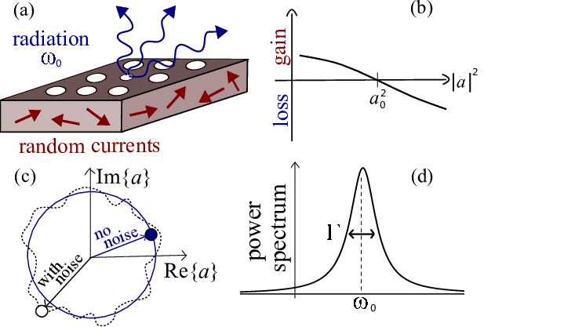

Figure 1. Include figure if needed. Caption centered, 10pt.
References should be listed just below the abstract body [1]. Web URL (Internet references) are accepted [2].

REFERENCES
[1] F. Author, S. Second, T. Third, J. Phys. Soc. Jpn. 99, 1234 (2001).
[2] http://www.photonica.ac.rs

