Synthesis of Bimetallic Germanium-Copper Oxide Nanoparticles by Pulsed Laser Ablation in Liquids: Potential Application for LIBS Signal Enhancement

S. Zivkovic¹, M. Momcilovic¹, N. Krstulovic², G. Galbacs³
¹Department of Physical Chemistry, Vinca Institute of Nuclear Sciences, University of Belgrade, Belgrade, Serbia
² Centre for Advanced Laser Techniques, Institute of Physics, Zagreb, Croatia
³Department of Molecular and Analytical Chemistry, University of Szeged, Szeged, Hungary
e-mail: sanjaz@vin.bg.ac.rs

A novel laser-based strategy was developed for the synthesis of functional germanium–copper oxide nanoparticles, with the aim of enhancing the analytical performance of LIBS. A thin germanium film was deposited onto a copper substrate by pulsed laser deposition (PLD) in vacuum, using an Nd:YAG laser (λ = 1064 nm, ≈300 mJ per pulse, 5 Hz repetition rate, 4 ns duration), with the target and substrate placed ~1 cm apart and rotated continuously for uniform coating, over 3000 pulses. The resulting material was then used to fabricate nanoparticles using the laser ablation technique in liquids. This target was immersed into 3 ml of Milli-Q water, and the surface area of approximately 25 mm² was continually scanned by a pulsed laser beam in order to achieve homogeneous ablation of the sample using an Nd:YAG laser (7 mJ, 10 Hz, 150 ps pulse duration, wavelength of 1064 nm). Characterization of the formed bimetallic nanocolloids was performed by measuring the SPR band using UV-VIS spectrophotometry and TEM microscopy.

Additionally, nanoparticles were used for Nanoparticle-Enhanced Laser-Induced Breakdown Spectroscopy (NELIBS) of an aluminum sample. LIBS measurements were performed using a TEA CO₂ laser-based setup with an Avantes spectrometer and optical triggering. Bimetallic nanocolloid solution was applied by the drop-and-dry technique [1]. Preliminary results have shown an improvement in analytical sensitivity for the detection of Mg in aluminum.
a) 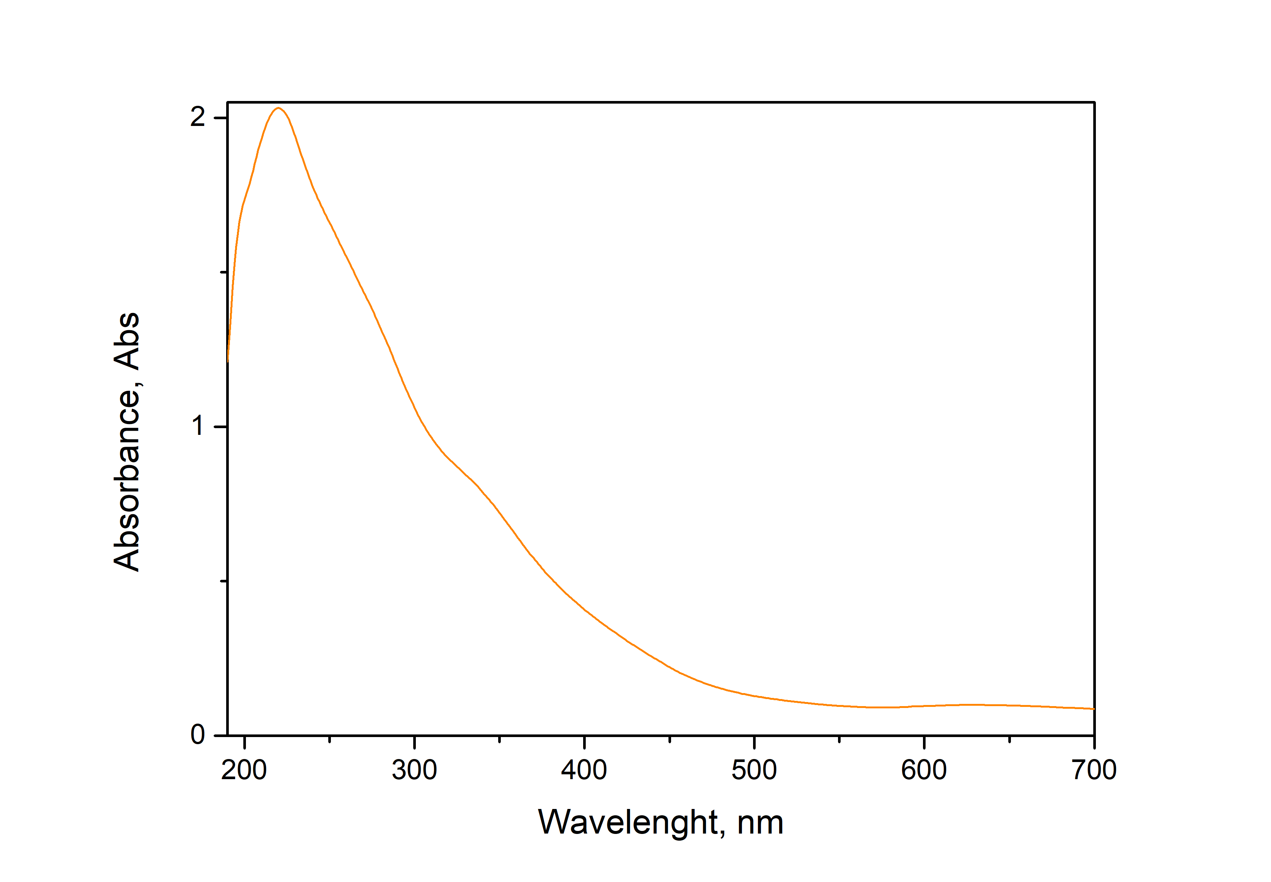 | b) 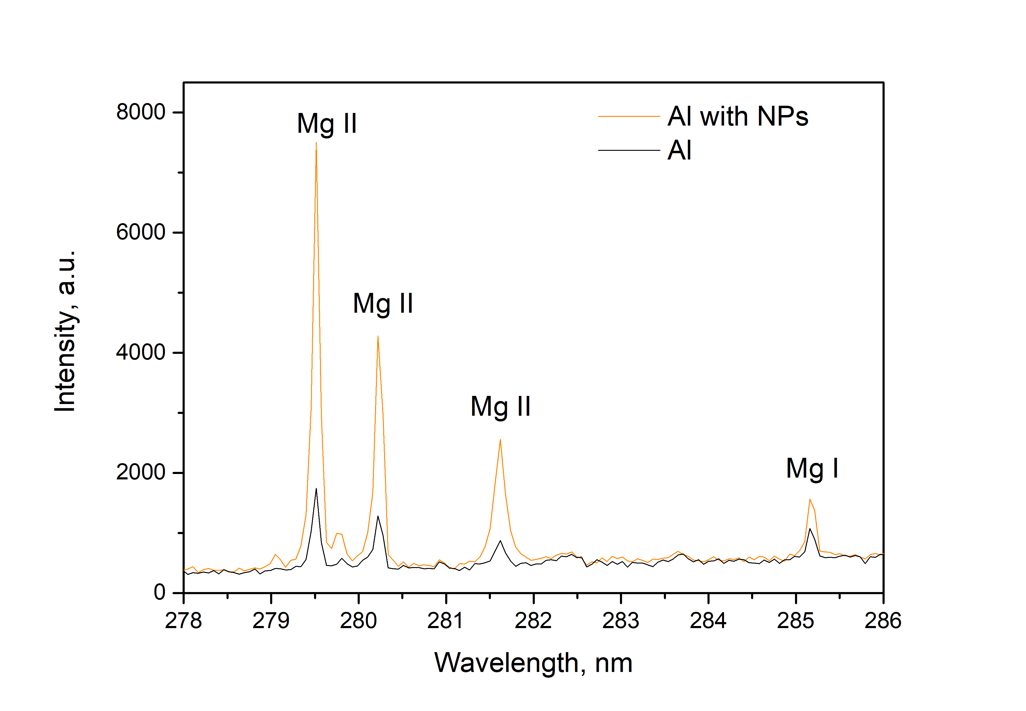
Figure 1. a) UV Vis spectrum of LASIS nanoparticles, b) obtained LIBS spectra of aluminum sample with and without nanoparticles

REFERENCES:
[1] M. Momcilovic, J. Petrovic, M. Nemoda, J. Ciganovic, N. Krstulovic, M. Ognjanovic, S. Zivkovic, Appl. Phys. B 129, 62 (2023).

