Photonic Biosensors for Discriminating Sepsis, UTI, and Bladder Cancer via Biofunctionalized Optical Probes

Paweł Wityk^{1,2}, Wiktoria Brzezińska¹, Patryk Sokołowski², Joanna Raczak-Gutknecht¹, Małgorzata Szczerska²
¹Medical University of Gdańsk, Gdańsk, Poland
²Gdańsk University of Technology, Gdańsk, Poland
e-mail: pawel.wityk@pg.edu.pl

We report on the development and validation of a fiber-coupled photonic biosensor platform for the differential analysis of urine samples from patients with sepsis, urinary tract infections (UTI), and bladder cancer. The system employs custom-engineered optical probes operating in the 200–1000 nm spectral range, allowing simultaneous acquisition of absorbance, fluorescence, and scattering signatures.
The sensing surface is biofunctionalized with disease-specific monoclonal antibodies, enabling molecular recognition of inflammatory cytokines, oxidative stress markers and tumor-derived metabolites (Fig. 1). The optical interface operates in a reflective mode, ensuring maximal contact with analyte-containing fluid and enhancing photon collection efficiency.
High-sensitivity detection is achieved via integrated low-noise spectrofotometer, narrow-band optical filtering, and real-time spectral deconvolution. Preliminary clinical validation on a pilot cohort demonstrated distinct biomolecular optical signatures for each disease group, with sensitivity and specificity exceeding 85% and total acquisition times below 5 minutes per sample [1, 2, 3]
This portable, label-free, and non-invasive photonic technology holds strong potential for rapid bedside stratification of patients in emergency care, with prospective applications in point-of-care diagnostics, infection control, and oncological screening.

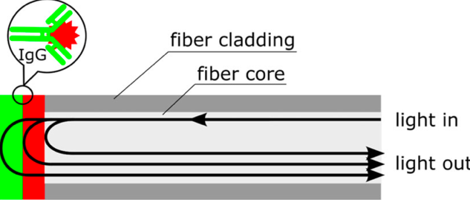
Figure 1. Schematic representation of biofunctionalized probe.

REFERENCES
[1] Wityk, Paweł, et al. "Optical method supported by machine learning for urinary tract infection detection and urosepsis risk assessment." Journal of Biophotonics 16.9 (2023): e202300095.
[2] Krawczyk, Beata, et al. "Uropathogenic Escherichia coli Associated with Risk of Urosepsis—Genetic, Proteomic, and Metabolomic Studies." International Journal of Molecular Sciences 26.12 (2025): 5681.
[3] Sokołowski, Patryk, et al. "Optical method supported by machine learning for dynamics of C‐reactive protein concentrations changes detection in biological matrix samples." Journal of Biophotonics (2024): e202300523.

