All optical fiber whispering gallery mode resonator

D. N. Wang¹, Y. L. Mei², Qiaoben Wang² and Chao Wang³
¹College of Urban Transportation and Logistics, Shenzhen Technology University, Shenzhen, China
²College of Optical and Electronic Technology, China Jiliang University, Hangzhou 310018, China
³School of Future Technology, Shenzhen Technology University, Shenzhen, China
e-mail: wangdongning@sztu.edu.cn

Whispering gallery mode (WGM) resonator can strongly confine light within the structure by continuous total internal reflection [1], and is widely used in optical filters, modulators, micro-lasers, frequency comb generators, nonlinear optics and high-sensitivity sensor devices. However, most of WGM resonators are usually discrete optical devices, which have integration difficulties with optical fiber system.

Here we present a new type of optical fiber WGM resonator based on cylindrical cavity, which is located in the multimode fiber (MMF) core as shown in Fig. 1. When the light transmission path in the fiber core is tangent to the cylindrical cavity wall, it is coupled into the cylindrical cavity through the evanescent field, circulates along the cylindrical cavity wall and excites WGM resonance in the glass wall before leaving the cylindrical cavity in the same tangential path and traveling along the fiber core again.
The WGM resonator is fabricated by femtosecond laser micromachining together with fast hydrofluoric acid etching techniques. Firstly, a ring structure is carved on the surface of the MMF. Then the focused laser beam moves downward to start inscribing the same ring structure again. Such a process continues until a cylindrical structure is formed, as shown in Fig. 2(a). Next, a small amount of hydrofluoric acid solution is dropped at the cylindrical structure position to from a cylindrical cavity as shown in Fig. 2(b).

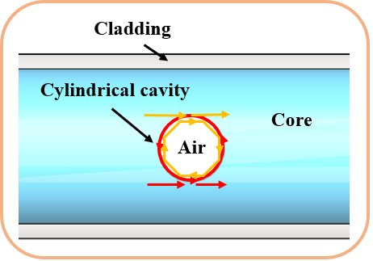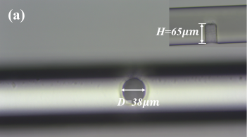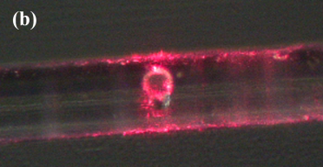
Figure 1. Schematic of the WGM resonator Figure 2. Microscope image of the WGM resonator. (a) Top view. Inset: the cross-section view. (b) Top view under the red light illumination.

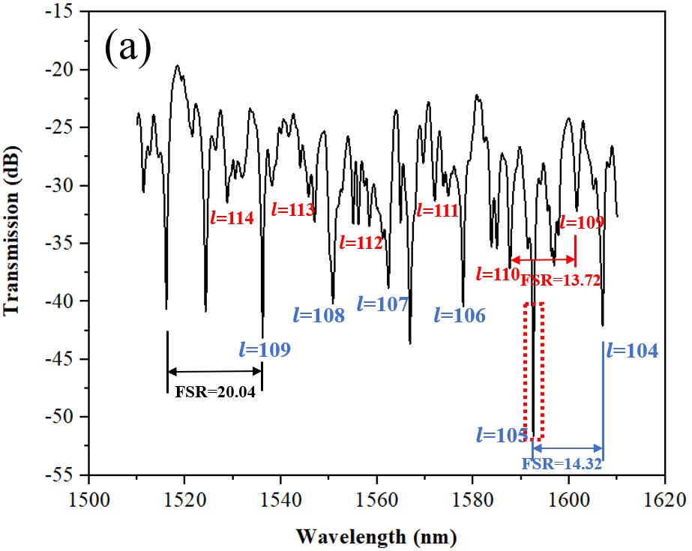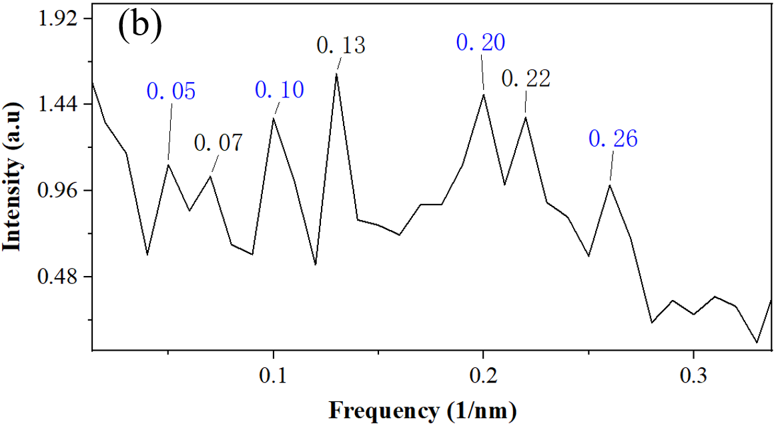
Figure 3. (a) The transmission spectrum of the optical fiber WGM cylindrical cavity resonator with diameter of 38 μm. (b) The corresponding spatial frequency spectrum.

Fig. 3(a) shows the transmission spectrum of the WGM resonator. The corresponding spatial frequency spectrum is shown in Fig. 3(b). It can be observed that the first two peaks are located at 0.05 nm⁻¹ and 0.07 nm⁻¹, respectively, and the rest peaks are multiples of these two peak frequencies. It can be determined that these two peaks correspond to WGM resonator operation.

REFERENCES
[1] A. Matsko and V. Ilchenko, IEEE J. Sel. Topics Quantum Electron., 12, 3 (2006).

