Design and first tests of the optical setup for experiments
with the free-space OAM waves

J.Z. Trajković^{1,2}, S.V. Savić³, B. Kasalica¹, I. Belča¹ and A.Ž. Ilić²
¹Faculty of Physics, University of Belgrade, 11000 Belgrade, Serbia
²Institute of Physics Belgrade, University of Belgrade, 11080 Belgrade, Serbia
³School of Electrical Engineering, University of Belgrade, 11000 Belgrade, Serbia
e-mail: jelena.trajkovic.ff@gmail.com, andjelijailic@ieee.org

Within the last decade, waves carrying orbital angular momentum (OAM) have been recognized as one of the key technological enablers of high-data-rate wireless communications and free-space optical communications [1], [2]. Moreover, data encryption schemes using the composite OAM waves consisting of different combinations of multiple OAM modes have been proposed for the combined capacity and security enhancements [3], [4]. Towards the development of novel data encryption algorithms and their experimental verification, as well as carrying out different other experiments, we have designed and assembled an experimental setup using the transmissive light modulator (TLM) plate for the precise control of phase modulation of the transmitted Gaussian beam (Figure 1). The Gaussian beam has been produced by the HeNe laser source (~632.8 nm wavelength), whereas the received waves are being monitored by the CCD camera and post-processed by the custom-designed algorithms.

Here we report on the system design and the observed system performances. We present a summary of the results from the first trials of our experimental equipment, with special emphasis on the production of composite OAM waves and their decryption on the receiving side.

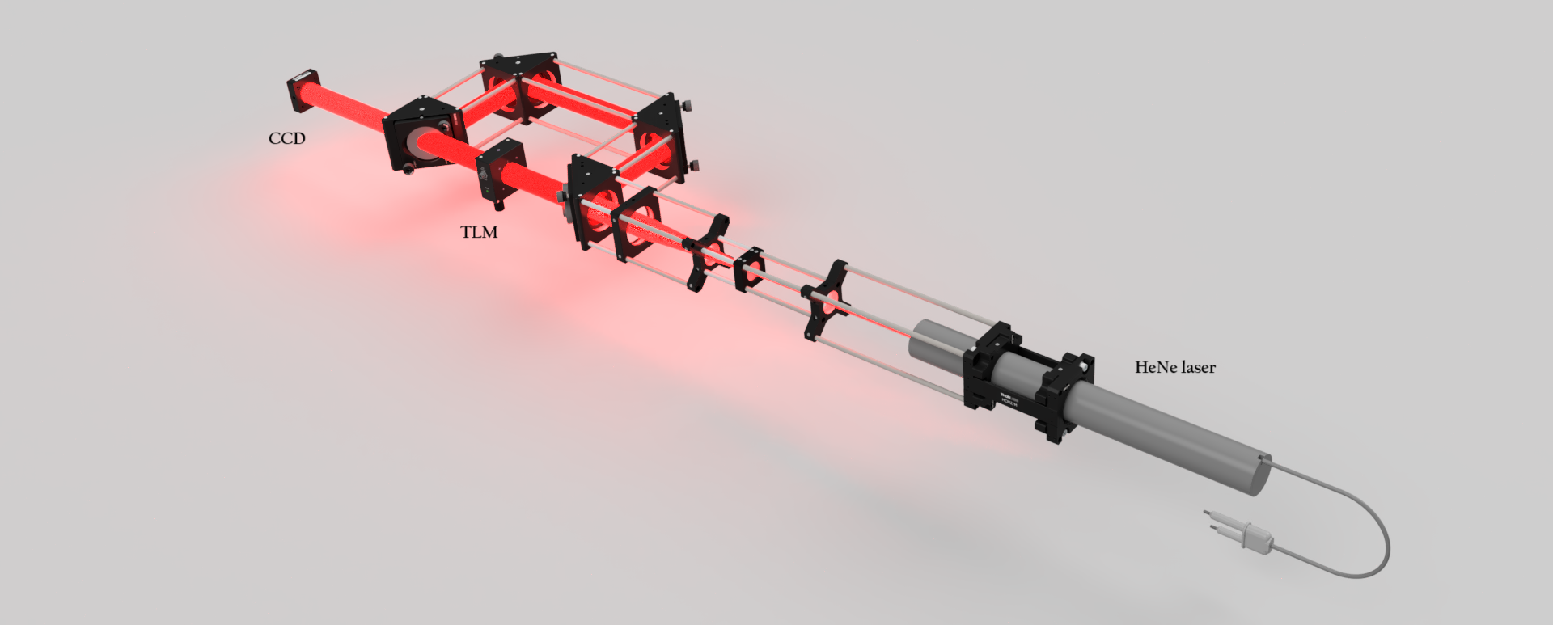
Figure 1. Proposed layout of the experimental setup.
Acknowledgments: This work was financially supported by the SEED Research Grant of the Institute of Physics Belgrade (for young researchers), through the SAIGE Project (Serbia Accelerating Innovation and Growth Entrepreneurship), as well as by the grants to the Institute of Physics Belgrade, Faculty of Physics and School of Electrical Engineering, provided by the Ministry of Science, Technological Development, and Innovations of the Republic of Serbia.

REFERENCES
[1] S. Tripathi, N.V. Sabu, A.K. Gupta, H.S. Dhillon, Millimeter-wave and terahertz spectrum for 6G wireless; In: Y. Wu, et al., 6G Mobile Wireless Networks, Computer Communications and Networks, Springer, Cham (2021). https://doi.org/10.1007/978-3-030-72777-2_6
[2] J. Wang, J. Liu, S. Li, Y. Zhao, J. Du, L. Zhu, Nanophotonics 11(4), 645–680 (2022).
[3] I.B. Djordjevic, IEEE Access 5, 16416–16428 (2017).
[4] X. Yu, J. Fan, X. Li, H. Zhu, S. Nie, J. Ma, C. Yuan, J. Light. Technol. 43(6), 2535–2543 (2025).

