Modelling of Terahertz Quantum Cascade Laser Self-Mixing Dynamics

N. Stanojević^{1, 2}, N. Vuković¹, M. Ignjatović¹ and J. Radovanović¹
¹School of Electrical Engineering, University of Belgrade, Serbia
²Vlatacom Institute of High Technologies, Belgrade, Serbia
e-mail: novak.stanojevic@vlatacom.com

Quantum cascade lasers operating at terahertz frequencies (THz QCLs) [1, 2] emit in the traditionally hard-to-reach far-infrared part of the spectrum, which has enabled their growing use in fields such as medical diagnostics, chemical detection, and imaging. In this work, we use a theoretical model developed in [3] based on the effective semiconductor Maxwell–Bloch equations (ESMBEs) [4] to study the dynamics of a THz QCL in a Fabry–Perot (FP) configuration. The model incorporates the key features of the semiconductor active medium, such as asymmetric, frequency-dependent gain and refractive index, as well as phase–amplitude coupling described by the linewidth enhancement factor. This approach accounts for standing wave formation in the resonator, resulting in spatial hole burning. We study the self-mixing dynamics of an experimentaly grown GaAs/AlGaAs bound to continuum THz QCL designed for emission at 2.0 THz [5] using transport parameters calculated via the density matrix model. The simulation results show that adding external feedback for a QCL operating at the threshold current density leads to the spectrum of the emitted light changing from a single-mode to a multimode regime as well as a significant increase in both the average output power and steady-state time. The model predicts high sensitivity of the QCL output power to changes in the external resonator length. For numerical calculation of the ESMBEs we use the finite difference method to discretize the variables both in time and space and solve in a travelling wave manner.
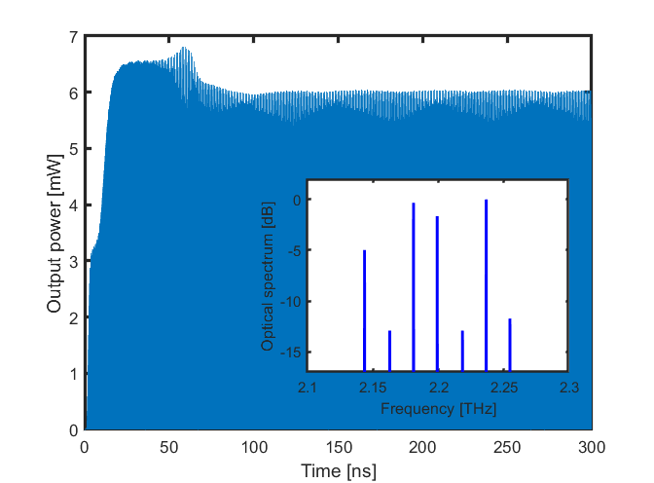
Figure 1. Output power waveform at threshold current for a QCL with external feedback. The inset shows the optical spectrum of the emitted light where the QCL is emitting in a multimode regime.
Acknowledgment: This work was financially supported by the Vlatacom Institute of High Technologies under project 178, the Ministry of Science, Technological Development and Innovation of the Republic of Serbia under contract number: 451-03-65/2024-03/200103, Science Fund of the Republic of Serbia, Grant No. 10504, ''Ultra-short pulsations from TERAhertz quantum cascade laser using passive mode-LOCKing with graphene saturable absorber''-TERALOCK, European Cooperation in Science and Technology (COST) Action CA21159 PhoBioS.

REFERENCES
[1] J. Faist, et al., Science 264, 553-556 (1994).
[2] R. Köhler, et al., Nature, 417(6885), 156-159, (2002).
[3] C. Silvestri, L. L. Columbo, M. Brambilla, and M. Gioannini, Opt. Express 28(16), 23846–23861, (2020).
[4] C. Z. Ning, R . A. Indik, and J. V. Moloney, IEEE J. Quantum Electron. 33(9), 1543–1550, (1997).
[5] A. Demić, et al. IEEE Transactions on Terahertz Science and Technology 7, 368–377, (2017).

