**Wood Phantoms as Reference Material for Machine Learning Optical Spectroscopy of Construction Wood**

K. Słowiński1, J. Nyga1, M. Szczerska1, M. Babińska1, J. Bąbińska2, A. Dąbrowska2,   
and A. Władziński1

1*Department of Metrology and Optoelectronics, Faculty of Electronics, Telecommunications and Informatics, Gdańsk University of Technology, Gdańsk, Poland*

2*Department of Building Engineering, Faculty of Civil and Environmental Engineering,   
Gdańsk University of Technology, Gdańsk, Poland*

e-mail: [s188973@student.pg.edu.pl](mailto:s188973@student.pg.edu.pl)

Construction wood is one of the most common materials used in construction [1, 2], so it's important to make sure that the natural wood used is of high quality. Traditional methods for checking wood quality often depend on human judgment, which can be inconsistent [2]. Optical techniques offer a more accurate and repeatable way to analyze wood that can determine its content [3, 4]. This study looks at using wood phantoms – artificial samples made from cellulose and resin – as reference materials in optical spectroscopy. The end goal is to develop a reliable method for identifying and classifying construction wood based on how it interacts with light.

This research focuses on Raman spectroscopy as the main technique to study the wood samples. It compares different phantom samples with varying amounts of cellulose to see how the mixture affects the results. Wood phantoms are useful because their ingredient – cellulose and resin – can be carefully measured and mixed, allowing for consistent and repeatable samples, unlike natural wood where each sample is different.

In this study, data were collected using an 830 nm laser (in the near-infrared range) to minimize fluorescence background [5]. Next, the data were preprocessed using simple baseline correction before being input for machine learning models, that will be used for classification of wood and phantoms (Figure 1). Initial results have shown that Raman spectroscopy not only makes it possible to detect the presence of lignin and cellulose but also allows for the determination of their relative concentrations across samples. This capability makes it possible to distinguish between samples based on variations in cellulose content.

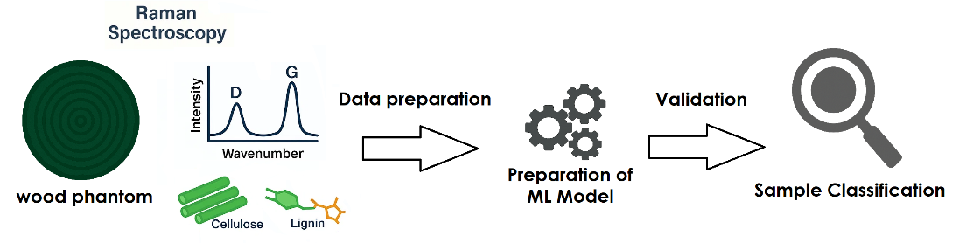

Figure 1. - Proposed workflow.

REFERENCES

[1] M. H. Ramage et al., “The wood from the trees: The use of timber in construction,” Renewable and Sustainable Energy Reviews, doi: 10.1016/j.rser.2016.09.107.

[2] R. Ross, Wood handbook: Wood as an engineering material Wood handbook: Wood as an engineering material,<https://research.fs.usda.gov/treesearch/62200>

[3] V. Ondrejka, et al., “Innovative methods of non-destructive evaluation of log quality,” Central European Forestry Journal, vol, doi: 10.2478/forj-2020-0021.

[4] X. Wang, R. J. Ross, In-Forest Wood Quality Assessments—Where Are We with NDT Technologies?, <https://www.fpl.fs.usda.gov/documnts/pdf2022/fpl_2022_wang005.pdf>

[5] A. Władziński, et al., “Biomarker Detection in the Wastewater Phantom,” Journal of Biophotonics, doi: 10.1002/jbio.202500003.