**Temperature tunable biopolymer photonic structure**

S. Savic-Sevic1, B. Muric1 and J. Potocnik2

1*Institute of Physics, Belgrade, Serbia*

2*Vinca Institute of Nuclear Sciences, Belgrade, Serbia*

e-mail: savic@ipb.ac.rs

Tunable biopolymer photonic structures responsive to temperature changes are investigated. Two types of biopolymers are employed: pullulan, characterized by a linear polysaccharide structure, and dextran, which has a branched configuration. The photonic structures are fabricated by holographic recording in dichromate-doped pullulan and dextran. Properties of pululan [1,2] and dextran [3] films as holographic material - surface gratings, its diffraction efficiency, copying and environmental stability, were previously investigated.

Photonic structures, fabricated using a simple counter-propagating beam holographic setup, consist of multilayered biopolymer configurations, separated and supported by nanopillars. This complex morphology is formed through the combined action of holographic recording and nonsolvent-induced phase separation.

The optical properties of the resulting biopolymer photonic structures were analyzed during heating and cooling cycles. A Peltier element was used to control the sample temperature, while reflection spectra from white halogen light were recorded using a fiber-optic spectrometer. During heating, the reflectance peaks shifted toward shorter wavelengths (blue-shifted), showing a negative spectral shift of 60 nm for pullulan and 27 nm for dextran with a temperature increase of +50 K. Upon cooling, the spectral peaks nearly returned to its original position.

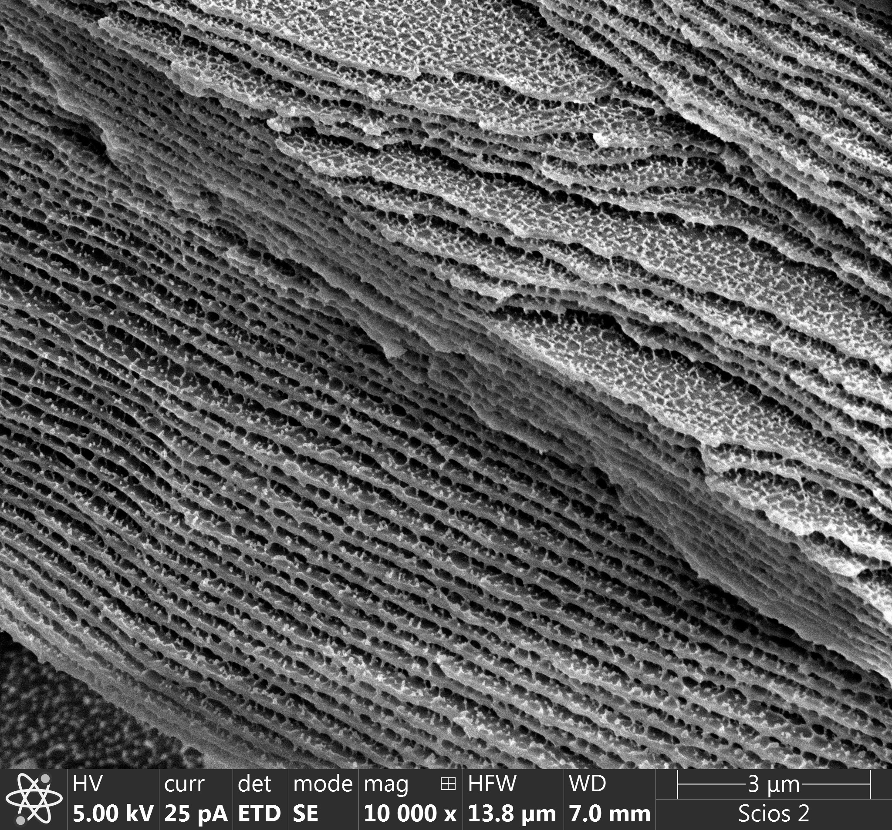 C:\Users\svetlana\Desktop\sss021dex\pl4_7_07_021\1\grejanje_522-485nm.tif

Figure 1. A cross-section of dextran structure. Figure 2. Reflectance spectra of dichromate-sensitized

dextran photonic structure as a function of temperature

REFERENCES

[1] S. Savic-Sevic, D. Pantelic, Appl. Opt. 46, 287 (2007).

[2] S. Savic-Sevic, D. Pantelic, Optics Exp. 13, 2747 (2005).

[3] S. Savic-Sevic, D. Pantelic, Optical Mater. 30, 1205 (2008).