**Fiber optic interferometer sensor for condition surfaces monitoring**

K. Rychert1, M. Szczerska2, K. Cierpiak1, and M. Szczerska1

1*Department of Metrology and Optoelectronics, Faculty of Electronics, Telecommunications and Informatics,*

*Gdańsk University of Technology, Poland*

2*GUT Optica Student Chapter, Gdańsk University of Technology, Poland*

e-mail: s190601@student.pg.edu.pl

The increasing dependence on real-time data acquisition and analysis in industrial processes, electronic communications, and manufacturing requires precise and scalable monitoring methods. This research explores the potential of a fiber optic interferometry based system for metal surface condition monitoring, addressing challenges in predictive maintenance and process optimization [1, 2]. Through integration of optical sensing with large-scale data processing, the system enables high-precision diagnostics of surface degradation and monitors key parameters like distance and clearance to maintain geometry and machine performance under continuous motion [3]. Measurements on various materials ranged from 10 to 500 µm in 5 µm increments. Signal changes from the interferometer allowed abrasion levels to be determined. The collected data is processed using machine learning algorithms to improve accuracy and support real-time diagnostics, machine learning algorithms were employed for classification of material wear based on spectral data collected from the fiber-optic interferometer. A set of 52 features was extracted from each spectrum, including peak morphology, intensity distribution, and spectral entropy. Using feature selection and ensemble classifiers such as Random Forest and Extra Trees, the models achieved up to 83% accuracy in distinguishing four wear levels with micrometer precision [4]. These models effectively captured non-linear relationships between optical features and degradation patterns, demonstrating the potential of data-driven approaches in predictive maintenance applications.

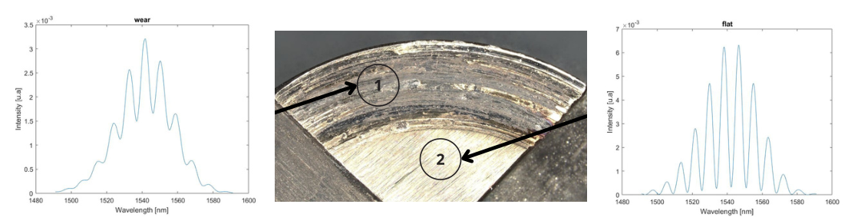

Figure 1. Obtained signal of flat and wear surfaces of measured stainless steel sample.

*Acknowledgment: The project is co-financed by DS programs of Faculty of Electronics, Telecommunications and Informatics of Gdańsk Tech, and by the 7/1/2024/IDUB/III.4c/Tc grant under the TECHNETIUM Talent Management Grants program and by 6/1/2025/IDUB/III.4a/Pu grant under the Plutonium Supporting Student Research Teams, which is herein gratefully acknowledged.*

REFERENCES

[1] M Jedrzejewska-Szczerska, *at all* Low-coherence fiber-optic interferometric sensors, (2011), Acta Physica Polonica A 120 (4), 621-624

[2] D. Milewska, *at all*, Application of thin diamond films in

low-coherence fiber-optic Fabry Pérot displacement sensor, Diamond and Related Materials, Volume 64, 2016, https://doi.org/10.1016/j.diamond.2016.02.015.

[3] P. Sokołowski, *at all* "Fiber optic interferometer as a sensor for surface conditions measurement",(2024), Proc. SPIE 13187, Advances in 3OM: Opto-Mechatronics, Opto-Mechanics, and Optical Metrology 3OM 2023, 1318707; <https://doi.org/10.1117/12.3021424>

[4] Cierpiak, K., *at all* (2023). Application of fiber optic sensors using Machine Learning algorithms for temperature measurement of lithium-ion batteries. Photonics Letters of Poland, 15(3), 36–38. <https://doi.org/10.4302/plp.v15i3.1207>