In search of robust polaritonic platforms: strong light-matter interaction in spherical dielectric voids and universal coupling limits in plasmonic meta-atom ensembles

E. Ryabkov¹, D. G. Baranov¹
¹Center for Photonics and 2D Materials, Moscow Institute of Physics and Technology, Dolgoprudny, Russia
e-mail: ryabkov.research@gmail.com

Optical and material excitations in the strong coupling regime — a distinct regime of electromagnetic interaction — host stationary hybridized states known as polaritons [1]. Realizing light-matter coupling and boosting its strength relies on various cavities to confine electromagnetic radiation. In this context, the systems with better fabrication robustness and less demanding fabrication process are of considerable interest [2]. We theoretically investigate the strong coupling and polaritonic spectra in spherical voids embedded in generic resonant dielectrics, Fig. 1(a). We find the parameter range leading to the regimes of weak and strong interaction and explain the effect of quality factor boost in the region of resonance with the surrounding media.

Reaching higher degrees of coupling (ultrastrong or deep strong coupling) generally requires special conditions, such as low temperatures, high vacuum or strong magnetic fields. However, recent studies have shown that so-called meta-atoms can serve as platforms for reaching the ultrastrong coupling regime at ambient conditions [3]. Determining the limits of the coupling constant in such systems and analyzing their dependence on material parameters remains a pressing problem. In extension of the present work, we examine the strong coupling between arrays of spherical plasmonic meta-atoms and an optical field, Fig. 1(b). Owing to the harmonic energy ladder inherent to this nanostructure, we calculate the transition dipole moment for meta-atoms of various radii and material properties. This enables us to quantify the collective coupling constant and to identify its universal bounds for the ensembles of plasmonic meta-atoms and free-space photons.
The obtained results will strongly contribute to the field of polaritonic studies, and will be valuable for quantum technology and material design.

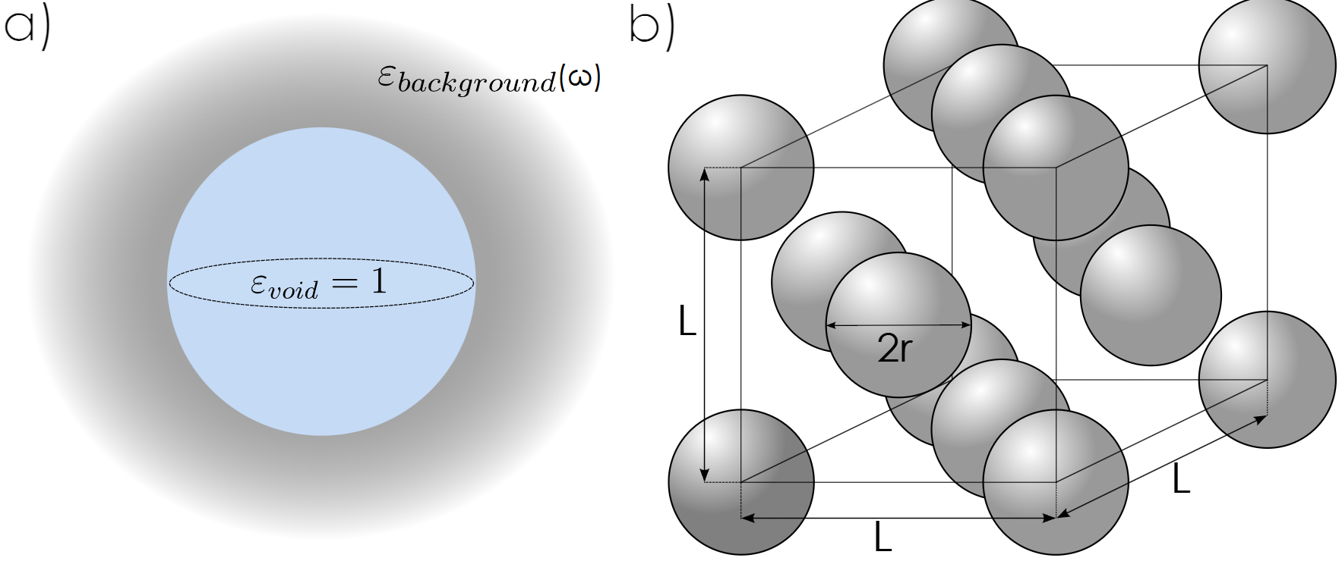

Figure 1. Schematics of the systems under study. a) Spherical voids in generic resonant medium; b) an array of densely packed spherical plasmonic meta-atoms.
REFERENCES
[1] D. L. Mills and E. Burstein, Polaritons: The electromagnetic modes of media, Rep. Prog. Phys 37, 817 (1974).
[2] D. G. Baranov, M. Wers¨all, J. Cuadra, T. J. Antosiewicz, and T. Shegai, Novel Nanostructures
and Materials for Strong Light-Matter Interactions, ACS Photonics 5, 24 (2018).
[3] N. S. Mueller, Y. Okamura, B. G. Vieira, S. Juergensen, H. Lange, E. B. Barros, F. Schulz, and S. Reich, Deep strong light–matter coupling in plasmonic nanoparticle crystals, Nature 583, 780 (2020).

