**Effect of pulse energy on the formation of Laser-Induced Periodic Surface Structure on Nb/Ti multilayer thin films**

S. Petrović1, N. Božinović1, V. Rajić1, D. Canteli2, C. Munoz Garcia2, C. Molpecres2

1*Vinča Institute of Nuclear Sciences, University of Belgrade, P.O.Box 522, 11001 Belgrade, Serbia*

2*Centro Laser, Universidad Politecnica de Madrid, Alan Turing 1, 28038 Madrid, Spain*

e-mail: [spetro@vin.bg.ac.rs](mailto:spetro@vin.bg.ac.rs)

The possibilities of creating Laser-Induced Periodic Surface Structure (LIPSS) on Nb/Ti multilayer structures were investigated through surface modification with picosecond laser radiation. Using DC ion sputtering, fifteen (Nb/Ti) bilayers were deposited to create multilayer thin films with a total thickness of 440 nm on (100) Si wafers. Dynamic laser modifications, such as laser-etched lines, were performed using picosecond (15 ps) laser pulses of a Nd: YVO4 laser operating at 532 nm, with pulse energies ranging from 1.5 to 2.8 µJ. The development of LIPSS was accompanied by different morphological features depending on the applied pulse energy; the different absorbed energy stimulated diverse processes in a multilayer 15x(Nb/Ti)/Si system. By gradually increasing the pulse energy at a constant scanning speed (5 mm s -1 and 1 mm s-1), the development of LIPSS included the following morphological changes: (i) initial surface melting with the formation of clusters, (ii) elongation of melted regions and formation of HSFL (high spatial frequency LIPSS); (iii) separation of droplets and their arrangement in LSFL (low spatial frequency LIPSS); (iv) cracks appearance corresponding to positions of LSFL; (v) material recrystallization; and (vi) material ablation at the highest pulse energies. The analysis of changes in composition after laser modification revealed the presence of oxygen in a higher concentration than in the untreated area, realizing the possibility of forming an ultra-thin oxide layer composed of Nb- and Ti-oxides. The obtained results for the development of periodic structures in the form of LIPSS, depending on the pulse energy (fluence) at the selected scan speeds, provide a relatively satisfactory prediction of the LIPSS formation with the desired morphological characteristics.

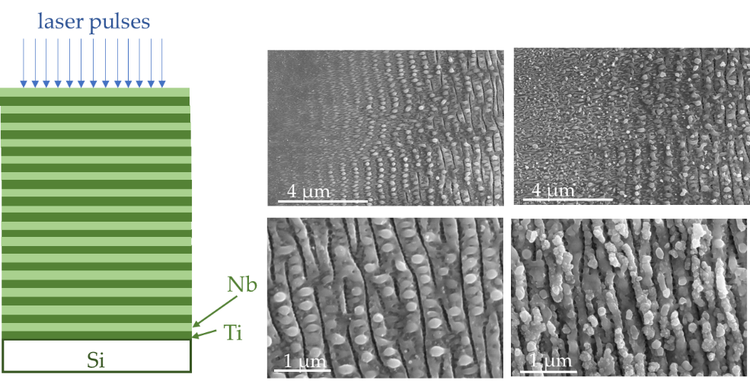

Figure 1. Schematic view of the multilayer 15x(Nb/Ti)/Si system with SEM images of the centre of the laser-inscribed lines on the surface of the 15x(Nb/Ti)/Si multilayer system at a constant scanning speed of 5 mm s-1 for: 1.5 µJ, 1.8 µJ, 2.0 µJ, and 2.4 µJ.

REFERENCES

[1] S. Petrovic, et al. J. Appl. Phys. 122, 115302 (2017)

[2] S. Petrovic, et al. Materials Chemistry and Physics 143, 530-535 (2014)