Effect of dielectric environment on electronic and optical properties of spherical core/shell quantum dot: comparison of two models

Lj. Stevanović, V. Pavlović, M. Miladinović, M. Živković, S. Milenović, O. Stefanović and M. Perić
Department of Physics, Faculty of Sciences and Mathematics, University of Niš, Serbia
e-mail: vladan.pavlovic@pmf.edu.rs

Core/shell quantum dot (CSQD) is a quantum dot consisting of a core and a shell made of different semiconductor materials. The reason for studying CSQDs is their application in optoelectronics, bioimaging, quantum computing [1].

The subject of this study is the influence of dielectric environment on the energies and wave functions of electron in conduction band of CdSe/ZnS spherical CSQD and oscillator strength of 1s→1p intraband transition. We use two common approaches to take into account the effect of dielectric matrix, which consist in adding term Σ [2] or W [3] to the electron Hamiltonian. We perform calculations using effective mass approximation by imposing the corresponding boundary conditions on the values of wave function and its first derivative for the cases when CSQD is embedded in SiO₂ and HfO₂ dielectric matrix. The effect of CdSe/ZnS spherical CSQD radius on results is discussed.

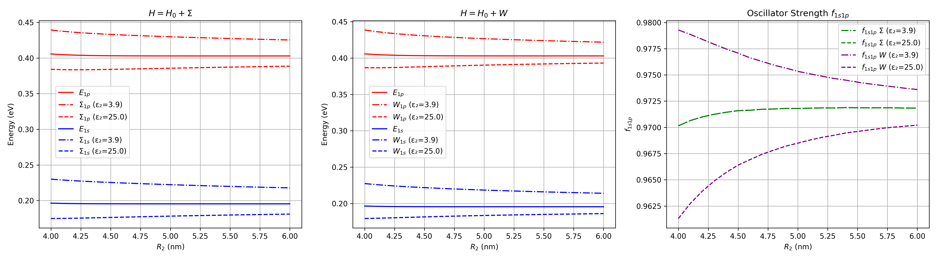

Figure. Energies of 1s and 1p states and oscillator strength of 1s→1p intraband transition in CdSe/ZnS spherical CSQD as functions of quantum dot radius.
We found that wave functions are the same in both models as for the plane CdSe/ZnS spherical CSQD. The model with term Σ in the Hamiltonian gives energy levels that are shifted up or down depending on dielectric constant of dielectric matrix and predicts the same value for the oscillator strength as for the plane quantum dot. On the other hand, inclusion of term W into Hamiltonian gives different energies and oscillator strength in comparison with the plane CdSe/ZnS spherical CSQD. Moreover, both models give very similar energy values.

REFERENCES
[1] A. Sahu, D. Kumar, J. Alloys Compd. 924, 166508 (2022).
[2] K. Hasanirokh, A. Naifar, Plasmonics 19, 2317 (2023).
[3] N. Yahayaoui, N. Zeiri, P. Baser, M. Said, S. Saadaoui, Plasmonics 18, 1489 (2023).

