**Raman spectroscopy as a predictive tool for Laser-Induced Graphene from wooden biomass**

J. Nyga1, K. Słowiński1, A. Władziński 1, M. Szczerska 1, J. Bąbińska2, A. Dąbrowska2, M. Babińska 1

1*Department of Metrology and Optoelectronics, Faculty of Electronics, Telecommunications and Informatics, Gdańsk University of Technology, Gdańsk, Poland*

2*Department of Building Engineering, Faculty of Civil and Environmental Engineering, Gdańsk University of Technology, Gdańsk, Poland*

e-mail: s188631@student.pg.edu.pl

The synthesis of laser-induced graphene (LIG) is a relatively new and rapidly developing field of materials engineering, offering new opportunities for fabricating functional carbon structures for optoelectronic and sensing applications [1, 2]. However, the wooden materials, despite their promising properties, remain poorly understood in the context of LIG formation [3].

In this work, the use of Raman spectroscopy as a predictive, pre-LIG diagnostic tool to assess wood as a precursor. Presented data obtained from wood samples - spruce, in raw form as offcuts. Raman spectra were collected using an 830 nm laser (near infrared - to reduce background fluorescence) [4], revealing key fingerprints related to cellulose/lignin ratio and sample unity. These factors appear to influence the result of LIG structure - morphological uniformity, low defect density, and potential electronic conductivity relevant for sensing applications.

Preliminary results of spectroscopy show high potential of material carbonization [3]. A relatively simple workflow is proposed, using baseline correction, and highlight peaks, to pre-select wood and extract well-structured graphene-like carbon parts, as illustrated in Figure 1. Raman spectroscopy appears to be a promising predictive tool to suggest which wooden materials can form into effective bio-microelectrodes with potential utility in optical and electrochemical sensing fields.

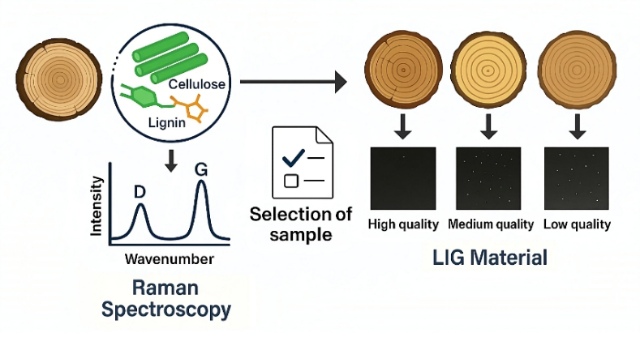

Figure 1. Raman spectroscopy for wooden material classification.

*This research was supported by the "Excellence Initiative – Research University" (IDUB) program: Technetium Talent Management Grants (7/1/2024/IDUB/III.4c/Tc), by the “European Cooperation in Science and Technology” (COST Action CA21159), and by the Gdańsk University of Technology, Faculty of Civil and Environmental Engineering Project Fund (NR038216).*

REFERENCES  
[1] S. K. Lengger *et al.*, “Laser-induced graphene formation on different wood species: Dependence of electronic performance on intrinsic features of certain types of wood”,   
doi: 10.1016/j.susmat.2024.e00936.  
[2] K. Avinash and F. Patolsky, “Laser‑induced graphene structures: From synthesis and applications to future prospects”*,* doi: 10.1016/j.mattod.2023.10.009.  
[3] R. Ye *et al.*, “Laser‑induced graphene formation on wood”, doi: 10.1002/adma.201702211.  
[4] A. Władziński *et al.*, “Biomarker detection in the wastewater phantom”, doi: 10.1002/jbio.202500003.