Rapid vs. Conventional Annealing: Impact on Optical Losses in TiN Thin Films

M. Novakovic¹, D. Jugovic², D. Tosic¹ and M. Popovic¹
¹Vinca Institute of Nuclear Sciences - National Institute of thе Republic of Serbia, University of Belgrade, Belgrade, Serbia
²Institute of Technical Sciences of SASA, Belgrade, Serbia
e-mail: mnovakov@vinca.rs

Titanium nitride (TiN) is emerging as a promising alternative to noble metals for plasmonic and photonic applications, offering stability and CMOS compatibility [1,2]. This study investigates the effects of 150 keV Au ion implantation followed by rapid thermal annealing (RTA) and conventional annealing on the optical and metallic properties of sputtered TiN thin films. Ion implantation modifies the dielectric function by introducing damage and smaller crystallites, which reduces the metallic character and optical losses (Figure 1). Post-implantation RTA significantly enhances the metallic response, decreasing plasma frequency and Drude broadening, thus minimizing optical losses. Comparable results are achieved by conventional annealing; however, it requires longer processing time. At 500 °C, conventional annealing leads to the formation of Au nanoparticles, introducing additional absorption due to scattering. Overall, RTA proves to be a more efficient route for tuning the plasmonic performance of TiN films, making it highly suitable for applications in the visible–NIR range where low optical losses and defined metallic behavior are essential.

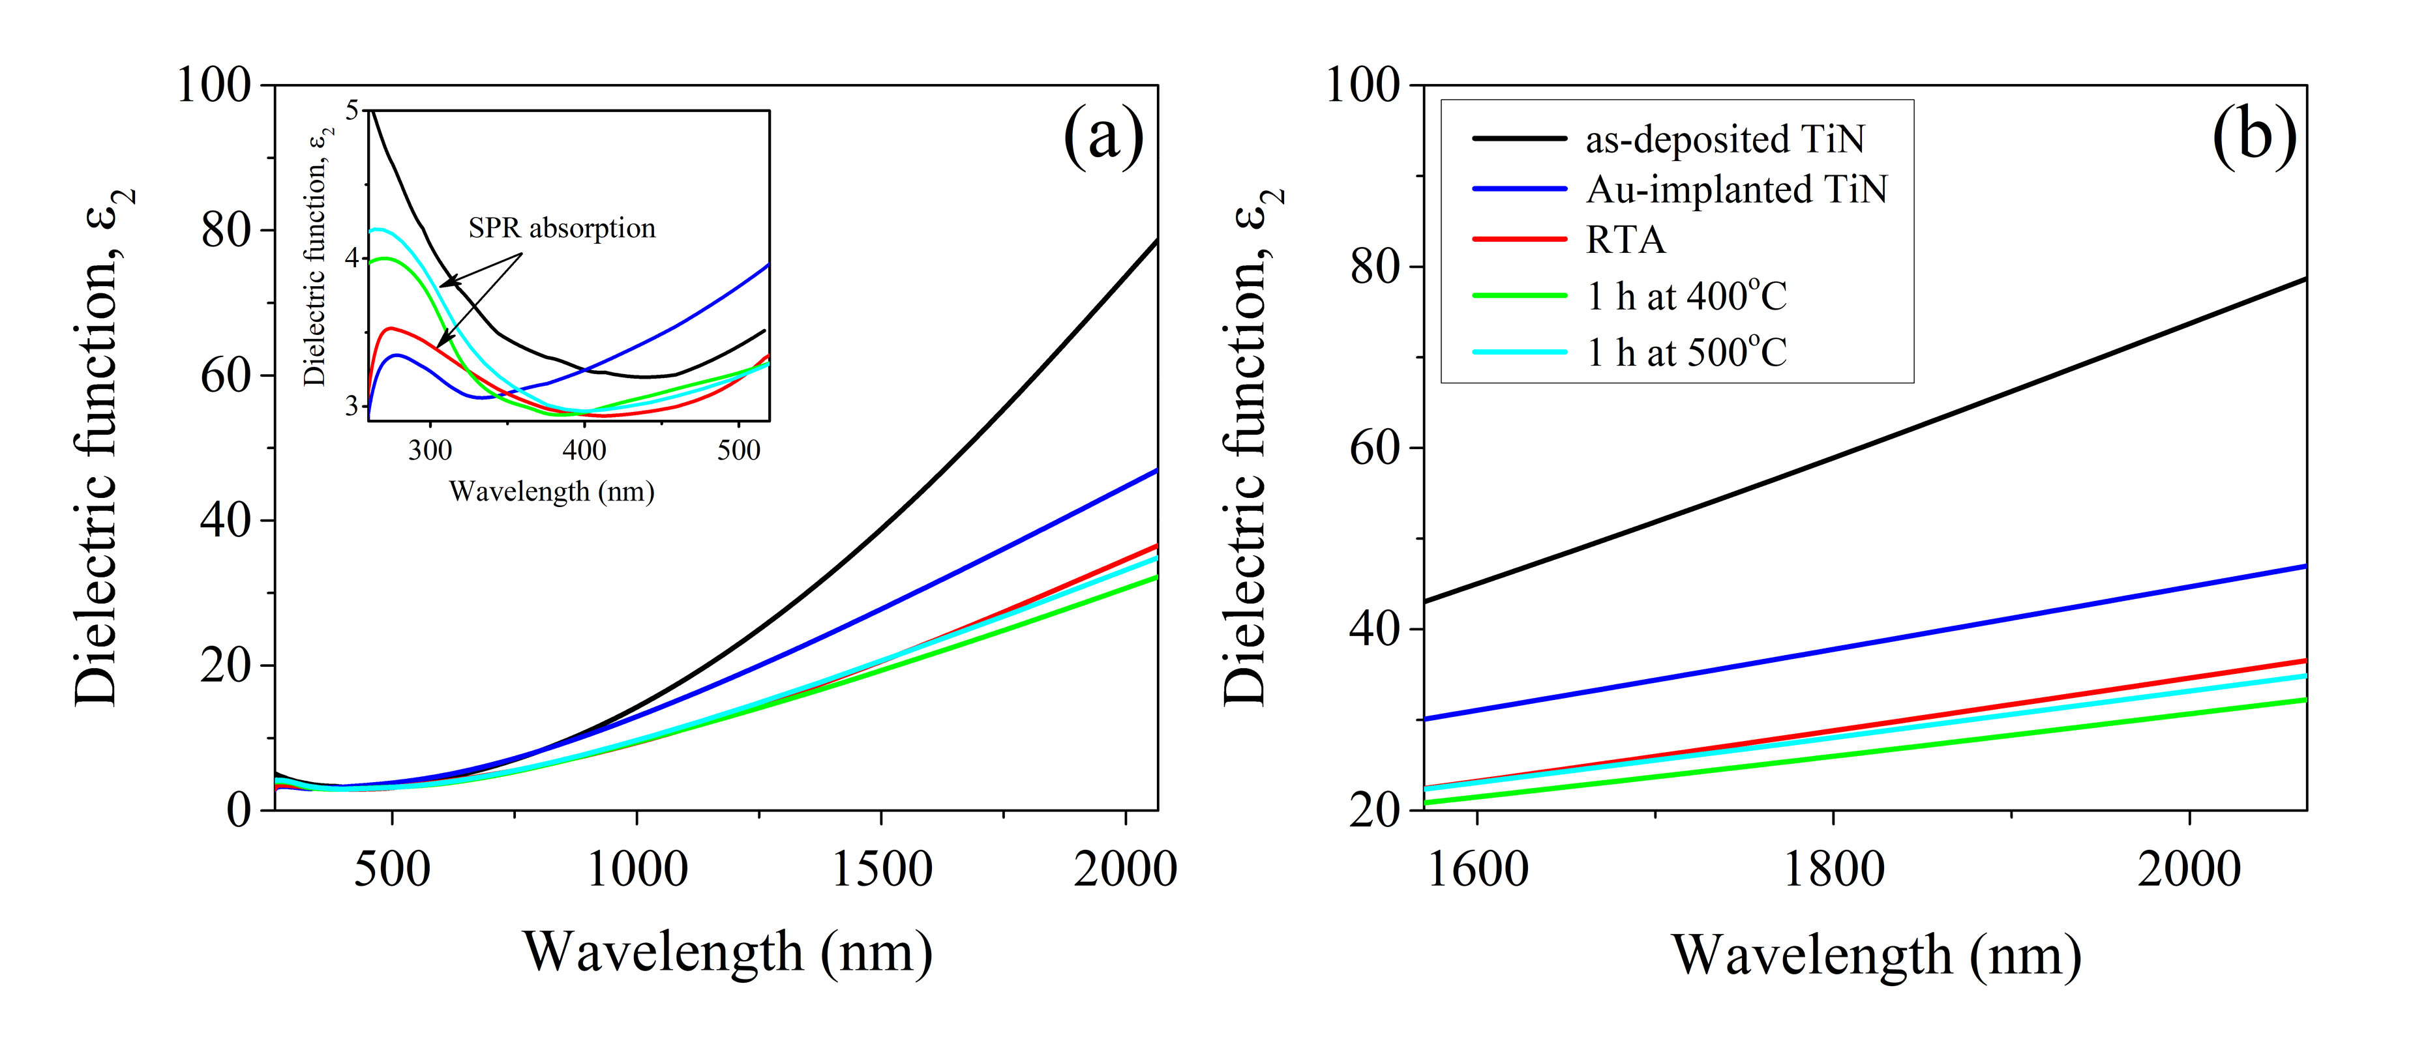
Figure 1. Imaginary part of the dielectric function for TiN films: as-deposited, Au-implanted (150 keV, 5×10¹⁶ ions/cm²), and post-annealed (RTA/conventional, 400–500 °C, 1 h); (a) 260–2066 nm with SPR peaks (inset); (b) high-wavelength region detail.

REFERENCES
[1] M. Dasog, Chem. Mater. 34, 4249 (2022).
[2] U. Mahajan, M. Dhonde, K. Sahu, P. Ghosh, P.M. Shirage, Mater. Adv. 5, 846 (2024).

