An exploration of the electromagnetic boundary conditions for two-dimensional materials with out-of-plane polarization

A. Hansen and Z. Mišković
Department of Applied Mathematics, University of Waterloo, Waterloo, Ontario, Canada
e-mail: zmiskovic@uwaterloo.ca

We have re-derived the set of electromagnetic boundary conditions applicable to the macroscopic Maxwell's equations in the presence of a conductive 2D material, modelled as an infinitesimal sheet, placed in an interface between two distinct isotropic, lossless, dielectric media, where both the in-plane conductivity and the out-of-plane polarizability of that material are included [1,2]. Two important issues were addressed: identifying the effective electric fields that drive the response of the 2D material and exploring the possible screening effects of the out-of-plane response by the nearby dielectrics. This is done by first placing the 2D material inside a finite vacuum gap between the dielectrics and solving the Fresnel's problem, followed by "closing" the gap. The resulting theoretical model was tested against ellipsometric measurements and revealed significant influence from the out-of-plane response even at optical frequencies and in a graphene on substrate configuration, as shown in Figure 1. The comparison data included fixed frequency (ℏω=1.95 eV) angular sweeps across the pseudo-Brewster angle [3], and fixed angle frequency sweeps across the range 1 eV < ℏω < 5 eV [4]. Ab initio computed in-plane and out-of-plane sheet conductivities were used to model the undoped graphene [5]. Finally, we tested the model for doped graphene at the THz to the midinfrared frequencies and observed significant alteration to the in-plane plasmon mode as a result of interaction with the out-of-plane polarizability when the nearby media have different permittivities [6].

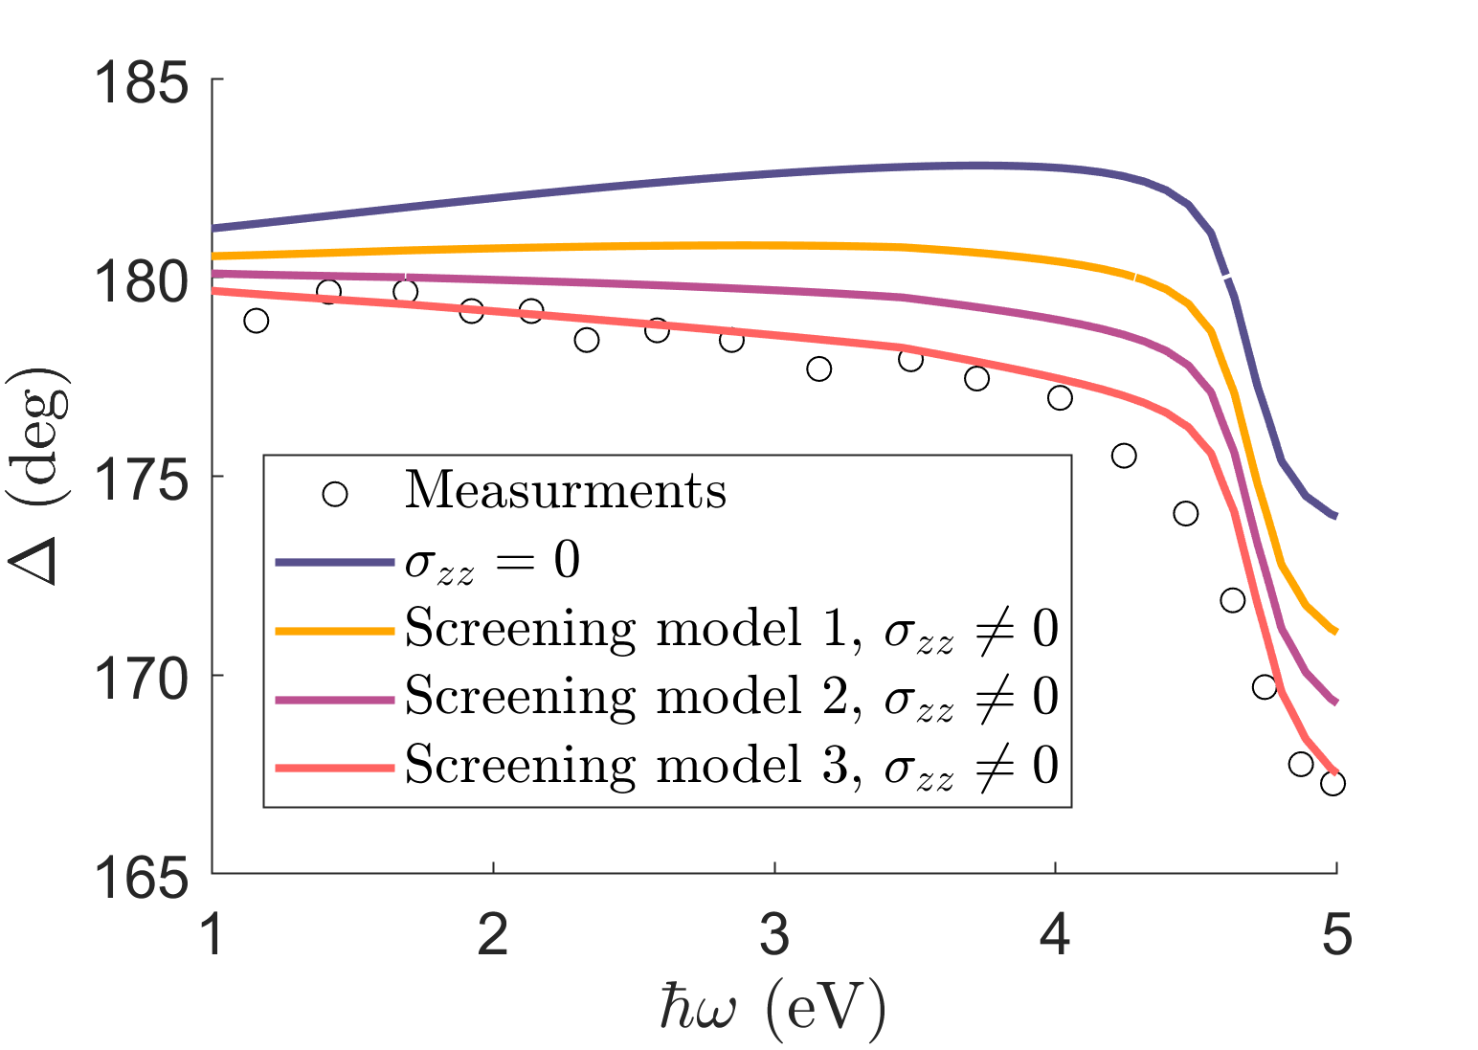
Figure 1. Comparison between three model predictions based on ab initio conductivity data for graphene and ellipsometric phase measurements [4] at a fixed incident angle of θ_{i} = 50°.
REFERENCES
[1] M Idemen, et al. Boundary conditions of the electromagnetic field. Electronics Letters, 13(23):704–705, 1987.
[2] T Senior, et al. Sheet simulation of a thin dielectric layer. Radio Science, 22(07):1261–1272, 1987.
[3] Z Xu, M Merano, et al. Optical detection of the susceptibility tensor in two-dimensional crystals. Communications Physics, 4(1):215, 2021.
[4] F Nelson. Study of the Dielectric Function of Graphene from Spectroscopic Ellipsometry and Electron Energy Loss Spectroscopy. [PhD thesis, College of Nanoscale Science and Engineering], State University of New York at Albany, 2012.
[5] L Matthes, et al. Influence of out-of-plane response on optical properties of two-dimensional materials: First principles approach. Physical Review B, 94(20):205408, 2016.
[6] Y Bludov, et al. A primer on surface plasmon-polaritons in graphene. International Journal of Modern Physics B, 27(10):1341001, 2013.

