Studying electronic properties and plasmonic reactivity of (functionalized) nanoparticles by x-ray aerosol photoelectron spectroscopy (XAPS)

A. R. Milosavljević¹, D. Danilović², R. Schürmann³, R. Dojčilović², D. Božanić² and I. Bald⁴
¹Synchrotron SOLEIL, L'Orme des Merisiers, 91190 Saint-Aubin, France
²Vinca Institute of Nuclear Sciences, Belgrade, Serbia
³Physikalisch-Technische Bundesanstalt (PTB), Abbestr. 2-12, 10587 Berlin, Germany
⁴Institute of Chemistry – Hybrid Nanostructures, University of Potsdam, Karl-Liebknecht-Straße 24-25, 14476 Potsdam, Germany
e-mail: aleksandar.milosavljevic@synchrotron-soleil.fr

We present the experimental technique for x-ray aerosol photoelectron spectroscopy (XAPS) at the PLEIADES beamline of the SOLEIL synchrotron (France) [1,2]. It allows us to measure the electronic properties of (functionalized) nanoparticles (NPs) isolated in the gas-phase, free of any solvent or substrate, therefore, to study the intrinsic physicochemical properties of such complex targets. This could help to develop new materials and improve our understanding of the light interaction with such materials. Furthermore, the corresponding theoretical results could be compared to the experiment, therefore further improving our understanding of newly developed materials.

In the present contribution, we will show results for two types of NPs. The first class corresponds to the lead halide perovskite nanocrystals [3], as well as silver-bismuth iodide nanoplatelets [2,4]. The former NPs belong to the hybrid perovskite materials that have attracted extensive research interest in recent years as they exhibit optical and semiconducting properties favorable for the fabrication of optoelectronic devices such as solar cells, light-emitting diodes, and photodetectors. The later Ag-Bi-I NPs have been considered as a possible more stable and lead-free replacement for methylammonium lead halides. The second class of materials that we will present corresponds to the functionalized noble metal NPs. Such system can undergo localized surface plasmon resonances that can induce and drive reactions of adsorbed ligand molecules [5]. They have been intensively investigated in recent years as they provide opportunities in chemical synthesis, optoelectronics etc. (see [5] and references therein).
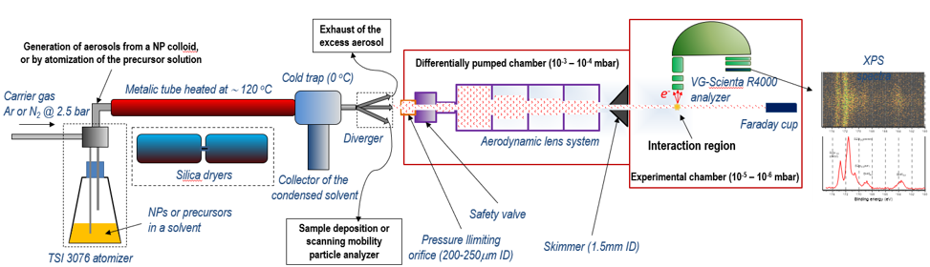

Figure 1. XAPS setup at PLEIADES, SOLEIL [2].

REFERENCES
[1] A. Lindblad et al., Rev. Sci. Instrum. 84, 113105 (2013)
[2] D. Danilović et al., J. Phys. Chem. C 124, 23930 (2021)
[3] A. Milosavljevic et al, J. Phys. Chem. Lett. 9, 3604 (2018)
[4] D. Danilović et al., J. Phys. Chem. C 1126, 13739 (2022)
[5] R. Schürmann et al., J. Chem. Phys. 157, 084708 (2022)

