Integrated Quantum Photonics:

***Physics, technology, applications***

E. Kapon

*Institute of Physics EPFL, Lausanne, Switzerland*

e-mail: [eli.kapon@epfl.ch](mailto:eli.kapon@epfl.ch)

One of the emerging platforms for quantum technologies, integrated quantum photonics combines quantum light emitters with sub-wavelength photonic confinement and guidance to create and manipulate quantum states of light *on-chip*. Applications include efficient sources of single photons for secure quantum communications. This tutorial will review the physics and technology behind these systems, organized in two parts.

The first part will introduce the concepts of quantum confinement leading to the realization of semiconductor quantum dots (QDs) as emitters of quantum light, and of photonic crystals (PhCs) that make possible photonic confinement and guidance at sub-wavelength dimensions. The particular technology of pyramidal QDs, with its essential feature of producing QDs with site-control at the ~10nm scale, will be presented. The design and fabrication of PhC cavities and waveguides made on the same semiconductor substrates as the pyramidal QDs will be reviewed. The optical properties of the resulting QDs and PhCs will be illustrated and interpreted [1].

The second part will describe the fabrication and properties of the integrated structures, consisting of site-controlled QDs properly positioned within PhC cavities and waveguides. New features of light-matter interaction brought about by the modification of the photonic environment introduced by the PhCs will be evidenced and explained [2]. Examples of integrated structures employed for enhancing single photon emission, for single photon multiplexing and for single photon routing will be discussed [3].

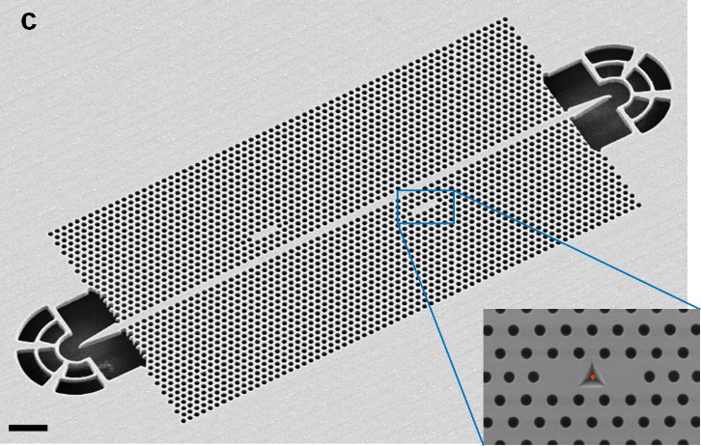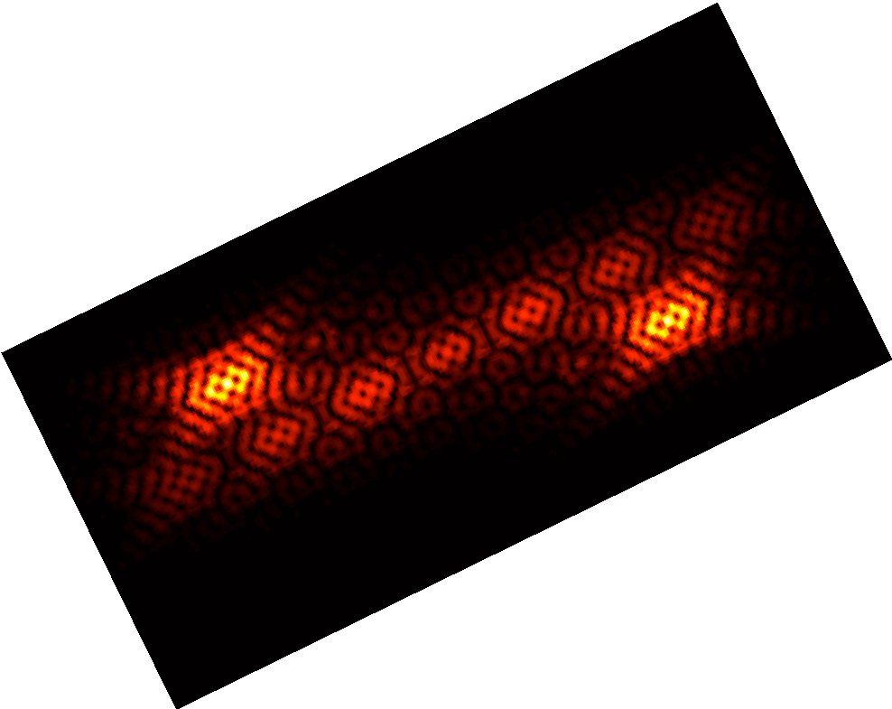

Figure 1. An example of an integrated quantum photonic structure.

REFERENCES

1. M. Calic, et al., *Scientific Reports* **7**, 4100 (2017).
2. A. Lyasota, et al., *Phys. Rev. X* **12**, 021042 (2022).
3. Y. Yu, et al., *Optica* **8**, 1605 (2021).