Data transmission rate estimates for OAM-carrying waves generated by various discrete EM radiating sources

A.Ž. Ilić¹, J.Z. Trajković^{1,2}, S.V. Savić³, and M.M. Ilić³
¹Institute of Physics Belgrade, University of Belgrade, Serbia
²Faculty of Physics, University of Belgrade, Serbia
³School of Electrical Engineering, University of Belgrade, Serbia
e-mail: andjelijailic@ieee.org

In progressing towards the ubiquitous connectivity of short-range beyond-5G and 6G systems, the millimeter-wave and optical waves carrying the orbital angular momentum (OAM) are expected to be amongst the key technological enablers [1], [2]. In the millimeter-wave wireless communication systems (WCS), the generation of OAM waves by the employment of electrically large antenna arrays has been proven as a cost-effective solution, also allowing relatively easy OAM mode reconfiguration and multiplexing of different OAM modes through a single aperture. The use of OAM modes generated by the discrete OAM EM wave source arrangements could also be of interest for other frequency ranges, e.g. free-space optical communications, as different parts of radiating metasurfaces or optical light modulators could be used to stream separate information channels. However, the source discretization affects generated OAM EM fields, producing unwanted sidelobes and radiation spikes in many directions, and also, reducing the OAM mode purity of the useful transmitted waves. Therefore, system optimization has to be carried out to adjust the power/phases of a limited number of discrete radiating sources for the best performance.

Data transmission rates in line-of-sight (LoS) scenarios can be estimated from the radiation characteristics of an antenna array [3]. Considering the unlicensed millimeter-wave frequency band around 60 GHz, and both the commonly used uniform circular antenna arrays (UCA) and sets of non-uniform linear or rectangular antenna arrays (LAA/RAA), we analyze the effects of source discretization on the EM field quality as well as the possibility to achieve the desired total data transmission rates by the use of multiple OAM modes simultaneously.
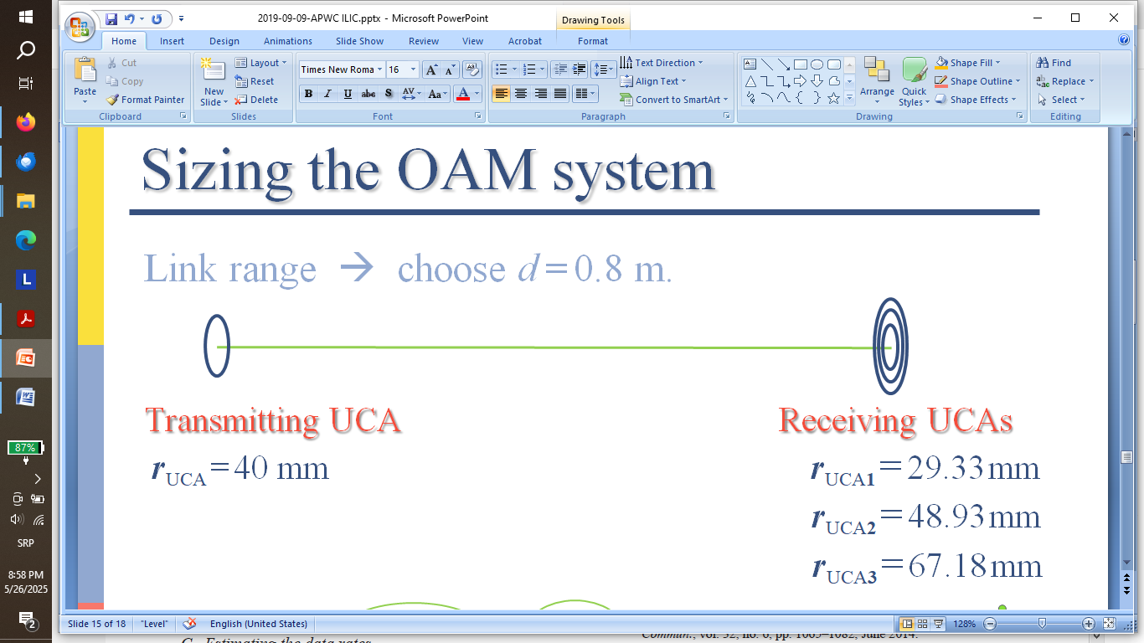
Figure 1. An example of the optimal sizing of the receiving UCAs for 60 GHz mm-wave transmission at the link range of 0.8 m. The OAM UCA source discretization, concerning the radial and azimuthal coordinates, affects the quality of an OAM wave representation. In the case of OAM waves produced by the sets of linear antenna arrays, additional effects due to the non-uniformity of spatial arrangements are observed.
Acknowledgments: The authors acknowledge funding provided by the Institute of Physics Belgrade and School of Electrical Engineering, University of Belgrade, through the grants by the Ministry of Science, Technological Development, and Innovations of the Republic of Serbia.

REFERENCES
[1] S. Chen, Y. Liang, S. Sun, S. Kang, W. Cheng, M. Peng, IEEE Wirel. Commun. 27, 218–228 (2020).
[2] P. Yang, Y. Xiao, M. Xiao, S. Li, IEEE Netw. 33, 70–75 (2019).
[3] A.Ž. Ilić, N.M. Vojnović, S.V. Savić, N. Maletić, E. Grass, M.M. Ilić, Performance assessment for OAM antenna arrays, 2019 IEEE-APS Topical Conf. Antennas and Propagation in Wireless Comm. (APWC), Granada, Spain, 171–173, (2019). https://doi.org/10.1109/APWC.2019.8870549

