Coupled phase-intensity bistability in Fabry-Pérot lasers under optical injection

P. Atanasijević, K. Jović, M. Banović, J. Crnjanski, M. Krstić and D. Gvozdić
University of Belgrade, School of Electrical Engineering, Serbia
e-mail: gvozdic@etf.bg.ac.rs

The concept of real-valued photonic neural networks has recently been extended to complex-valued and Kramers–Kronig neural networks, which process data using inputs, weights, and activation functions that account for both magnitude and phase [1,2]. In this work, we experimentally demonstrate that dispersive bistability in Fabry–Pérot laser diodes (FP-LDs) under optical injection can produce stationary optical phase hysteresis accompanied by optical intensity hysteresis, linked through the Kramers–Kronig relations.
To enable the coherent detection of the FP-LD's output, the experimental setup used in the investigation of quasi-static injection locking (IL) of FP-LDs [3] is complemented with an additional local oscillator (LO) branch and a balanced photodiode (BPD), creating an interferometer illustrated in Fig. 1(a). The master laser’s (ML) optical output with a wavelength λ_{m} is injected into the m = −3 side mode of the FP-LD, for several different values of frequency detuning ranging from −15 to −21 GHz (negative values corresponding to а red shift with respect to the central mode). The FP-LD’s output signal at λ_{m}t is spectrally selected using an optical bandpass filter (BPF) and interrogated using the interferometer. ML’s power is gradually varied, shifting the FP-LD between the IL and the free-running states, experimentally verifying the coupling between the intensity and phase hysteresis loops [4] shown in Figs. 1(b) and (c). The arrows highlight the different directionality of the coupled loops, leading to the conclusion that the transition to the IL state is accompanied by a rise in power and a decline in the phase difference between the ML and the FP-LD. Increasing the magnitude of the frequency detuning in the investigated range is shown to yield wider regions of the coupled intensity-phase bistabilities, achievable for higher input powers. Thus, the complex-valued response is shown to be reconfigurable, with experimentally demonstrated extinction ratios of up to ~8 dB and phase jumps of up to 0.9 rad.
These findings indicate that, in a dynamical regime under optical pulse injection, an FP-LD can serve as an activation unit, providing simultaneous nonlinear responses in both signal intensity and phase, demonstrating the existence of their Kramers–Kronig relation.
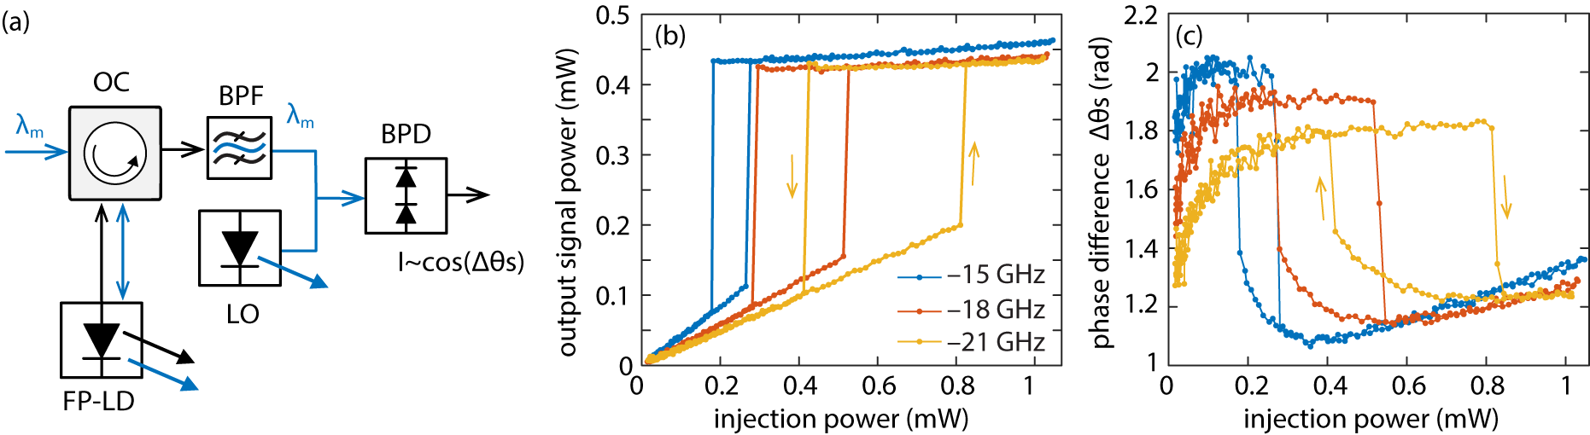
Figure 1. (a) The schematic of the experimental setup used for injection locking of the FP-LD and coherent detection. Static (b) intensity and (c) phase hysteresis loops for different frequency detunings.
Acknowledgment: The research was supported by Science Fund of the Republic of Serbia (#7750121, ORCA-LAB), and by Serbian Ministry of Science, Technology and Innovation (451-03-65/2024-03/200103). The research was partially conducted in the premises of the Palace of Science, Miodrag Kostić Endowment.
REFERENCES
[1] H. Zhang, et al., Nature Communications 12, 457 (2021).
[2] Ye Tian, et al., Advanced Photonics Research 4, 2300062 (2023).
[3] M. Banović, et al., Optics Letters 48, 4165 (2023).
[4] D. Gvozdić, M. Krstić, and J. Crnjanski, Optics Letters 36, 4200 (2011).

