Semiconductor-driven tunable nanostructured metamaterial with epsilon-near-zero transition layer

T. Gric¹, E. Rafailov²
¹Vinca Institute of Nuclear Sciences, (Times New Roman 10, Italic)
Belgrade, Serbia
²School of Electrical Engineering, University of Belgrade, Serbia
³Institute of Physics, Belgrade, Serbia
e-mail: tatjana.gric@vilniustech.lt

The metamaterials offer much-needed atypical material features to help with the subwavelength concentration of electromagnetic fields, which is the focus of nanophotonics research. By investigating propagation of surface plasmon polaritons (SPPs) at the boundary of semiconductor based nanostructured metamaterial with epsilon-near-zero transition layer, we demonstrate that the surface plasmon's dispersion along with the absorption is altered by a continuous dielectric function that is temperature dependent opening the wide avenues for sensing applications. A continuous function ε(z) of the normal to the interface coordinate z describes the properties of the nanostructured metamaterial structure due to the existence of the transition layer. It should be topologically equal to a kink, however the major results for the spectrum of SPP are not sensitive to the particular form of ε(z). Here, we'll look at a semiconductor-based metamaterial heterostructure made up of stacked anisotropic semiconductor sheets separated by dielectric layers, as schematically shown in Figure 1.

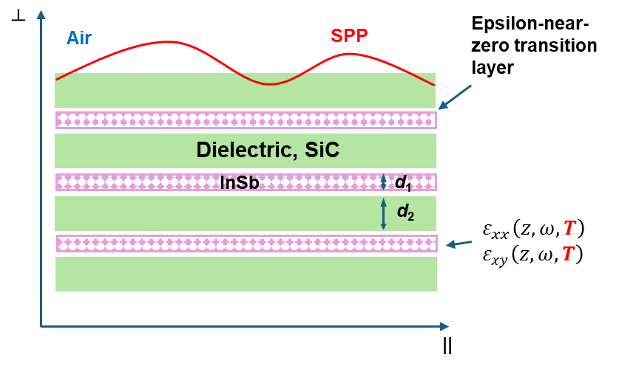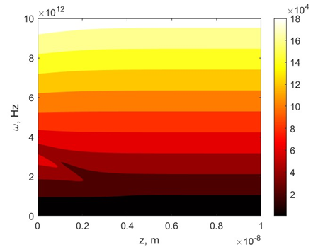
- (b)
Figure 1. Diagram showing the contact between air and an infinitely layered nanostructured metamaterial made of alternating dielectric and semiconductor layers (a). Real part of the propagation constant β (b). Herein, d₁=6 nm, d₂=10 nm, T=350K.
To describe the optical response of such a system, we employ the effective-medium technique, which is suitable when the wavelength of the light in question is substantially larger than the thickness of any layer. It should be mentioned that the frequency range of surface wave existence may be significantly controlled by adjusting the permittivities and thicknesses of the layers [1] utilized in the metamaterial. One must evaluate the tangential components of the electric and magnetic fields at the interface and generate a single surface mode with the propagation constant in order to determine the unique dispersion relation for the surface modes restricted at the interface between metamaterial and air.
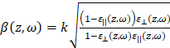, (1)
where k is the wavevector's absolute value in vacuum and β is the wavevector component parallel to the interface.

REFERENCES
[1] T. Gric, Prog. Electromagnetics Res. 46, 165–172 (2016).

