The comparative analysis of electromagnetic shielding efficiency of graphene oxide composites with different silver nanostructures

S. Dorontić¹, D. Kepić¹, M. Yasir², K. Haddadi³, B. Nardin⁴, S. Jovanović¹
¹Vinča Institute of Nuclear Sciences - National Institute of the Republic of Serbia, University of Belgrade, Mihajla Petrovića Alasa 12-14, 11351 Belgrade, Serbia
²Department of Computing Science, University of Oldenburg, D-26129 Oldenburg, Germany
³Univ. Lille, CNRS, Centrale Lille, Univ. Polytechnique Hauts-de-France, UMR 8520 - IEMN - Institut
d’Electronique de Microélectronique et de Nanotechnologie - Lille, 59650 Villeneuve-d’Ascq, France
⁴Faculty of Polymer Technology, Ozare 19, 2380 Slovenj Gradec, Slovenia
e-mail: sladjana.dorontic@vin.bg.ac.rs

The electronic devices and gadgets that emit electromagnetic waves are omnipresent in modern society. They are causing the saturation of the environment with electromagnetic waves that might jeopardize human health , emphasizing the need to seek effective electromagnetic shielding materials . This study provides a comparative analysis of the electromagnetic interference shielding effectiveness (EMI SE) of graphene oxide (GO) composites with two distinct silver nanostructures: AgNWs and AgNPs. AgNWs were synthesized using the "polyol" method and combined with GO, while AgNPs were directly formed on GO through low-dose gamma irradiation. By applying different microscopy and spectroscopy characterization techniques, the morphological and structural properties of the prepared composites were examined. The EMI SE measurement revealed a superior EMI SE of GO-AgNW composites compared to GO-AgNPs. Composites with higher concentrations of AgNWs exhibit increased total shielding effectiveness and reflective shielding effectiveness (SE_{T} values of 0.9, 1.4, and 4.0, and SE_{R} values of 0.4, 0.8, and 2 dB for GO-AgNWs 5:5, GO-AgNWs 3:7, and GO-AgNWs 1:9, respectively) (Figure 1.). As the amount of AgNWs in the composites increases, there is a slight rise in the measured SE_{A} values, which increase from 0.4 dB to 1.9 dB concerning the AgNWs content. This difference may be attributed to the structural differences between the Ag nanostructures.
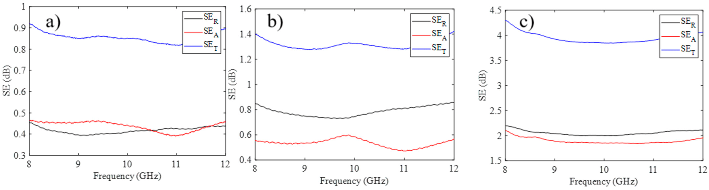
Figure 1. SE_{T}, SE_{A}, and SE_{R} values for GO-AgNWs 5:5 (a), GO-AgNWs 3:7 (b), and GO-AgNWs 1:9 (c), measured in the frequency range of 8-12 GHz. Reproduced with permission [4]. Copyright: Int. J. Mol. Sci. 2024.

Acknowledgments: This work was supported by the Horizon Europe program Coordination and Support Action, project ‘’Twinning for new graphene-based composites in electromagnetic interference shielding’’ - GrInShield [No. 101079151] and by the Ministry of Science, Technological Development and Innovation of the Republic of Serbia [grant number 451-03-136/2025-03/200017].

REFERENCES
[1] M. Bagheri Hosseinabadi, N. Khanjani, M. H. Ebrahimi, B. Haji and M. Abdolahfard, Electromagn Biol Med, 38, 96-101, (2019).
[2] Y.-J. Wan, P.-L. Zhu, S.-H. Yu, R. Sun, C.-P. Wong and W.-H. Liao, Carbon, 122, 74-81, (2017).
[3] F. M. Oliveira, J. Luxa, D. Bouša, Z. Sofer and R. Gusmão, ACS Appl. Nano Mater. 5 (5) 6792-6800, (2022).
[4] M. Milenković, W. Saeed, M. Yasir, D. Sredojević, M. Budimir, A. Stefanović, D. Bajuk-Bogdanović and S. Jovanović, Int. J. Mol. Sci. (25) 24, 13401, (2024).

