Sustainable Surface Engineering of Stainless Steel: Antimicrobial and Antiviral Functionalization via Femtosecond Laser Processing and Magnetron Deposition of Cu and Ag

A.Daskalova¹, L. Angelova¹, Angela Ivask², Harleen Kaur², Maja Sikiric³, Tihomir Car³, Abeer Shalaan ⁴, Lucy di Silvio⁴, Stuart Neil⁴, Zhenxue Zhang⁵, Artemis Stamboulis⁵
¹Institute of Electronics, Bulgarian Academy of Sciences, 72, Tzarigradsko Chaussee Blvd.1784 Sofia
²Institute of Molecular and Cell biology, U Tartu Riia 23-301, Tartu, Estonia
³Ruđer Bošković Institute, Bijenička c. 54, 10 000 Zagreb, Croatia
⁴Faculty of Dentistry, Guys Hospital SE1, 9RT London,UK
⁵School of Metallurgy and Materials, University of Birmingham, Edgbaston B15 2TT, UK
e-mail: albdaskalova@gmail.com

Stainless steel (SS) is the most widely used material in healthcare and public infrastructure. Known cleaning methods via diverse chemicals could not be very effective and long lasting, thus leading to non continuous protection against diverse pathogens. This research is directed towards avoidance of SS surface contamination, and reducing microbial and viral transmission in high contact zones. A hybrid surface modification by employing femtosecond laser processing and magnetron sputtering, leading to formation of laser induced periodic surface structures (LIPSS) on SS surface followed by deposition of silver (Ag) and copper (Cu) thin films is presented in this study.
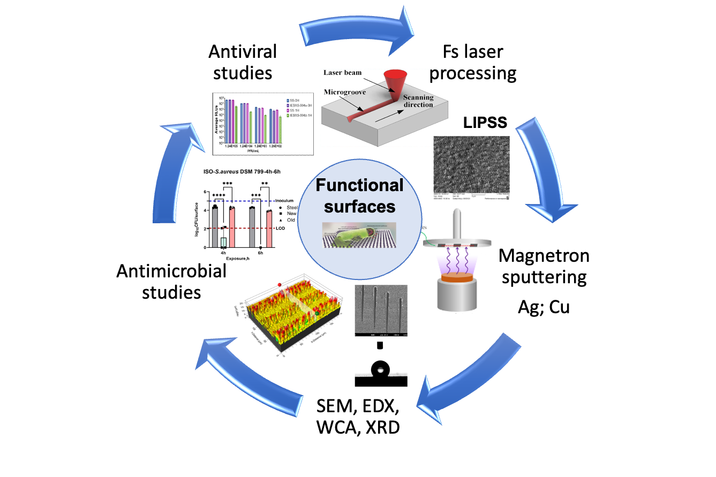
Figure 1. Schematic cycle of functional SS surfaces creation via femtosecond laser processing and magnetron sputtering.
The tests performed with S. Aureus demonstrated that the created LIPSS surfaces posses impoved antimicrobial properties. By additionally applying Ag and Cu thin films, it is possible to enhance the antimicrobial and antiviral efficacy of the SS surface. Femtosecond laser modification creates nanometric LIPSS structures, thus improving the surface area, wettability, and adhesion properties for deposition of thin metallic Cu and Ag layers. The sustainability of the applied coatings, was checked by nano scratched test, which showed a good adhesion properties of Cu and Ag thin films. Viral inactivation was detected on LIPSS sputtered with Cu layer. The combination between surface morphology and addition of antimicrobial metal agents was examined via SEM, EDX, WCA, and XRD and biological tests were done according to ISO-standard antimicrobial assays and antiviral activity tests. This synergetic approach is promising towards creation of effective antimicrobial, antiviral materials surfaces that meet sustainability criteria and are suitable for application in high-risk environments.

Acknowledgments: This work was funded by the European Union: Horizon Europe program under the Grant Agreement № 101057961, „Surface transfer of pathogens” (STOP). The research was carried out with the help of infrastructure purchased under the National Roadmap for Scientific Infrastructure (ELI-ERIC-BG), project D01-351.

REFERENCES
[1] Y. Meng, H. Wen, T. Yuan, Z. Ya, S. Qiang, Z. Bing, Sci China Tech Sci 65, (2022)

