Computational capacity of LA-VCSEL devices with complex resonator shapes

L. Cardenas-Razo¹, A. Skalli¹, M. Marciniak², M. Gebski², S. Reitzenstein³, J. A. Lott³, T. Czyszanowski² and D. Brunner¹
¹Institut FEMTO-ST, Université Marie et Louis Pasteur, CNRS UMR, 6174, Besancon, France
²Institute of Physics, Lodz University of technology, Wólczańska 217/22190-005 Łódź, Poland
³Institut für Festkörperphysik, Technische Universität Berlin, Hardenbergstraße 36, 10623 Berlin, Germany
e-mail: lucero.cr@femto-st.fr

In our current era of data and information, the amount of energy required to sustain modern AI is reaching formidable levels. Motivated by this, novel hardware architectures such as optical neural networks (ONN) have emerged as a high-performance, energy-efficient and scalable alternatives.

We have recently demonstrated a ONN using a semiconductor multimode vertical-cavity surface-emitting laser (LA-VCSEL) [1] as the nonlinear neuron substrate, realizing spatial multiplexed photonic neurons with trainable input and output weights, see Fig. 1(a). This network is inherently autonomous, parallel and fully realized in hardware, using off-the-shelf components. Training was achieved using model-free training algorithms, obtaining 93% test accuracy, outperforming the digital linear classifier, hence highlighting the nonlinear transformation produced by the laser.

However, the link between a LA-VCSEL’s area, shape and operating conditions and an ONN’s computational dimensionality is non-trivial. Here, we perform a detailed, data-driven study to link different physical parameters of the ONNs to general computational metrics, such as the number of neurons. Furthermore, we explore circular as well as chaotic resonator shapes and their impact on these principle performance predictors.
In these experiments, we recorded with a camera the response of LA-VCSELs with different chaotic cavity geometries and aperture sizes to each image in the MNIST training dataset. Additionally, we scanned different injection laser positions inside the laser aperture. We applied Principal Component Analysis (PCA) to carry out a dimensionality study on the acquired images. The number of linearly independent principal components (PCs) determines the LA-VCSEL’s computational dimensionality, i.e., the neurons in our system. To account for the noise in the ONN, we used a criterion presented in [2] to separate the dimensions resulting from real data variations from those where noise was predominant, thus arriving at a more physically meaningful dimensionality. To link the dimension of the device to a performance metric, we performed classification of MNIST digits under the same injection conditions. Our results identify a potential link between dimensionality and ONN computing performance, see Fig. 1 (b).
In conclusion, this study established a bridge between the computational performance of LA-VCSELs through a simple and fast measurement to determine the system’s dimensionality, and through that provides physical insights to guide the design of novel LA-VCSELs for optical computing.
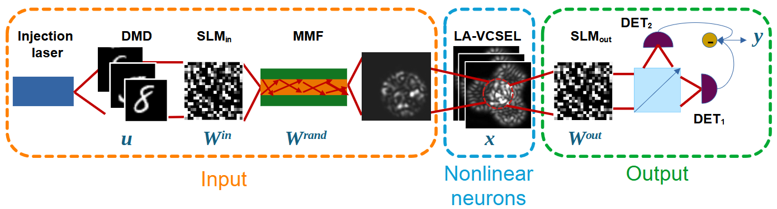
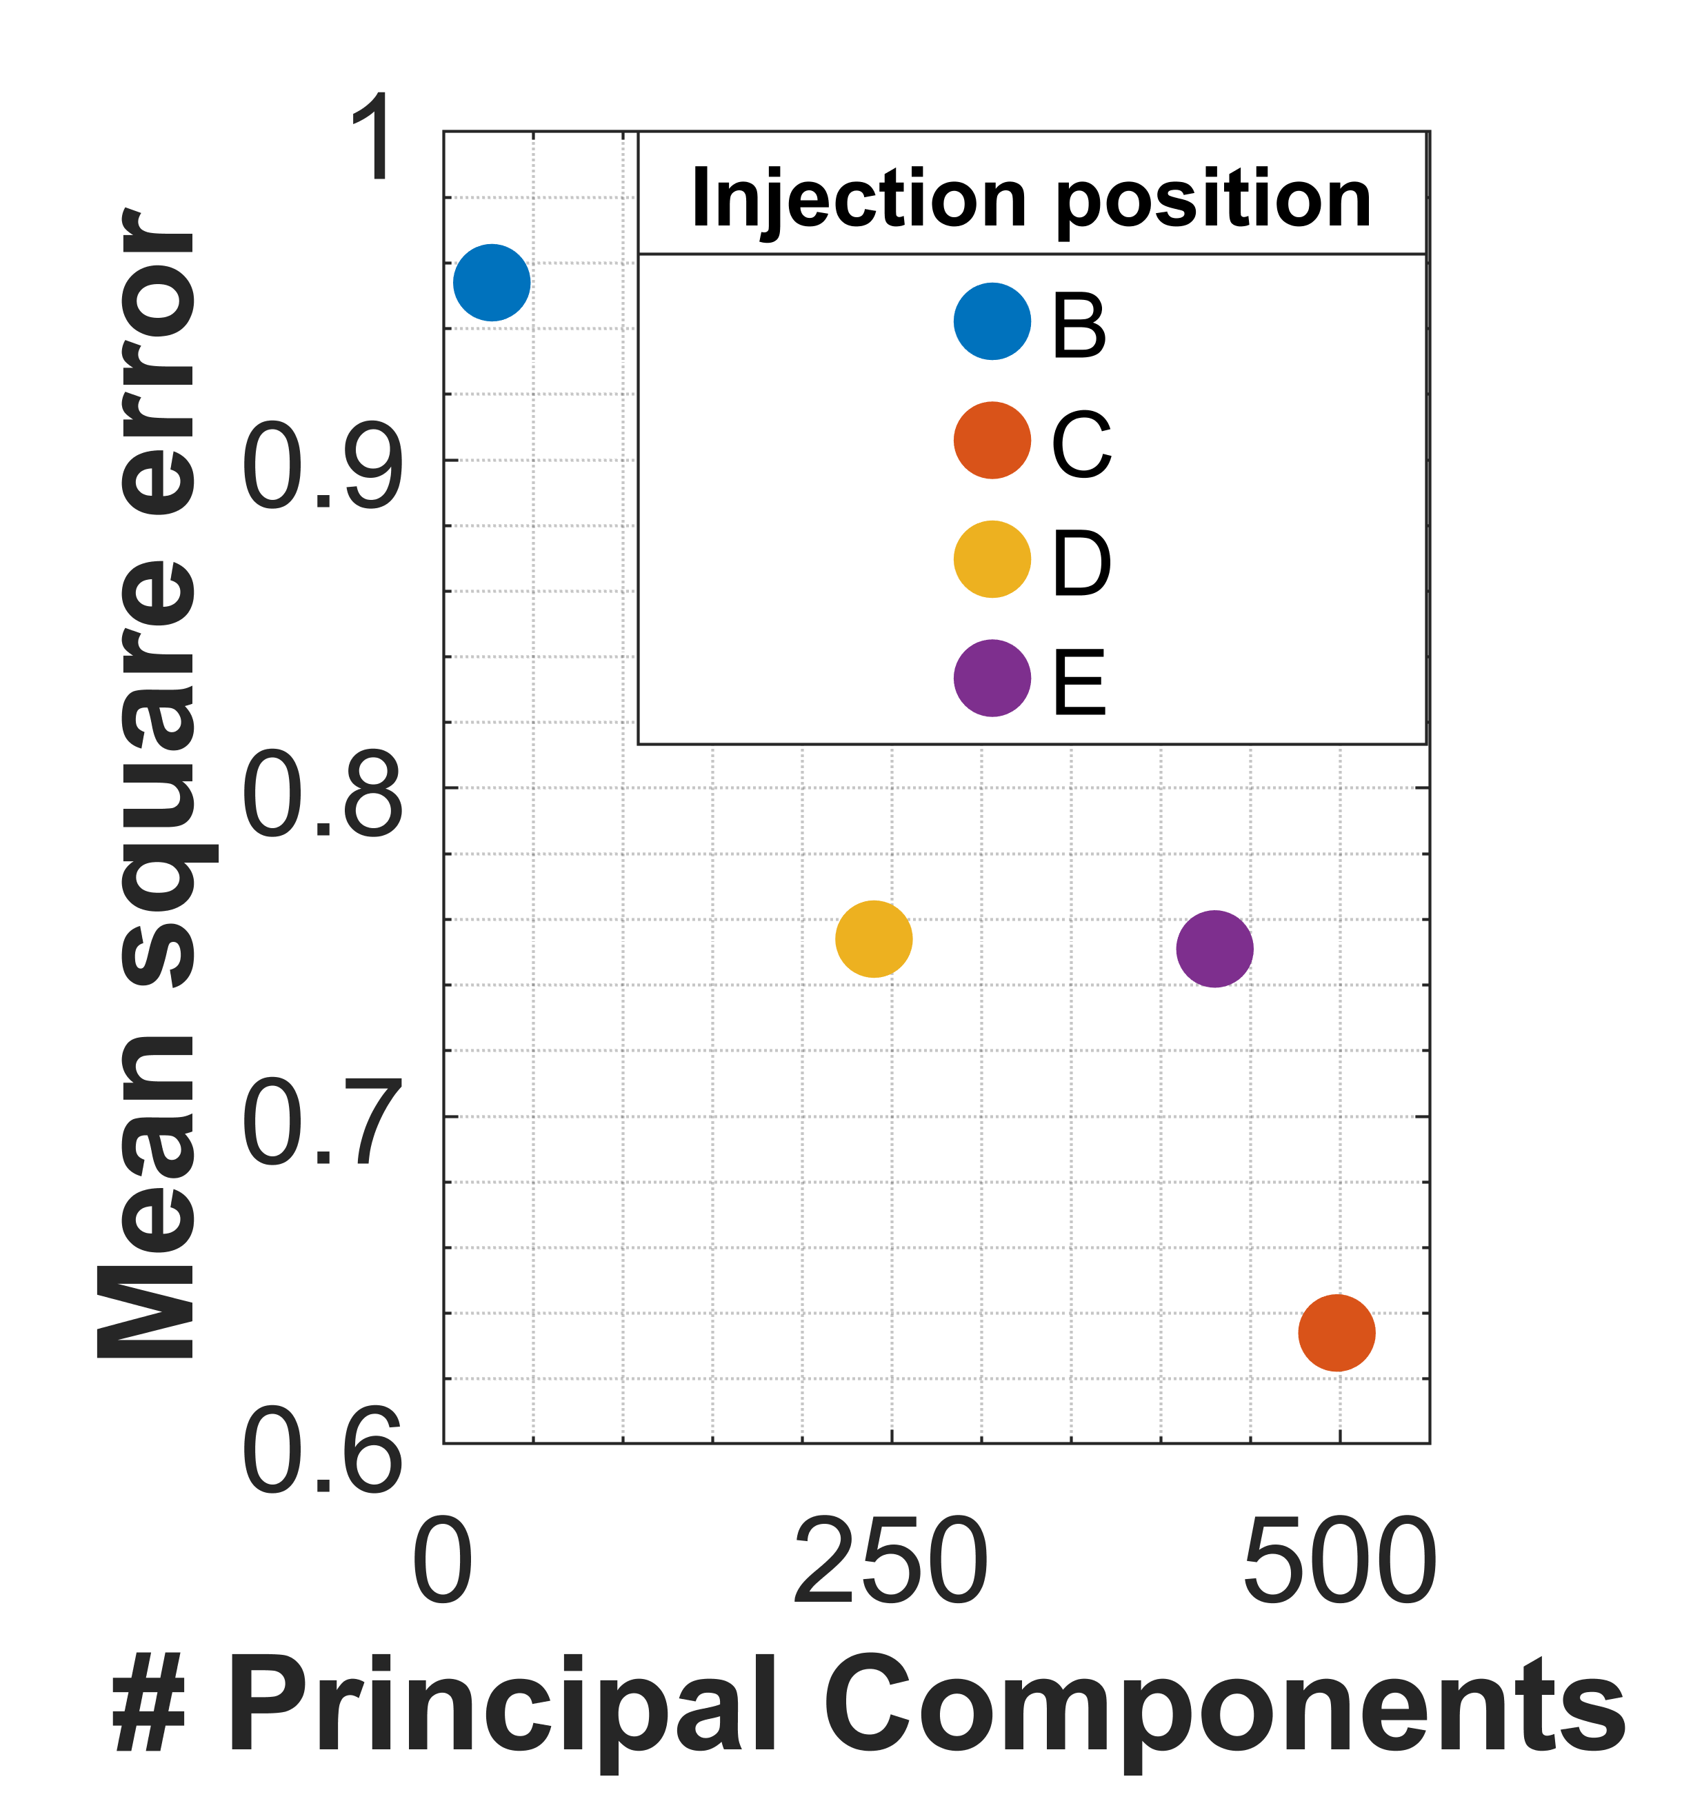
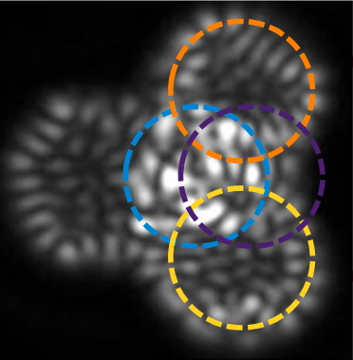
a)
b)

Figure 1. (a) Experimental setup of the ONN. (b) Computing power vs dimensionality represented by plotting MSE (mean square error) vs number of PCAs/ neurons in the LA-VCSEL.
REFERENCES
[1] Skalli, A., et al. (2025). Model-free front-to-end training of a large high performance laser neural network.https://arxiv.org/abs/2503.16943
[2] Skalli, A., et al. (2022). Computational metrics and parameters of an injection-locked large area semiconductor laser for neural network computing. https://doi.org/10.1364/OME.451524

