Impact of Growth Pressure on the Physical Properties of Two-Step Grown Sb₂Se₃ Absorbers for Thin Film Solar Cell Applications

A. Cantas¹
¹Department of Electric and Energy, Pamukkale University, Denizli, Türkiye
e-mail: abagdas@pau.edu.tr

As a result of growing population density and industrialization, the energy demand has been rising continuously. To meet the growing demand of energy consumption in the world, clean energy-based technology, such as photovoltaic technology, has been widely developed. The primary component of a solar cell system is the absorber layer. Thin-film solar cells rely on inorganic absorbers. However, the low stability and the high toxicity of some absorber layers could prevent the commercialization of these solar cells. Finding a novel, earth-based, and environmentally acceptable material for thin-film solar cells is crucial in this situation. Recently, Sb₂Se₃ thin film has drawn a lot of attention from researchers as a potentially useful photovoltaic absorber material. Earth-abundant and non-toxic, antimony selenide (Sb₂Se₃) has a direct bandgap of 1.1–1.3 eV and a high absorption coefficient (more than 10⁵ cm⁻¹) [1]. These good properties make antimony selenide an extremely suitable absorber layer for thin-film solar cells. Although the theoretical studies have predicted that the conversion efficiency of Sb₂Se₃ can reach 30%, these values have not yet been reached experimentally [2]. Many methods have been used to prepare Sb₂Se₃ thin films. Still, most of them employ toxic chemicals and solvents or easily introduce impurities into the film as a result of the processes. Therefore, the two-step method has been preferred to deposit Sb₂Se₃ thin films. Firstly, the magnetron sputtering technique (Fig.1) has been used to grow Sb₂Se₃ thin films under different pressures, and then the selenization process has been applied. The different growth pressures have been applied to obtain the Sb₂Se₃ thin films (Fig.2) with desired properties. Scanning electron microscopy (SEM), energy dispersive X-ray (EDX), X-ray diffraction (XRD), Raman spectroscopy, X-ray photoelectron spectroscopy (XPS), UV/VIS/NIR spectroscopy, and the Hall system have all been used in this study to describe the complete characterization.

 | 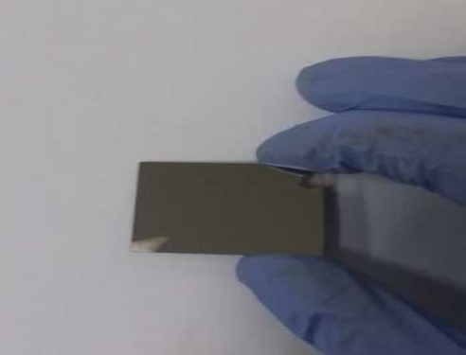
Figure 1. Growth of Sb₂Se₃ thin film. | Figure 2. Sb₂Se₃ thin film.

The grown absorber films have different atomic compositions and have band gap energy values ​​in the range of 1.2-1.4 eV. They exhibited an orthorhombic crystal structure with different preferred orientations. Electrical measurements of Sb₂Se₃ thin films demonstrated a p-type characteristic with varied resistivity. Substrate or superstrate thin film solar cells will be fabricated with absorber layers having the properties required for photovoltaic applications, and their efficiency values ​​will be discussed.
The study received support from the Scientific and Technological Research Council of Turkey (TUBITAK) under project number 118F143. The author expresses gratitude to the Research and Application Center for Quantum Technologies (RACQUT) of IZTECH for providing access to its experimental resources.

REFERENCES
[1] X. Huang, Y. Zhang, L. Fang, X. Zhou, Q. Yu, K. Meng Results in Optics 16, 100734 (2024).
[2] A. Cantas, Phys. Scr. 99, 105993 (2024).

