Fluorescent proteins as perspective elements of optoelectronic devices

A.S. Kudriavtseva^{1,2}, N.P. Nekrasov³, I. Bobrinetskiy^{2,4}
¹Prokhorov General Physics Institute of the Russian Academy of Sciences, Moscow, Russia
²Moscow Institute of Physics and Technology, Moscow Region, Russia
³National Research University of Electronic Technology, Moscow, Russia
^{4*}BioSense Institute - Research and Development Institute for Information Technologies in Biosystems, University of Novi Sad, Novi Sad, Serbia
e-mail: bobrinet@gmail.com

Fluorescent proteins (FPs) are widely used in biomolecular research due to their high quantum yield and stability. A broad range of engineered FPs have been developed, enabling tuning their spectral sensitivity, wavelength conversion, and chemical modifications. Recently, FPs were proposed as a light converter for photovoltaics and bioelectronics applications.

In this work, we demonstrate the functionalization of field-effect transistors based on individual single-walled carbon nanotubes (SWCNT-FETs) with FPs to introduce novel optoelectronic properties (Figure 1a). We employed a developed protein immobilization approach on carbon nanomaterials, that have been used also for biosensor development [1].

First, the sensitivity of green FPs (GFPs) photochemically immobilized on carbon lattices was investigated and specific photoresponse at 470 nm (Figure 1b) was shown [2]. Two types of engineered proteins have been studied with different positions of introduced non-natural amino acids containing phenyl-azide chemistry: the barrel wall of GFP and the bottom side. We demonstrated that the photoresponse is site-specific, and influenced by the number of charge traps associated with the hydrophobicity of the protein surface (Figure 1c).

Additionally, for SWCNT-FETs functionalized with red FPs, we used a PBASE linker adsorbed onto the nanotube surface [3]. These devices exhibit an unexpected gating effect on channel conductivity under FP-specific light irradiation. In this configuration, electrons can only transfer from the FPs when the gate voltage is below the threshold voltage, resulting in a negative photoresponse. Thus, engineering of FPs pave a way for novel optoelectronic devices with tunable properties.

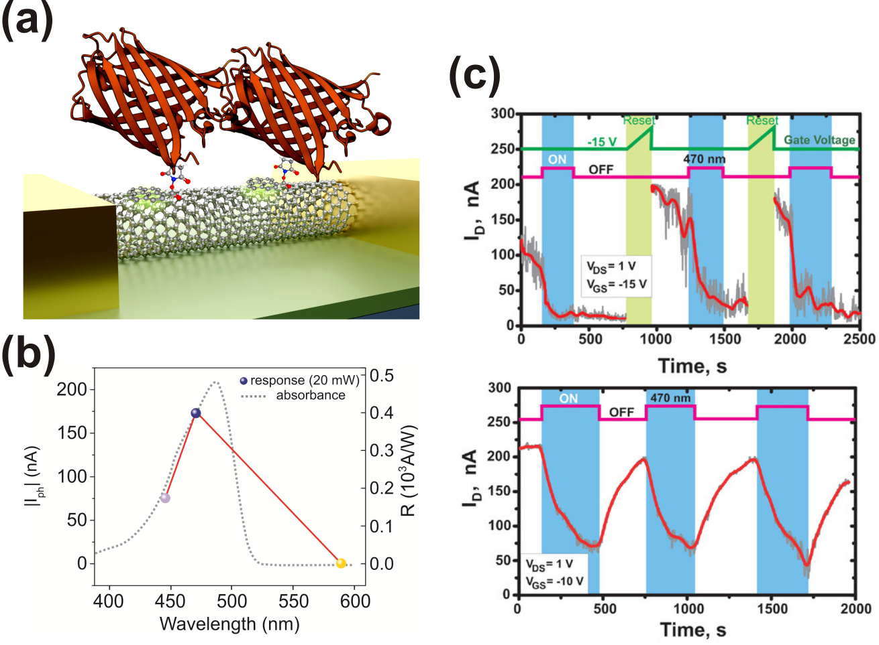
Figure 1. The performance of FP/SWCNT FET. (a) Scheme of SWCNT-FET with immobilized fluorescent proteins. (b) Spectral selectivity of bio-FET response. (c) The role of FPs immobilization site with memory response (top) and photodetector mechanism (bottom).
REFERENCES
[1] N. Nekrasov, S. Jaric, D. Kireev, et al. Biosens. Bioel. 200, 113890 (2022).
[2] A.S. Kudriavtseva, N.P. Nekrasov, D.V. Krasnikov, et al., Adv. Electron. Mater. 11, 2400329 (2025).
[3] R.E. Gwyther, N.P. Nekrasov, A.V. Emelianov, et al., Adv. Funct. Mater. 32, 2112374 (2022).

