Edge modes in nonlinear zig-zag modulated waveguide arrays with zero average modulation

P. P. Beličev¹, G. Gligorić¹, M. Stepić¹, M. Johansson², R. A. Vicencio^{3, 4} and A. Maluckov¹
¹COHERENCE Centre, Department of Atomic Physics, Vinča Institute of Nuclear Sciences,
National Institute of the Republic of Serbia, University of Belgrade, Belgrade, Serbia
²Department of Physics, Chemistry and Biology (IFM), Linköping University, SE-581 83 Linköping, Sweden
³Departamento de Física, Facultad de Ciencias Físicas y Matemáticas, Universidad de Chile, Chile
⁴Millenium Institute for Research in Optics - MIRO, Chile
e-mail: petrab@vin.bg.ac.rs

Topological edge states in periodically driven (Floquet) systems have attracted significant interest in recent years, particularly in photonic platforms, where their experimental realization and manipulation are highly controllable [1]. Among the key features of such systems are the so-called π-modes — robust edge-localized states with quasienergies locked at half the driving frequency — which are unique to time-periodically modulated lattices and have no static analog [1-5]. While extensive studies have addressed linear Floquet topological phases, the impact of nonlinearity remains an active area of research with many open questions [1].

In this work, we examine edge π-modes in nonlinear Su-Schrieffer-Heeger (SSH) lattices driven by zero-average time-periodic modulation as shown in Figure 1. Building on prior studies that identified nonlinear Floquet edge solitons bifurcating from linear π-modes in the high-frequency regime [6, 7], we extend the analysis to examine their nonlinear continuation under Kerr-type interactions and explore their behavior across both fast and slow driving regimes. We aim to map the stability properties of the resulting nonlinear π-mode family through detailed Floquet linear stability analysis.

In addition, we consider the emergence of topological mode bifurcations induced by nonlinearity, focusing on transitions between distinct families of edge-localized states and the onset of dynamical instabilities. These findings contribute to the broader understanding of nonlinear Floquet topological phases and open pathways for engineering robust edge-localized excitations in photonic systems governed by time-periodic driving.
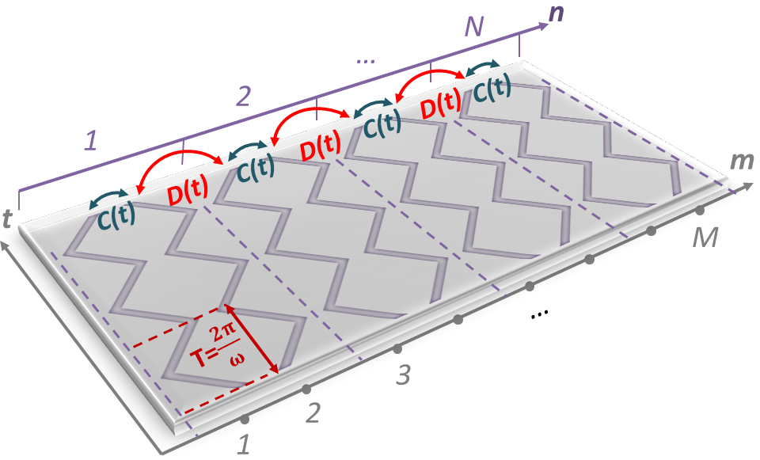

Figure 1. Schematic representation of longitudinally modulated zig-zag photonic lattice with periodically alternating coupling constants. Indices m and n stand for number of waveguides and 'dimers', respectively.

REFERENCES
[1] Y.V. Kartashov et al., Phys. Usp. 67, 1095-1110 (2024).
[2] V. Dal Lago, M. Atala, L.E.F. Foa Torres, Phys. Rev. A 92, 023624 (2015).
[3] Q. Cheng et al., Phys. Rev. Lett. 122, 173901 (2019).
[4] S. Wu et al., Opt. Express 30, 44983-44991 (2022).
[5] Z. Chen et al., Phys. Rev. B 109, L020302 (2024).
[6] H. Zhong et al., Phys. Rev. A 107, L021502 (2023).
[7] M. Arkhipova et al., Science Bulletin 68, 2017–2024 (2023).

