Manipulation of photoinduced reaction dynamics with
strong laser fields

L. Bañares^{1,2}
¹Departamento de Química Física and Center for Ultrafast Lasers, Facultad de Ciencias Químicas, Universidad Complutense de Madrid, 28040 Madrid, Spain
²Instituto Madrileño de Estudios Avanzados en Nanociencia, IMDEA Nanoscience, C/ Faraday 9, 28049 Madrid, Spain
e-mail: lbanares@ucm.es

With current technology, ultrafast laser radiation can easily achieve electric fields that are intense enough to induce changes or even dramatically modify the behavior of molecules. Thus, a strong external laser field can be regarded as an additional reagent in molecular processes such as chemical reactions, and one that may be used to steer the reaction towards desired targets. In recent experiments, we have studied ultrafast molecular photodissociation processes taking place under the influence of strong laser fields. We have shown that it is possible to modify observables such as quantum yields, lifetimes, translational energies, or spatial distributions of the ejected fragments (i.e. the reaction stereodynamics) with strong picosecond or femtosecond near-infrared pulses. The control
is achieved by opening new strong-field-induced reaction channels, or by creating light-induced conical intersections and modulating the potentials around them by light-induced potentials. These control scenarios and the outlook for future work will be the subject of the conference.

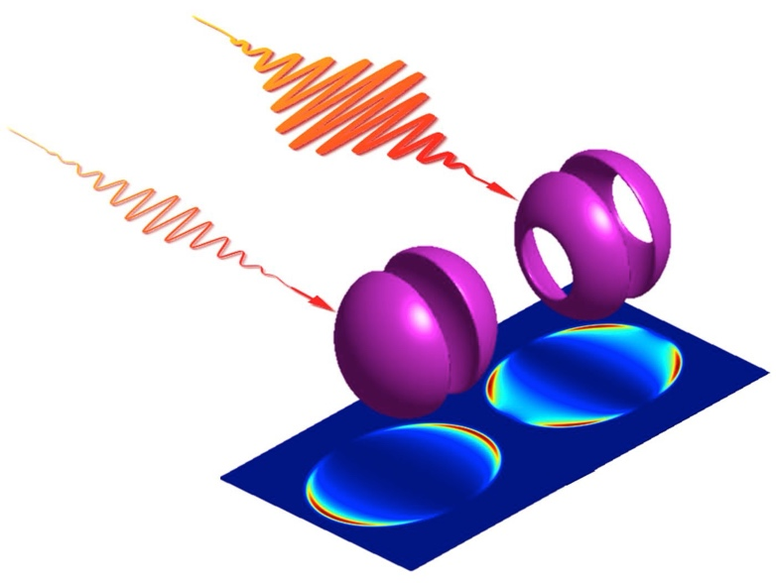
Figure 1. Effect of strong laser fields on stereodynamics of photodissociation reactions.

REFERENCES
[1] I. R. Solá, J. González-Vázquez, R. de Nalda, L. Bañares, Phys. Chem. Chem. Phys. 17, 13183 (2015).
[2] M. E. Corrales, G. Balerdi, V. Loriot, R. de Nalda, L. Bañares, Faraday Discuss. 163, 447 (2013).
[3] M. E. Corrales, J. Gonzá lez-Vázquez, G. Balerdi, I. R. Solá, R. de Nalda, L. Bañares, Nature Chem. 6, 785 (2014).
[4] M. E. Corrales, R. de Nalda, L. Bañares, Nature Comm. 8, 1345 (2017).
[5] I. M. Casasús, L. Bañares, et al. work in progress (2025).

