Next-Generation Load Sensing: FBG Sensors vs. Classic Strain Gauge Approach

J. S. Bajić¹, A. Joža¹, M. Dramićanin¹, M. Kovačević²
¹Faculty of Technical Sciences, University of Novi Sad, Novi Sad, Serbia
²Faculty of Sciences, University of Kragujevac, Kragujevac, Serbia
e-mail: bajic@uns.ac.rs

Load cells represent one of the most important types of sensors in force measurement applications across various industries, with conventional strain gauge-based load cells being the standard one [1]. However, Fiber Bragg Grating (FBG) sensors are emerging as a promising alternative due to their unique measurement features [2], [3], [4]. In this work an industrial-grade (FBG) load cell designed for demanding applications is presented as a next-generation alternative to conventional strain gauge load cells. Accordingly, a comprehensive study and comparison between FBG-based and traditional strain gauge load cells is conducted, focusing on performance metrics such as accuracy, sensitivity, durability, and environmental resilience. Experimental evaluation conducted in laboratory conditions under different stress and temperature inputs, confirms that FBG load cells can achieve precision comparable to commercial strain gauge systems while offering unique features like additional outputs such as temperature and torque, as well as remote sensing and spectral multiplexing. Despite higher initial costs, the scalability, robust design, and potential of operability in extreme conditions provide FBG load cells a significant competitive edge important in demanding industries like aerospace, automotive, and smart manufacturing.

Fig. 1 illustrates sensors evaluated and compared in this work. In Fig. 1a conventional strain gauge load cell is depicted, while FBG-based cell is given in Fig. 1b. Equivalent response of the evaluated load cells are presented in Fig. 1c under tension and compression loading.
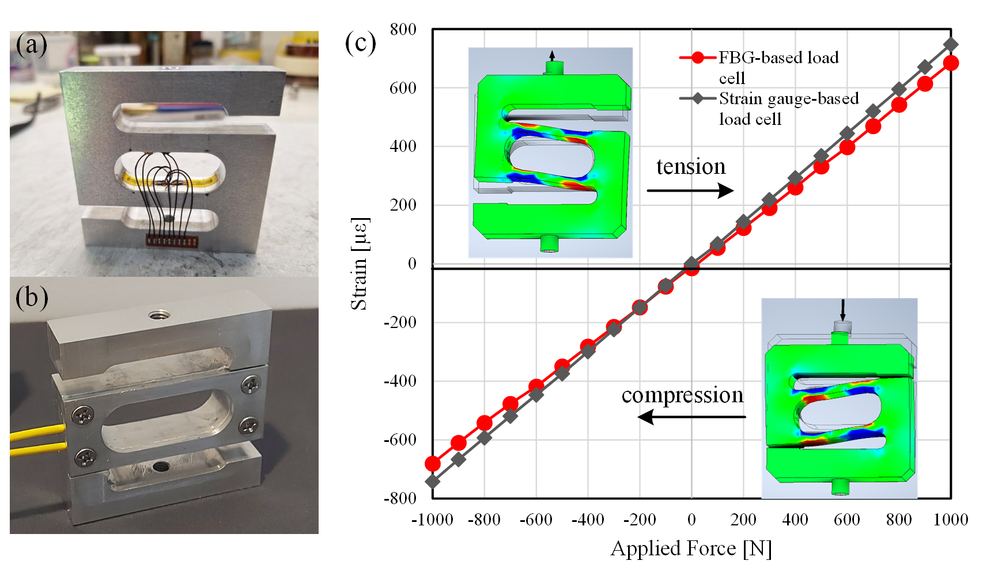
Figure 1. a) Strain gauge load cell, b) FBG load cell and c) Equivalent response of the evaluated load cells under tension and compression loading.

REFERENCES
[1] O. S. Al-Dahiree, M. O. Tokhi N. H. Hadi, N. R. Hmoad, R. A. R. Ghazilla, H. J. Yap, A. Albaadani, Sensors, 22 (2022).
[2] G. Ma, C. Li, J. Jiang, Y. Luo, Y. Cheng, Cold Regions Science and Technology, 71 (2012).
[3] A. Gautam, A. Kumar, K. Kinjalk, J. Thangaraj, V. Priye, IEEE Sensors Journal, 20 (2020).
[4] M. Bocciolone, G. Bucca , A. Collina, L. Comolli, Journal of Rail and Rapid Transit (2018).

