Magnetron Sputtered Grown LiCoO₂ and Li₇La₃Zr₂O₁₂ Thin Film Layers for All-Solid-State Lithium-ion Batteries

N. Esen¹, S. Karpuz¹, N. Karadeniz^{1,2}, L. Ozyuzer^{1,2}, M. Ozdemir², U. Unal³, A. Cantas⁴, K. Kosiel⁵, A. Szerling⁵, R. Socha⁶, G. Aygun¹
¹Department of Physics, Izmir Institute of Technology, Izmir, Türkiye
²Teknoma Technological Material Inc., IZTECH Campus, Izmir, Türkiye
³Department of Chemistry, Koc University, Istanbul, Türkiye
⁴Department of Electric and Energy, Pamukkale University, Denizli, Türkiye
⁵Łukasiewicz Research Network-Institute of Microelectronics and Photonics, Warsaw, Poland
⁶CBRTP S.A., 36 Czarnowiejska St. 30-054 Cracov, Poland
e-mail: gulnuraygun@iyte.edu.tr

All solid-state batteries have attracted considerable research interest in recent years due to their potential to provide higher energy density, improved thermal stability, and enhanced safety compared to conventional liquid-electrolyte lithium-ion batteries [1,2]. Among the key solid electrolyte materials, Li₇La₃Zr₂O₁₂ (LLZO) stands out for its high ionic conductivity and good chemical stability [3]. Moreover, LiCoO₂ (LCO), a widely used cathode material, continues to be investigated in solid-state systems, particularly with respect to its interfacial compatibility with solid electrolytes [4]. To mitigate issues such as interfacial chemical instability and lithium dendrite formation between LLZO and LCO, an Al₂O₃ buffer layer grown by atomic layer deposition (ALD) has been introduced as an interfacial modification strategy. In this context, the crystal structure of LLZO, its lithium-ion conduction mechanisms, and its interaction with LCO through the Al₂O₃ interlayer are considered key physical parameters in evaluating and optimizing the performance and cycle life of all solid-state lithium-ion battery (ASSLIB) technologies.

This study focuses on the deposition and characterization of thin film layers for ASSLIBs. LCO and LLZO layers were successfully deposited by radio-frequency magnetron sputtering (Fig.1 (a)), while the integration of lithium metal as the anode layer is planned for future stages of the project by thermal evaporation. LLZO target was fabricated to obtain sputtering material for thin film deposition. Titanium was selected as the current collector due to its high electrical conductivity and interfacial stability. To enhance structural integrity and electrochemical performance, thin oxide buffer layers were incorporated at both the cathode–electrolyte and anode–electrolyte interfaces. Al₂O₃ buffer layer between cathode and electrolyte layer was grown by ALD technique (Fig.1 (b)) to improve interfacial contact and chemical stability of ASSLIBs. The resulting multilayer thin film structures were comprehensively characterized using SEM, XRD, Raman spectroscopy, XPS, and electrochemical measurements. Details of the fabrication and characterization processes will be discussed.
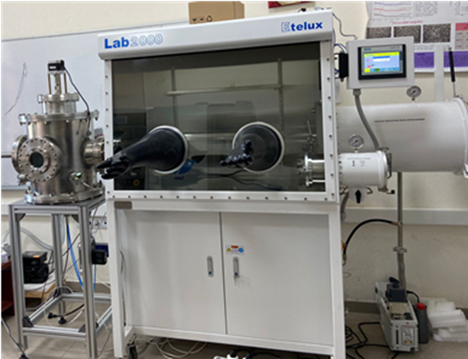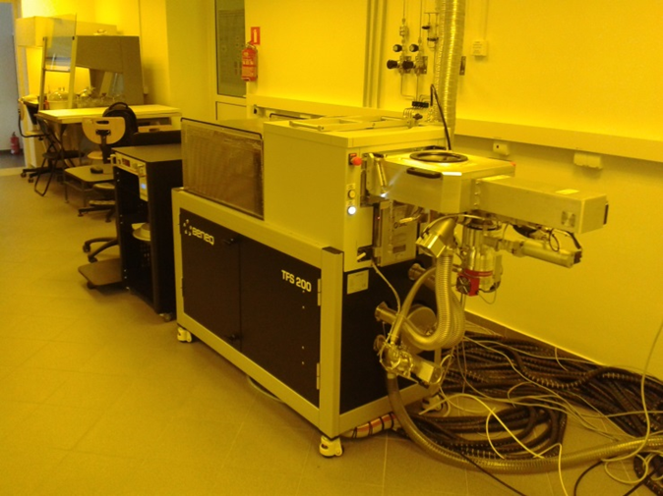
Figure 1. Images of (a) glove box and (b) ALD systems
This research was supported by TUBITAK with project number 122N410 under MERANET program. The authors would like to acknowledge the facilities of Research and Application Center for Quantum Technologies (RACQUT) of IZTECH.

REFERENCES
[1] P. U. Nzereogu, et al., Hybrid Advances, 8, 100339 (2025).
[2] S. Ulusoy, et al., Solid State Ionics, 324, 226-232 (2018).
[3] R. Murugan, V. Thangadurai, W. Weppner, Angew. Chem. Int. Ed., 46, 7778–7781 (2007).
[4] P. Ozcan, et al., Vacuum, 239, 114439 (2025).

