Real-time imaging using Morpho didius wing scales as biophotonic microcantilever pixels
P. Atanasijević¹, M. Mićić¹, D. Pavlović², B. Salatić², D. Pantelić³ and P. Mihailović¹
¹University of Belgrade, School of Electrical Engineering, Belgrade, Serbia
²University of Belgrade, Institute of Physics Belgrade, Belgrade, Serbia
³University of Belgrade, Senzor INFIZ, Belgrade, Serbia
e-mail: petarat@etf.bg.ac.rs

For decades, wide spectral range imaging has continued to allure researchers to develop novel high-performing, yet affordable focal plane array (FPA) technologies. In a vast field of published approaches, microcantilever FPAs stand out as a strong commercial contender due to their high sensitivity and ease of manufacture. Furthermore, they offer a high-speed optical spatial filtering readout (OSFR) using a simple 4f system, overcoming the drawbacks of complex, heat-generating electronic readout integrated circuits [1]. Building upon the presented ideas, highly sensitive bioinspired alternatives utilizing wing scales of Morpho butterflies as biophotonic microcantilevers were proposed, although somewhat burdened by their less practical [2] or computationally heavy interrogation approaches [3].
In our research, we combine the speed and simplicity of the OSFR principle proposed in [1] with the highly sensitive M. didius wing scales as biophotonic microcantilevers [3]. We demonstrate a real-time acquisition system capable of capturing wide spectral range images, limited in bandwidth by the thermal transients of the microcantilevers. The system, shown in Fig. 1 (a), consists of a conventional 4f setup projecting the biophotonic sensor plane, illuminated by a 532 nm laser, to the plane of a lensless CMOS imager (Basler acA2440-75um camera). The adjustable slit in the spectrum plane of the 4f system is used to convert the light-induced scale displacements to an intensity change of the acquired sample image [1]. The slit is followed by a 532 nm, narrow bandpass filter (BPF), ensuring only the wavelengths originating from the interrogating light will pass from the sample to the camera. To test the operation of the proposed system, the sample was illuminated using a 4.4 mW, 638 nm laser, resulting in the imager’s response presented in Fig. 1 (b).
Due to its high sensitivity of up to ~500 nm/K [3] and the 4f system’s acquisition frame rate of over 50 Hz, we conclude that the proposed OSFR interrogated bioinspired imager presents a compelling choice, leading the next generation of uncooled wide spectral range FPAs.

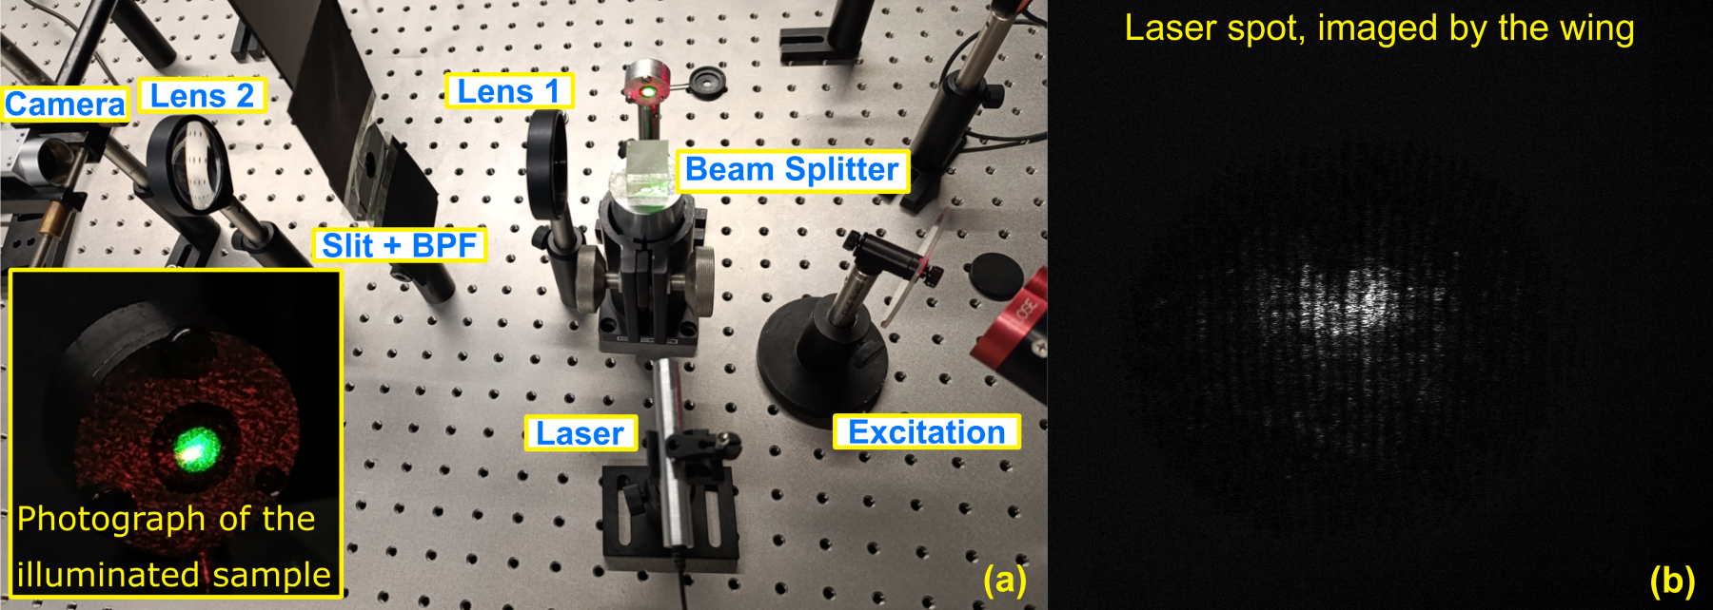
Figure 1. (a) The proposed 4f system, interrogating the M. didius wing. (b) The response of the imager to the 4.4 mW, 638 nm laser excitation.
Acknowledgment: The research was supported by the Serbian Ministry of Science, Technology, and Innovation (451-03-65/2024-03/200103). The research was partially conducted in the premises of the Palace of Science, Miodrag Kostić Endowment.

REFERENCES
[1] Y. Jin et al., Meas. Sci. Technol. 32 065202 (2021).
[2] A. Pris et al., Nature Photon 6, 195–200 (2012).
[3] P. Atanasijević et al., Opt. Laser Technol., 159, 108919 (2023).

