**The nonlinear Talbot effect of counterpropagating rogue waves**

M. Petrović1, A. Strinić1, N. Petrović2 and M. Belić3

1*Institute of Physics, University of Belgrade, P.O. Box 68, 11080 Belgrade, Serbia*

2*Mathematical Grammar School (MGS), Kraljice Natalije 37, 11000 Belgrade, Serbia*

3*College of Sciences and Engineering, Hamad Bin Khalifa University, 23874 Doha, Qatar*  
e-mail: petrovic@ipb.ac.rs

The Talbot effect (TE) is an image recurrence phenomenon manifested by a periodic repetition of planar field distributions in some types of wave fields [1]. The nonlinear TE of rogue waves was demonstrated in [2, 3]. Here, we investigated numerically mutual interaction of two Ahkmediev-like breathers travelling in the opposite directions. Ahkmediev breathers (ABs) can be used to model rogue waves because they are one of the solutions of the cubic nonlinear Schrӧdinger equation (NLSE). We observed the formation of perfect nonlinear Talbot carpets for small input intensities.

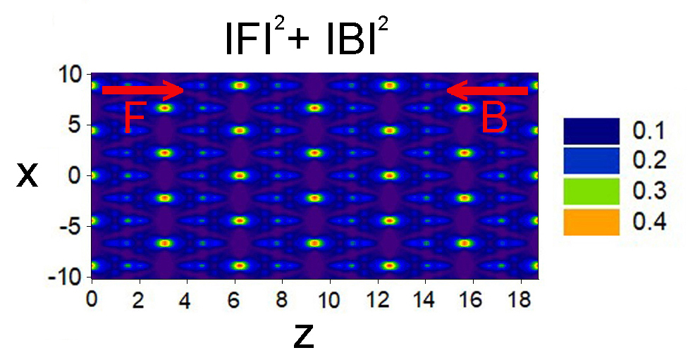

Figure 1. The nonlinear Talbot effect of counterpropagating rogue waves: input is Ahkmediev breather for both forward (F) and backward (B) propagating beams.

REFERENCES

[1] J. Wen *et al*., Adv. in Opt. and Phot. 5, 83-130 (2013).

[2] Y. Zhang *et al.*, Phys. Rev. E 89, 032902 (2014).

[3] Y. Zhang *et al.*, Phys. Rev. E 91, 032916 (2015).