**Counterpropagating Peregrine-like soliton**

A. Strinić1, M. Petrović1, I. Ilić2 and M. Belić3

1*Institute of Physics, University of Belgrade, P.O. Box 68, 11080 Belgrade, Serbia*

2*Mathematical Grammar School (MGS), Kraljice Natalije 37, 11000 Belgrade, Serbia*

3*College of Sciences and Engineering, Hamad Bin Khalifa University, 23874 Doha, Qatar*

e-mail: strinic@ipb.ac.rs

We investigated numerically mutual interaction of two Peregrine-like solitons travelling in the opposite directions. Both beams are adjusted such that their inputs and outputs overlap on both ends of the nonlinear medium. Peregrine solitons are one of the solutions of the cubic nonlinear Schrӧdinger equation (NLSE), and can be used to model rogue waves [1, 2]. We found that for small propagation distances and input intensities, both beams propagate in a straight line. Larger propagation distances and initial intensities lead to a transverse shift of the two counter-propagating discrete solitons through the beam bending [3].

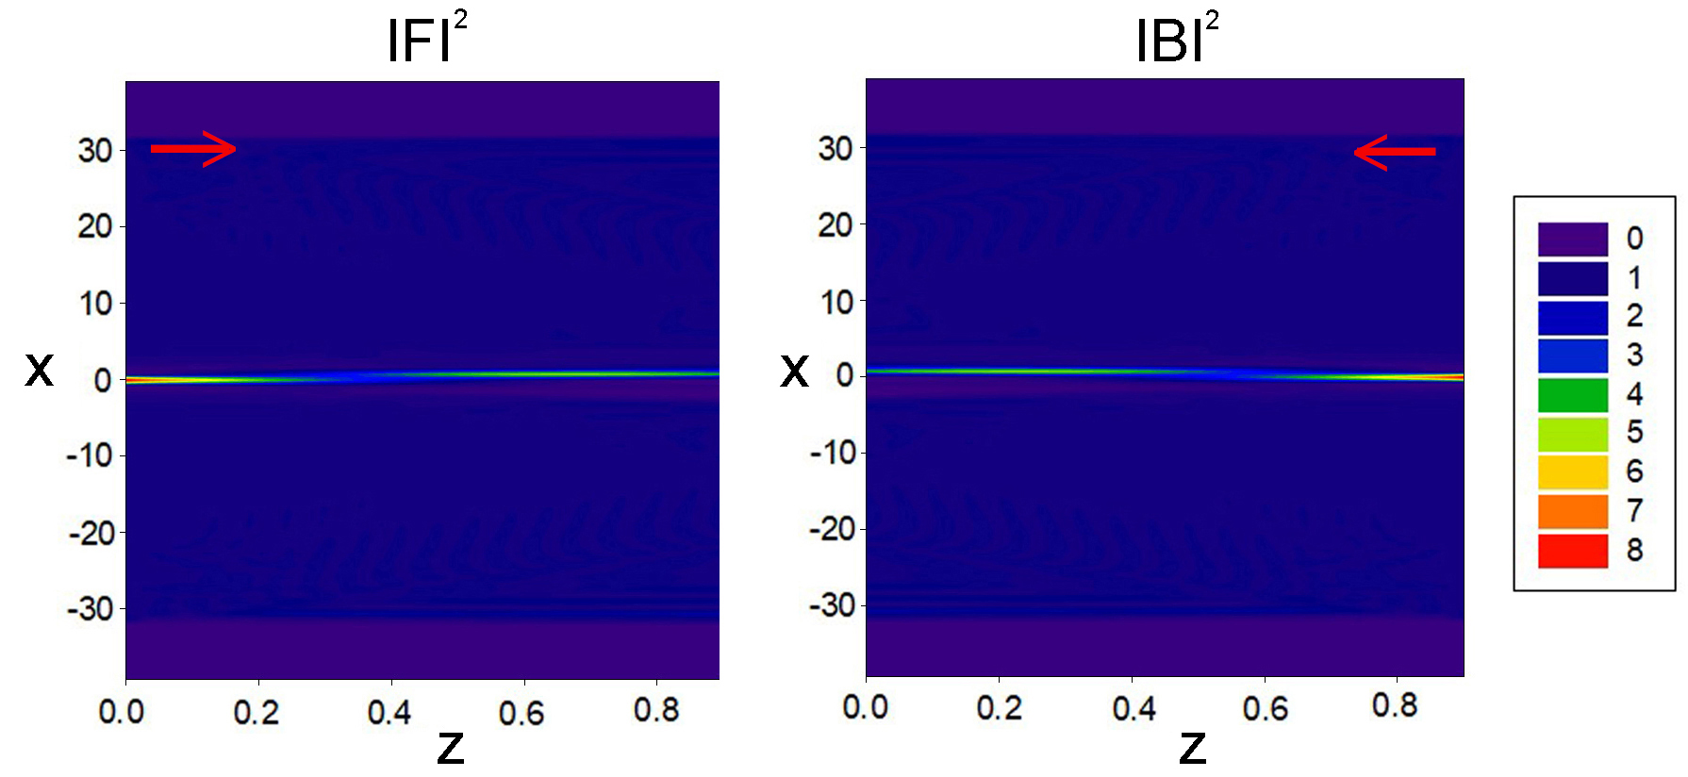

Figure 1. Counterpropagating rogue waves: input is Peregrine-like soliton for both forward (F) and backward (B) propagating beams.

REFERENCES

[1] Y. Zhang *et al.*, Phys. Rev. E **89**, 032902 (2014).

[2] Y. Zhang *et al.*, Phys. Rev. E **91**, 032916 (2015).

[3] M. Petrović *et al*., Las. Phot. Rev. **5**, 214-233 (2011).