**Hardware matrix multiplication through silicon photonics**

R. Minnullin, A. Sapegin, M. Makarov, A. Marakhin, A. Italyantsev

*JSC Molecular Electronics Research Institute, Zelenograd, Moscow, Russia*

e-mail: rminnullin@niime.ru

Matrix multiplication is of the utmost need and use in data processing. It has been used in a variety of applications including image processing and various types of data analysis, however substantial expansion of artificial intelligence and neural network technologies in recent years have made them primary contributors to the development of hardware matrix multiplication approaches. Vast research in this field have resulted in occurrence of specialized electronic integrated circuits for matrix multiplication, namely, application specific integrated circuits (ASICs), tensor processing units (TPUs) and neural processing units (NPUs), besides GPUs and field-programmable gate arrays (FPGAs) that have already been used for this purpose since the appearance of hardware acceleration concept [1]. Meanwhile, rapid progress in integrated photonics has also evoked outstanding opportunities for performing matrix multiplication on a hardware level with the use of light.

Variety of different approaches to realization of matrix multiplication in photonics can be classified into 4 principal groups:

1. mathematical matrix is represented as physical matrix of modulators: ring resonators or elements including phase change materials [2, 3] (Figure 1a);
2. mathematical matrix is factorized through singular value decomposition into a product of two unitary matrices and a rectangular diagonal matrix, which are further physically represented by the appropriate set of Mach–Zehnder interferometers and attenuators [4] (Figure 1b);
3. matrix coefficients are physically encoded into the specific geometry of a multimode interferometer (MMI) [5] (Figure 1c);
4. mathematical matrix is represented as physical matrix of attenuators but light propagates in free space out of the plane of a photonic chip in contrary to in-plane propagation in previous approaches – so called 3D approach [6] (Figure 1d).

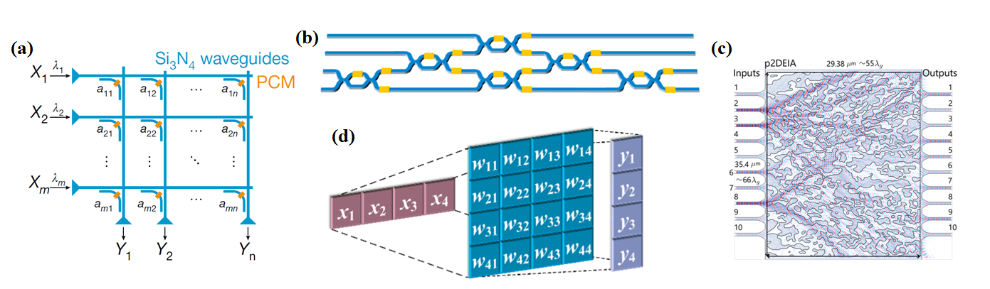

Figure 1. Approaches to photonic matrix multiplication

In this paper we review the latest research on realization of matrix multiplication in silicon photonics classifying them by approach into the aforementioned 4 groups, we briefly discuss the basic principles of these approaches noting their benefits and drawbacks, and report on our elaboration on the topic.

REFERENCES

[1] Reuther A., Michaleas P., Jones M. et al. 2020 IEEE HPEC Conf. 2020, pp. 1–12

[2] Feldmann, J., Youngblood, N., Wright, C.D. et al. *Nature* **569**, 208–214 (2019)

[3] Feldmann J., Youngblood N., Karpov M. et al. *Nature* **589**, 52–58 (2021)

[4] Zhang H., Gu M., Jiang X.D. et al. *Nat. Commun.* **12**, 457 (2021)

[5] Nikkhah V., Pirmoradi A., Ashtiani F. et al. *Nat. Photon.* **18**, 501–508 (2024)

[6] Lin X., Rivenson Y., Yardimci N.T. et al. *Science*, **361**, 1004–1008 (2018)