**Strain-Induced Corrugation and Its Impact on Electronic and Optical Properties of hBN-GaS, -GaSe, and -InS heterostructures**

Andrijana Šolajić and Jelena Pešić

*Laboratory for 2D Materials, Center for Solid State Physics and New Materials, Institute of Physics Belgrade, University of Belgrade, Pregrevica 118, 11080 Belgrade, Serbia*

e-mail: solajic@ipb.ac.rs

Two dimensional group IIIa monochalcogenides are promising two-dimensional semiconductors, known for their high carrier mobility and strong optical absorption in the visible and UV range. When integrated with hexagonal boron nitride (hBN) in van der Waals heterostructures, these materials benefit from the atomically flat and inert nature of hBN, which helps preserve their intrinsic electronic quality and enhances overall device performance. In our previous studies, hBN-based heterostructures with these monolayers exhibited favorable band alignment and optoelectronic characteristics [1,2,3].

In this work, we investigate the role of strain in shaping the structural and electronic behavior of hBN/GaS, hBN/GaSe, and hBN/InS heterostructures using first-principles DFT calculations. Contrary to heterostructures previously reported in the literature, these three systems develop a pronounced corrugated geometry as a result of compressive strain and lattice mismatch, coupled with the buckled nature of the monochalcogenide layers. We analyze how this strain-induced out-of-plane distortion modifies interlayer coupling, charge redistribution, band structure, and optical absorption spectra.

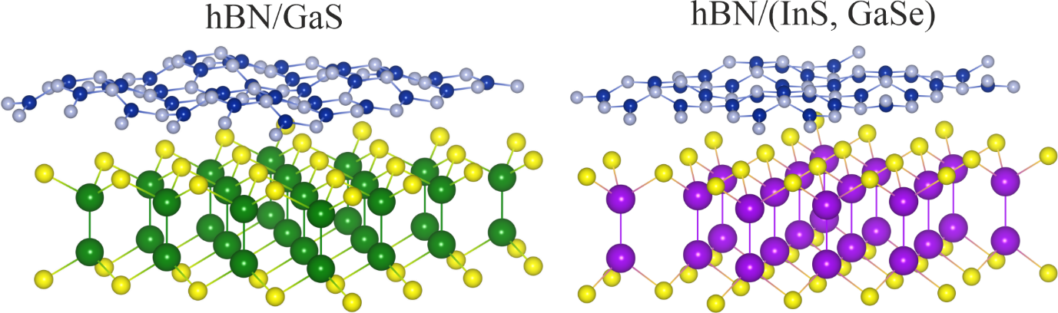

Figure 1. Crystal structure of corrugated heterostructures (hBN/InS, hBN/GaS, hBN/GaSe)

REFERENCES

[1] Šolajić, A., Pešić, J., *Journal of Physics: Condensed Matter.* **34(34)**:345301, 2022.

[2] Šolajić, A., Pešić, J., *Scientific Reports*, **14(1)**:1081, 2024.

[3] Šolajić, A., Pešić, J., *Optical and Quantum Electronics*, **56(7)**:1186, 2024.