**Optical reservoir computing with controlled complexity**

N. Marinin1 and M. Rafayelyan 3

1*PhotonicsAI lab, Yerevan State University, Armenia*

e-mail: nikita.marinin@ysu.am

Reservoir Computing (RC) is a computational approach based on a Recurrent Neural Network. There are many implementations of Optical Reservoir Computing [1]. In other works, different reservoir schemes with different connectivities and interconnections were explored [2]. We propose an advanced optical scheme using a Liquid Crystal Cell (LCC) with a voltage-controlled scattering as a reservoir.

The amount of scattering in the LCC and, as a result, the complexity of reservoir in corresponding RC scheme changes under different applied voltages. Our experimental results show gradual transition from dense, Gaussian-distributed to the identity diagonal matrix in a simple retrieval task.

In a high scattering case, results were comparable with the results of experiments with a fixed high-scattering media. Steady transformation of a retrieved transmission matrix from a Random Gaussian type (high scattering cases) to an identity diagonal type (low scattering cases) is shown.

Besides that, we compared the time predictions of spatiotemporal chaotic datasets obtained from the Kuramoto-Sivashinky equation, obtained with optical setup in different scattering cases, to the results of simulations with corresponding parameters of the reservoir. The results show the change in prediction quality for different reservoir complexities. Adjusting the reservoir according to the task may allow us to achieve better performance.

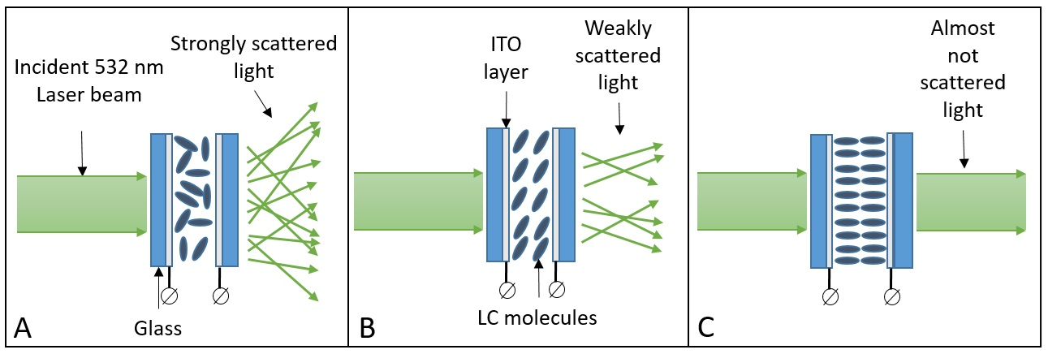

Figure 1. Different scattering cases for LCC. (A) No voltage. The LC molecules inside the cell are disordered. Light undergoes many scattering events inside the LCC. (B) Medium voltage. The LC molecules begin to orient themselves in the direction of the applied electric field. Light undergoes less scattering events inside the LCC. (C) High voltage. The LC molecules are oriented in the direction of the electric field. Light undergoes insignificant amount of scattering events inside the LCC.

REFERENCES

[1] M. Rafayelyan, J. Dong, Y. Tan, F. Krzakala, S. Gigan, “Large-scale optical reservoir computing for spatiotemporal chaotic systems prediction,” Physical Review X, 10(4), 041037 (2020).

[2] Pathak, Jaideep, et al. "Model-free prediction of large spatiotemporally chaotic systems from data: A reservoir computing approach." *Physical review letters* 120.2 (2018): 024102.