Deterministic aperiodic lattices generation with Weber beams
I. J. Vlaović Mitić¹, A. Ž. Tomović², V. P. Jovanović^{2,} D. V. Timotijević², and D. M. Jović Savić¹
¹Institute of Physics, University of Belgrade, P.O. Box 68, 11001 Belgrade, Serbia
²Institute for Multidisciplinary Research, University of Belgrade, Kneza Višeslava 1, 11030, Belgrade, Serbia
e-mail: isidora@ipb.ac.rs

Light propagation in periodic photonic structures is controlled by spatial and temporal photonic band gaps; however, the manipulation of light in deterministic aperiodic and complex photonic structures remains poorly understood and unexplored for practical applications [1]. Nondiffracting beams, characterized by their propagation-invariant intensity profiles, are well-suited for creating photonic lattices in photosensitive media [2,3]. A method for generating deterministic aperiodic photonic lattices through the interference of two coherent Weber beams is presented [4]. These patterns are used to induce refractive index modulations in a photorefractive SBN crystal via single-pass optical induction. Various two-dimensional truncated aperiodic lattices were realized by adjusting the beams' parabolicities, relative phases, orientations, and spatial displacements. The resulting structures exhibit asymmetric domains, localized and extended defects, and enclosed macro-defect regions, offering diverse configurations suitable for studying wave localization, photonic surface states, and light manipulation in aperiodic systems. The formation and properties of the induced lattices were predicted through numerical simulations based on an anisotropic model. Their existence and guiding behavior were experimentally confirmed by probing with an extraordinarily polarized Gaussian beam. This approach provides a robust and versatile platform for the fabrication of deterministic aperiodic photonic media using structured light, with potential applications in integrated photonic devices, nonlinear optics, and topological light control.

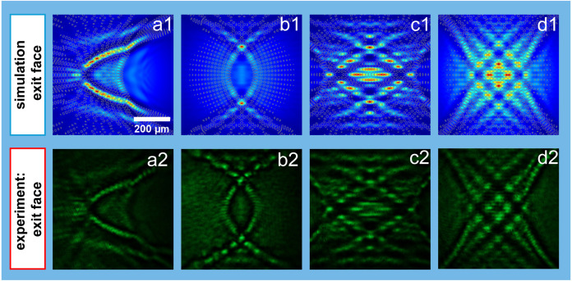

Figure 1. Verification of deterministic aperiodic photonic lattices inscribed in a photorefractive SBN crystal through probe beam propagation. Intensity distributions of the probe beam at the exit face of the crystal obtained numerically (the top row) and experimentally (the bottom row). Contours in numerical results indicate waveguide position.

REFERENCES

[1] Z. V. Vardeny, A. Nahata, A. Agrawal, Nat. Photonics 7, 177 (2013).
[2] M.A. Bandres, J.C. Gutiérrez-Vega, S. Chávez-Cerda, Opt. Lett. 29, 44–46 (2004).
[3] J. M. Vasiljević, A. Zannotti, D. V. Timotijević, C. Denz, D. M. Jović. Savić, Phys. Rev. A 96, 023840 (2017).
[4] A. Ž. Tomović, I. J. Vlaović Mitić, V. P. Jovanović, D. V. Timotijević, D. M. Jović Savić, Optical Materials 157, 116334 (2024).

