Controllable Splitting and Coherently Recombining Intense Femtosecond Pulses Using Structured Light

L. I. Stoyanov^{1, 2}, Y. Zhang^{3,4}, A. Dreischuh^{1,2,5} and G. G. Paulus^{3,4}
¹Department of Quantum Electronics, Faculty of Physics,
Sofia University "St. Kliment Ohridski", Sofia, Bulgaria
²National Centre of Excellence Mechatronics and Clean Technologies, Bulgaria
³Institute of Optics and Quantum Electronics, Friedrich Schiller University, Jena, Germany
⁴Helmholtz Institute Jena, Jena, Germany
⁵Bulgarian Academy of Sciences, Sofia, Bulgaria
e-mail: l.stoyanov@phys.uni-sofia.bg

It is generally known that at high energies/powers intense femtosecond beams/pulses are prone to instabilities (see e.g., [1]). These effects, to some extent, could be mitigated through the controlled splitting of the beam into sub-beams. However, this approach is only viable if there exists a reliable method to coherently recombine the sub-beams following their spectral broadening. To achieve this, we use known objects from the field of singular optics, namely optical vortex lattices [2-4]. Such beams enable controllable and reversible break-up into an ordered array of well-defined intensity peaks in the focal plane of a lens (i.e., in the artificial far field, where the intensity is high). A typical example of a square-shaped optical vortex lattice is shown in Fig. 1.

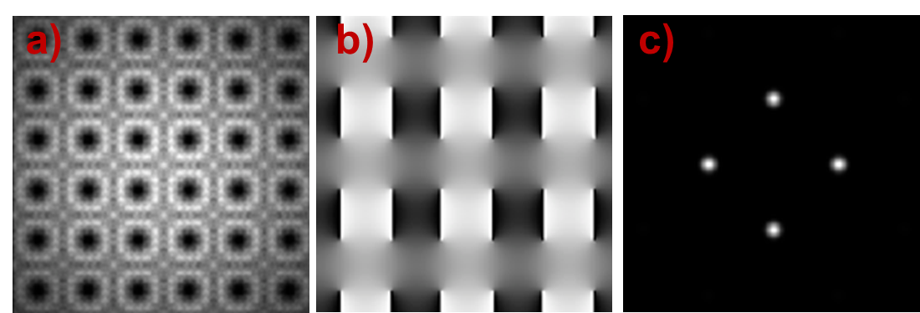
Figure 1. Numerical intensity and phase distributions (a) and (b) of a square-shaped optical vortex lattice composed by singly-charged optical vortices with alternative signs. (c) – intensity profile of the square-shaped optical vortex lattices in the focal plane of a lens.

In this talk, we will present our recent advances [5] in addressing spectral broadening and temporal compression of high-energy femtosecond pulses by the controllable splitting and coherent beam recombining of femtosecond beams/pulses using structured light, more precisely square-shaped optical vortex lattice. Moreover, the compression in time (down to the Fourier transform limit) of the spectrally broadened pulses will be demonstrated and discussed as well. In our view, the obtained results serve as a strong motivation for further optimization and investigation serving as potential alternative to the established methods for coherent beam recombining.

We acknowledge funding of the Bulgarian National Science Fund (project KΠ-06-H78/6). The work was also supported by the Bulgarian Ministry of Education and Science as a part of National Roadmap for Research Infrastructure, project ELI ERIC BG and by the European Regional Development Fund under "Research Innovation and Digitization for Smart Transformation" program 2021-2027 under the Project BG16RFPR002-1.014-0006 "National Centre of Excellence Mechatronics and Clean Technologies".

REFERENCES
[1] A. Braun, G. Korn, X. Liu, D. Du, J. Squier, and G. Mourou, Opt. Lett. 20, 73-75 (1995).
[2] L. Stoyanov, G. Maleshkov, M. Zhekova, I. Stefanov, D. N. Neshev, G. G. Paulus and A. Dreischuh, J. Opt. Soc. Am. B, vol. 35, pp. 402-409 (2018).
[3] L. Stoyanov, G. Maleshkov, M. Zhekova et al., Journal of Optics, vol. 20, Art. No. 095601 (2018).
[4] L. Stoyanov, G. Maleshkov, M. Zhekova et al., Scientific Reports, vol. 9, Art. No. 9:2128 (2019).
[5] L. Stoyanov, G. Maleshkov, M. Zhekova et al., Opt. Express 32, 48758-48771 (2024).

