Optomechanics of nanoparticles in a hybrid anapole state

S.R. Rozental, D.A. Kislov, A.S. Shalin
Moscow Institute of Physics and Technology, Moscow, Russia
e-mail: rozental.sr@phystech.edu

Nowadays, anapole states [1], which are distinguished by the absence of the far-field radiation from one of the multipole channels excited in the particle, have become a subject of significant interest in nanophotonics. These states are able to efficiently store energy, which allows their further use, for example, for laser generation [2]. It has recently been demonstrated that it is possible to combine several anapole states at the same wavelength, which leads to a significant suppression of light scattering by a nanoparticle. This phenomenon is referred to as the hybrid anapole state (HAS) [3, 4]. The present work analyses the effect of the hybrid anapole state on the optical forces acting on a silicon cylindrical nanoparticle irradiated by a focused Gaussian beam – Figure 1.
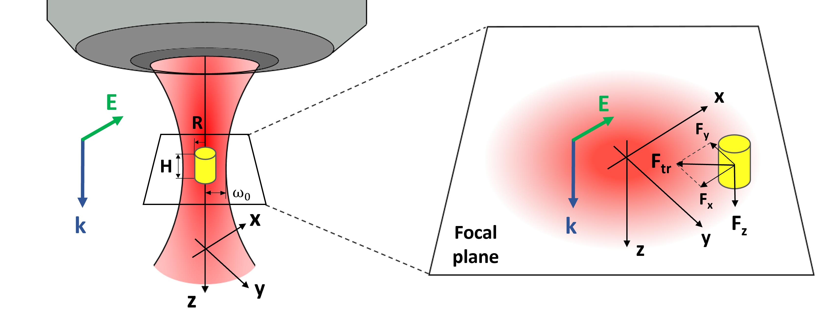
Figure 1. A cylindrical silicon nanoparticle placed in the focus of a linearly-polarized Gaussian beam. The inset shows the components of the optical force acting on the nanoparticle

It was found that near the HAS the system is highly sensitive to changes in the nanoparticle size. The Figure 2 compares transverse forces, acting on the HAS nanoparticle with the radius of 188 nm, and on the nanoparticle with normal scattering (R = 210 nm). Panels 1 and 3 show the distribution of the total transverse forces in the focal plane, and panels 2 and 4 show the trajectories of a nanocylinder subjected to these forces, which were obtained by solving the Langevin equation for some randomly selected 20 initial points in the focal plane.
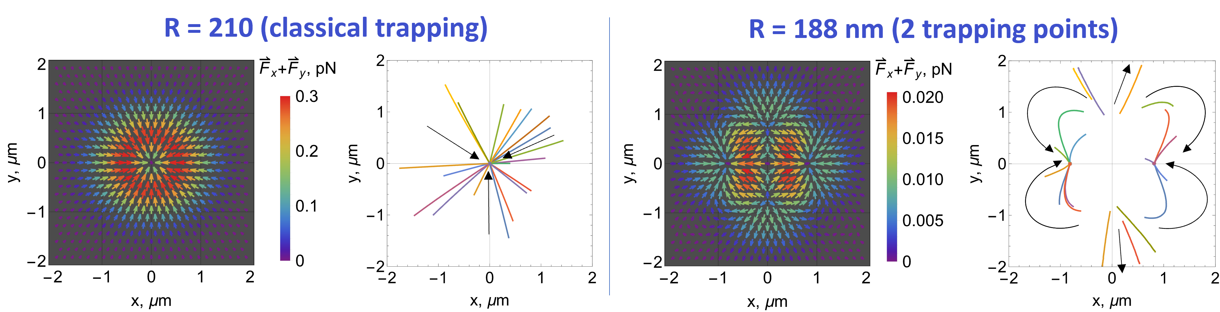
Figure 6. Distribution of the total transverse optical force acting on nanocylinders of different radii in the focal plane (left panels) and the trajectories of their movement under the influence of this force (right panels)

A fundamentally new phenomenon was identified, which is realized exclusively in the HAS: particle trapping at two points outside the optical axis. In contrast, within the non-anapole regime, a single trapping point is observed. The differences in the trapping scenarios can be leveraged for the purpose of optomechanical sorting of nanoparticles.

The author acknowledges the financial support from the Russian Science Foundation (Grant № 25-22-00266)).

REFERENCES
[1] E. A. Gurvitz, K. S. Ladutenko et al, Laser Photonics Rev. 13, 1–13 (2019)
[2] A. Tripathi et al, 21, Nano Letters, 1-7 (2021)
[3] B. Luk’yanchuk, R. Paniagua-Domínguez et al, Phys. Rev. A 95, 1–8 (2017)
[4] A. Canós Valero et al., Laser Photonics Rev. 15, 1–14 (2021)

