Efficacy of Multiple-Antenna Microwave Ablation in the Treatment of Liver Tumors

N. Bošković, B. Radjenović and M. Radmilović-Radjenović¹
Institute of Physics, University of Belgrade, Belgrade, Serbia
e-mail: marija@ipb.ac.rs

Microwave ablation (MWA) is a minimally invasive thermal ablation technique used to treat various tumors, particularly in the liver. Both single-antenna and multi-antenna MWA are similarly effective for local tumor treatment; however, synchronous multi-antenna MWA offers improved local tumor progression-free survival, especially for larger tumors [1].
In addition to clinical studies, computational models have significantly contributed to predicting MWA outcomes, particularly three-dimensional (3D) models of an antenna and targeted tissue without assumptions of homogeneity [2]. This study aimed to determine optimal parameters for treating a large tumor (from a database [3]) using two identical 10-slot coaxial antennas.
Figure 1 illustrates the results from a single probe (above) and three probes arranged in a triangular formation (below), operating at a) 15 W and b) 16 W per probe. At 15 W, the overlapping ablation zones from simultaneous activation significantly enhance the overall ablation size, covering almost the entire tumor. The total ablation volume is 57% larger than three times the volume of a single 15 W probe. Since only small tumor areas remain outside the ablation zone, a slight increase in power would likely suffice. At 16 W per probe, complete tumor destruction is achieved, with the ablation volume being 43% larger than three times the volume of a single 16 W probe and 10% larger than with three probes at 15 W.

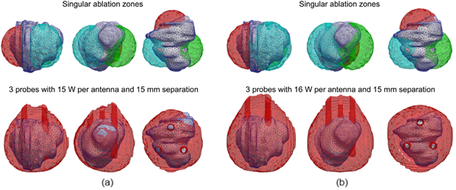

Figure 1. Ablation zones corresponding to a single antenna (above) and three antennas (below) with a separation of 15 mm and input power of: (a) 15 W per antenna, (b) 16 W per antenna.

REFERENCES
[1] N. Bošković, S. Nikolić, B. Radjenović, M. Radmilović-Radjenović, Bioengineering 11, 1133 (2024).
[2] N. Bošković, B. Radjenović, S. Nikolić, M. Radmilović-Radjenović, Open Phys. 22, 20240079 (2024).
[3] https://www.ircad.fr/research/data-sets/liver-segmentation-3d-ircadb-01/

