Grated target reflectivity evolution during laser prepulse irradiation.

A. Zubarev¹, M. Cuzminschi^{1,2}
¹National Institute for Laser, Plasma and Radiation Physics, 077125 Magurele, Ilfov, Romania
²Department of Theoretical Physics, ‘‘Horia Hulubei’’ National Institute for Physics and Nuclear Engineering, 07125 Magurele, Ilfov, Romania
e-mail: alxubarev@gmail.com

The laser-driven experiments are a promising way to produce accelerated particles and x-rays or to reproduce astrophysical phenomena in laboratory conditions. Laser target interaction can be significantly improved by choosing an appropriate target and the temporal profile of laser intensity. For the high performance of the laser-driven experiment, maximal radiation absorption is required.
In this work, we study the preplasma generation during prepulse target interaction and its influence on the target reflectivity. The prepulse influence on target reflectivity was studied numerically using the FLASH simulation program [1] and analytically using the effective refractive index model and Bloch wave approximation. The laser radiation heats the target and the material is ablated [2]. The preplasma distribution in front of the target for flat and grated targets is shown in Fig. 1 (a) and (b). The numerical simulations show that laser absorption is lower for a grated target than for a grated one (Fig. 1 (c)). The angle of incidence is about 15 degrees, which ensures the best radiation absorption for the grated target.
The analytical model predictions are in agreement with numerical simulation results. The reflectivity of the grated target decreases after the preplasma generation. During the preplasma generation its density increases and the reflectivity changes. After the preplasma density reaches critical value the reflectivity increases fast.
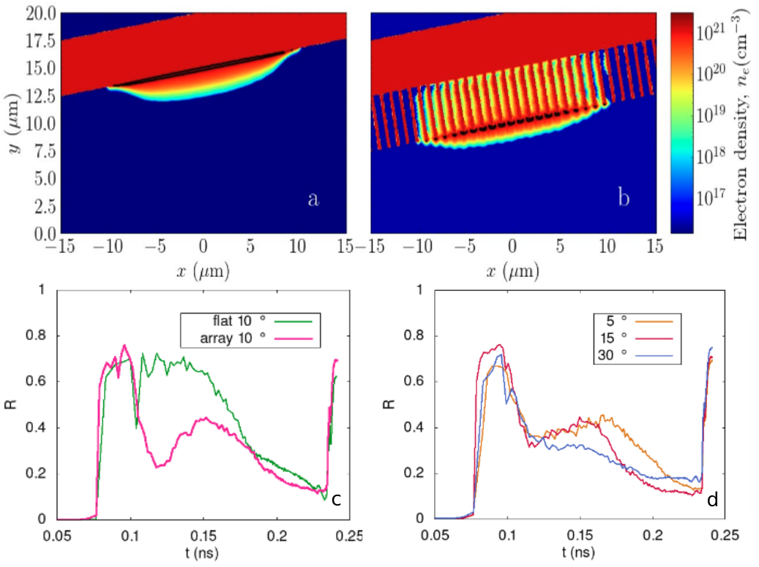
Figure 1. Preplasma evolution during prepulse iradiation in front of flat (a) and grated (b) targets. Reflectivity evolution during the irradiation for flat and grated tagets (c) and for grat targets for different angles of incidence (d). Figure reproduced from [3].
REFERENCES
[1] Fryxell, Bruce, et al. Astrophys. J Suppl. Ser. 131.1 (2000): 273.
[2] Ong, J. F., et al. Sci. Reports 13.1 (2023) 20699.
[3] Zubarev, A., et al. An. West Univ. Timis. Phys. Ser. 0001, Vol. LXVII, 2025
Funding: UEFISCDI PN-IV-P7-7.1-PED-2024-079, PN-IV-P2-2.1-TE-2023-1102 and IOSIN

