A CALIBRATION METHOD FOR LASER INTERFEROMETRIC INSTRUMENT COMPLEXES BASED ON STIMULATED MANDELSTAM-BRILLOUIN SCATTERING EFFECT

Tavleev Aleksey Aleksandrovich¹, Kubasov Pavel Vyacheslavovich¹, Tikhov Aleksandr Alekseevich¹, Kamenev Vladimir Gennadievich¹, Arapov Yuriy Dmitrievich¹
¹The Federal State Unitary Enterprise Dukhov Automatics Research Institute (VNIIA), Moscow, Russia
e-mail: alaltav@mail.ru

The work is dedicated to the study of nonlinear effects in optical fibers as a source of calibration signals for PDV and VISAR systems, as well as to the development of a method for generation calibration lines for laser interferometric instrument complexes intended for use in gas-dynamic experiments. In such experiments, the registration of the displacement (as well as the velocity and/or acceleration) of a moving surface of complex shape and multiple points. This problem is solved by measuring the Doppler shift of the frequency of scattered laser radiation from a moving surface. Interference of scattered laser radiation with a reference radiation (PDV) [1] or with itself, delayed in time by a fiber optic line (VISAR) [2] is used to determine the magnitude of the Doppler shift. Calibration of measurement systems using certified objects is necessary, so the development of a calibration method for these complexes that allows comparing measurement results obtained by different methods is a pressing task.
The presented work is aimed at solving the problem of creating a universal method for calibrating laser-optical measuring systems and expanding the operating range of measuring speeds. The report presents the results of assessments and experimental studies of the influence of nonlinear optical effects based on stimulated light scattering in optical fibers on the characteristics of Doppler laser diagnostic systems.
The proposed method is based on the occurrence of the nonlinear effect of stimulated Mandelstam-Brillouin scattering under the influence of laser radiation in optical fibers. Experimental verification of this method has been conducted on laser interferometric instrument complexes such as PDV and VISAR, which are used in gas-dynamic experiments in conjunction with other control and measurement equipment and technical means.
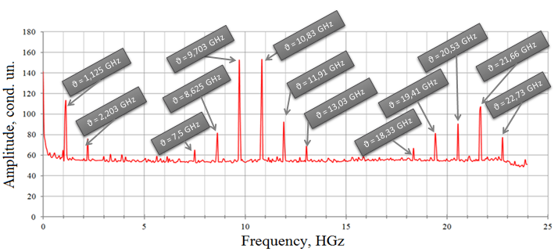
Figure 1. General calibration spectrum.
REFERENCES
[1] D.H. Dolan / Extreme measurements with Photonic Doppler Velocimetry (PDV) // Rev. Sci. Instrum. № 91, doi: 10.1063/5.0004363, 2020.
[2] Lynn M. Barker / The development of the VISAR, and its use in shock compression science // AIP Conf. Proc. 505, c.11-18, doi: 10.1063/1.1303413, 2000.

