Monitoring Adsorption and Reduction Kinetics in a Plasmonic Microreactor Using Methylene Blue as a Model System

O. Jakšić¹, K. Radulović¹, M. Bošković¹, M. Obradov¹ and D. Vasiljević-Radović¹
¹Department of Microelectronic Technologies, Institute of Chemistry, Technology and Metallurgy—National
Institute of the Republic of Serbia, University of Belgrade, Njegoševa 12, 11000 Belgrade, Serbia
e-mail: olga@nanosys.ihtm.bg.ac.rs
We explore a plasmonic microreactor concept designed for real-time monitoring of surface adsorption and catalytic transformations. As a model system, we study the adsorption and subsequent reduction of methylene blue (MB) on a gold surface, forming leuco-methylene blue (LMB). The proposed reaction is represented by a stoichiometric equation and schematically shown in Fig 1 (left).
To interpret the temporal sensor response, we develop a kinetic model that describes the evolution of MB in solution, its adsorption onto gold, and its conversion to LMB. The model incorporates rate constants for adsorption, desorption, and surface-bound reduction, along with a conservation law for total surface binding sites and MB molecules. For a realistic parameter set [1], Fig 1 (right) shows exponential relaxation toward a steady state, a numerical solution to the model, illustrating the dynamic changes in molecular populations.
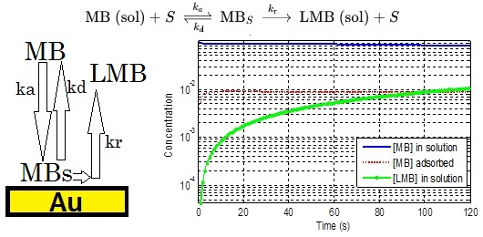
Figure 1. Top: Stoichiometric equation showing how free surface site S gets occupied byu an MB molecule and released again after MB catalytically reduces to LMB (which does not stay on the surface and does not re-adsorb). Left: schematic block diagram. Right: Temporal response of reactants assuming concentration of the reducing agent is constant and in large excess.
The refractive index change is proportional to the change in surface-bound MB population, so plasmonic read-out in these microreactors supports the integration of photonic devices allowing for simultaneous plasmonic sensing and reaction monitoring.
Further model refinement involves multicomponent adsorption, surface heterogeneity (e.g., gold microstripes), spatially varying reactivity and system alterations and optimizations with respect to practical problems [2]. This approach enables dual-function microreactors where optical read-out assists both in-situ detection and quantitative modeling of surface reactions.
REFERENCES
[1] Sharma, K., Sharma, S., Sharma, V., Mishra, P. K., Ekielski, A., Sharma, V., & Kumar, V. (2021). Methylene blue dye adsorption from wastewater using hydroxyapatite/gold nanocomposite: Kinetic and thermodynamics studies. Nanomaterials, 11(6), 1403.
[2] Aravind, A., Dhinasekaran, D., & Rajendran, A. R. (2025). Titanium Mxene: A Promising Material for Next‐Generation Optical Biosensors and Machine Learning Integration. Analysis & Sensing, 5(2), e202400095.

