**Topologically Protected Modes in Diamond-like Photonic Ribbons**

M. Nedić1, M. G. Stojanović1, G. Gligorić1, J. Petrovic1 and A. Maluckov1

1*COHERENCE,* *Vinca Institute of Nuclear Sciences, University of Belgrade, National Institute of the Republic of Serbia*

e-mail:milica.brankovic@vin.bg.ac.rs

The discovery of topologically protected modes has marked a major milestone in photonics, enabling robust light transport immune to disorder, backscattering, and fabrication imperfections. These modes have opened new possibilities in integrated photonic circuits, quantum information processing, and topological lasers. Recently, compact topological edge modes have been demonstrated experimentally in a quasi-one-dimensional ribbon structure with a hexagonal unit cell [1]. These modes combine the robustness of topological edge states with the spatial confinement of compact modes, offering dual-layer protection that makes them highly promising for applications.

Here, we investigate the necessary conditions for the emergence of such modes in ribbon lattices composed of diamond-like unit cells. We design two different geometries in which an energy spectrum can be engineered through femtosecond (fs) laser writing of S- and P-type waveguides [2]. The specific ordering of couplings in the lattice induces an effective π-flux, which plays a key role in the band flattening mechanism.

By continuously tuning this artificial flux, we theoretically demonstrate transitions between trivial and nontrivial topological phases. At Φ = π, all bands become flat, and compact localized states emerge. Using projector-based topological invariants and the mean chiral displacement method [3], we characterize the bulk-boundary correspondence and confirm the topological nature of the gapped bands and the associated edge modes.

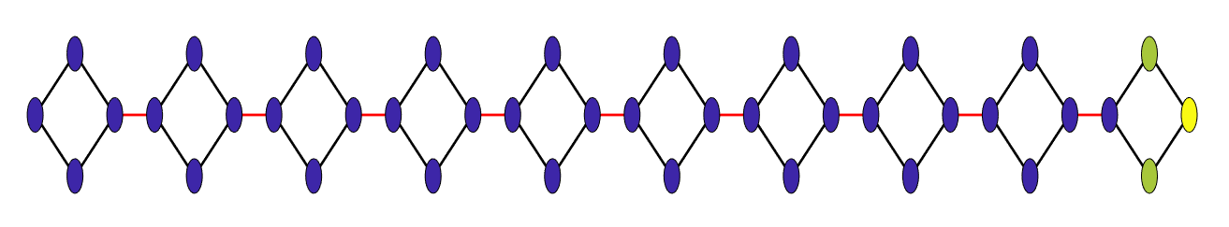

Figure 1. Topological edge state in diamond-like ribbon.

REFERENCES

[1] G. Cáceres-Aravena, M. Nedić, P. Vildoso, G. Gligorić, J. Petrovic, A. Maluckov, and R. A. Vicencio, Phys. Rev. Lett. 133, 116304 (2024).

[2] A. Szameit, D. Blömer, J. Burghoff, T. Schreiber, T. Pertsch, S. Nolte, A. Tünnermann, and F. Lederer, Opt. Express 13, 10552 (2005).

[3] F. Cardano, A. D’Errico, A. Dauphin, et al., Nat. Comm. 8, 15516 (2017).