Near-infrared Light-Driven Nanomotors: Toward Ballistic Transport of Medicaments Across the Cell Membrane

D. K. Božanić¹, D. Danilović¹, J. Pajović², B. Ristić³, A. Abu el Rub¹, V. Djoković¹, T. Mišeljić⁴

¹Vinča Institute of Nuclear Sciences – National Institute of the Republic of Serbia, University of Belgrade,
Belgrade, Serbia
²Faculty of Physics, University of Belgrade, Belgrade,Serbia
³Institute of Medical Research, University of Belgrade, Belgrade, Serbia
⁴The Danish National Research Foundation and Villum Foundation's Center for Intelligent Drug Delivery and Sensing Using Microcontainers and Nanomechanics, Department of Health Technology, Technical University of Denmark, Lyngby, Denmark
e-mail: bozanic@vinca.rs

Nanotechnology-based drug or gene delivery relies on effective internalization of molecular cargo in cells. However, external material is typically taken up via clathrin- or caveolae-mediated endocytosis, leading to localization of nanoparticles within lysosomes upon internalization. This endo-lysosomal pathway typically results in degradation of molecular cargo, rendering delivery inefficient and possibly inducing cell death. In this study, we outline a strategic framework to address this challenge by introducing an innovative method that utilizes near-infrared (NIR) light-driven nanomotors [1] for the ballistic transport of molecular cargo across cellular membranes (Figure 1.).

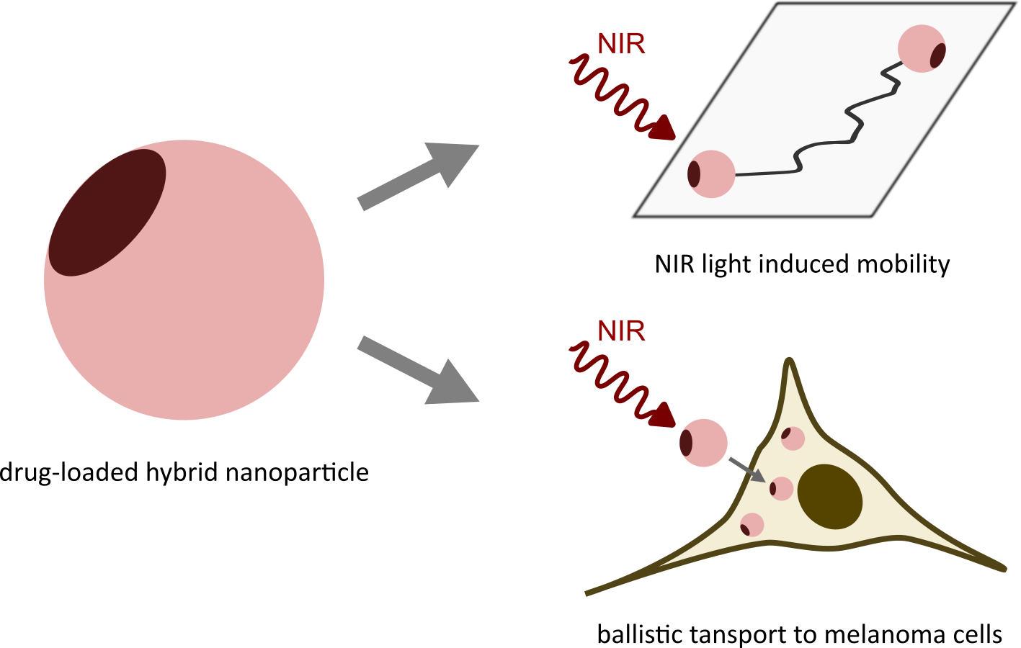

Figure 1. Roadmap to development of hybrid nanosystems capable of near-infrared light-induced ballistic transport of molecular cargo across the cell membrane.
REFERENCES
[1] D.Danilović, T. Maric, D.K. Božanić. J. Pajovic, G. Garcia, L. Nahon, Z. Zhang, A. Boisen, V.Djokovic, Nano research 18, 94907505 (2025)

