Morphological transformation of (In,Ga)N nanoshells grown around pencil-like GaN nanowires
Jovana Obradović¹, Miguel Tinoco², Laura Monge Bartolomé³, Víctor J. Gómez³, Almudena Torres-Pardo², Sergio Fernández-Garrido¹, Álvaro Guzmán¹, Žarko Gačević¹
¹ Institute for Optoelectronic Systems and Microtechnology (ISOM), Universidad Politécnica de Madrid, Madrid, Spain
² Inorganic Chemistry Department, Chemical Sciences Faculty, Universidad Complutense de Madrid, Madrid, Spain
³Nanophotonics Technology center, Universitat Politècnica de València, Valéncia, Spain
e-mail: j.obradovic@upm.es

GaN/(In,Ga)N/GaN pencil-like nanowires (NWs) are promising nanostructures for the development of single photon sources with highly tunable emission wavelengths and lifetimes [1]. A major challenge in advancing these structures lies in the limited understanding and control of In incorporation. One reason for complicated In incorporation into the NW shells could be the NW geometrical transition from r- (10-12) to s- (10-11) semi-polar crystal plane, observed from GaN to (In,Ga)N growth. In this work, we study and propose a growth model of (In,Ga)N nanoshells grown around (0001) oriented pencil-like GaN nanowires.
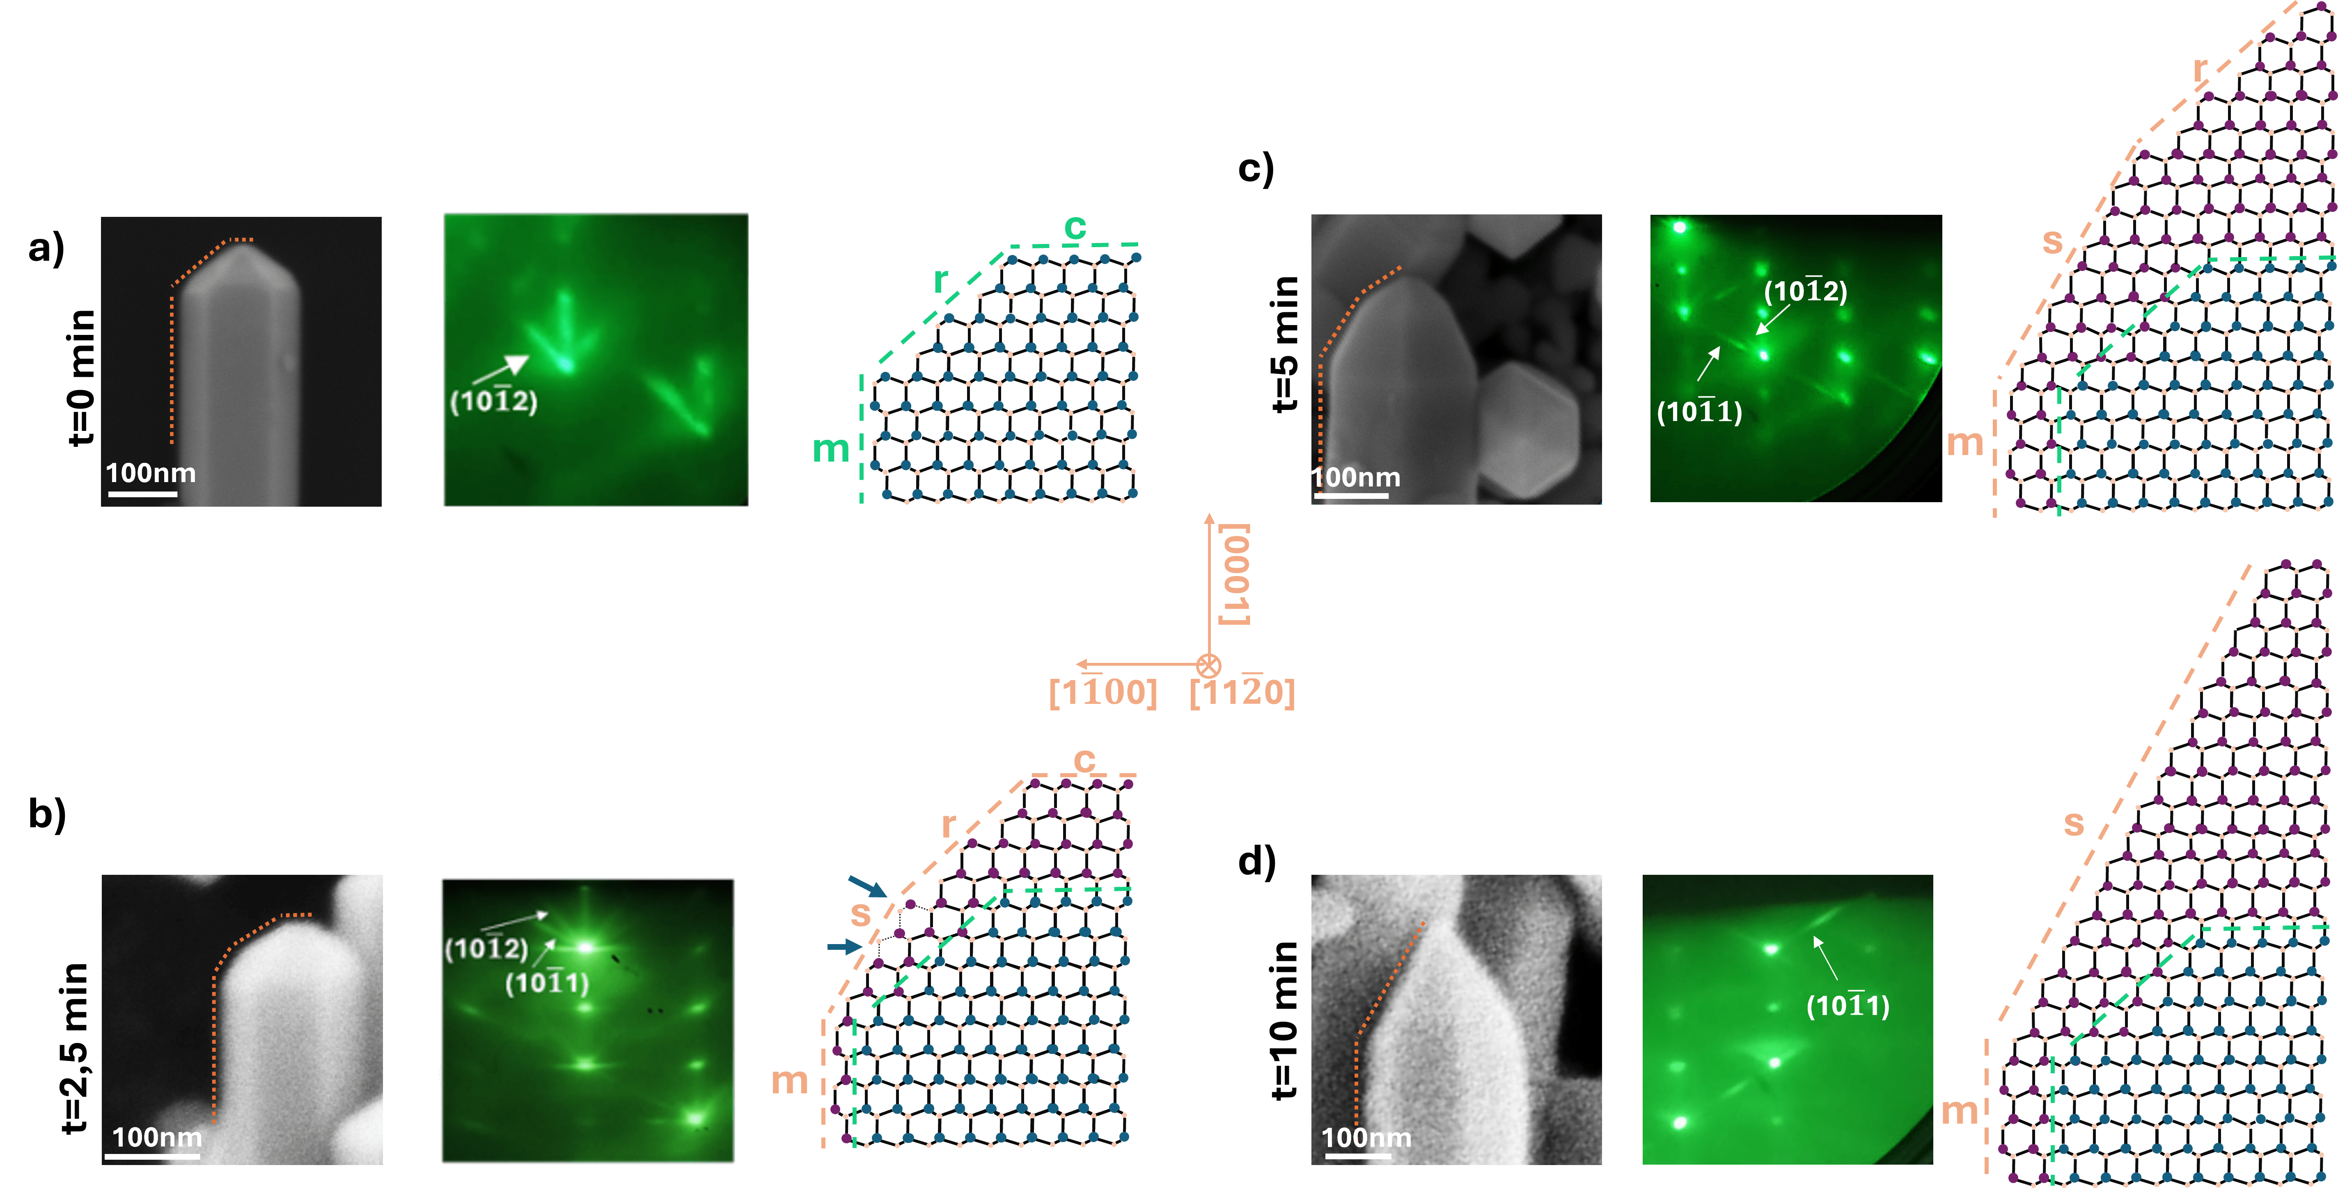
Figure 1 a)- d): Stages of the (In,Ga)N nanoshell growth, illustrated by a cross-view SEM images of single representative NW - RHEED diffraction patterns obtained along [11-20] azimuth, and an atomic sketches of the NW tip.

All samples were grown by plasma-assisted molecular beam epitaxy on commercial GaN-on-sapphire substrates, with a deposited Ti mask with nanoholes prior to the growth, so that growth selectivity can be achieved. The growth was performed in 2 steps: (i) GaN NWs growth, with fixed parameters, and (ii) (In,Ga)N nanoshell growth, with increasing growth time from sample H1 to sample H4 (0 min - 10 min, Figures 1 a)- d)). With addition of (In,Ga)N nanoshell, the initial GaN nanowires [Figure 1a)], progressively undergo through morphological changes, as shown in Figures 1b) and 1c). In this transition, semi-polar s- crystal planes appear and grow at the expense of r- and c- crystal planes, resulting in a structure dominated by m- and s- planes (Figure 1 d)). We propose a model of this geometrical transformation based on minimization of surface energy [2]. Furthermore, considering the instability of certain crystal planes we investigate In incorporation on the NW tops and sidewalls through two additional growth series, varying In impinging flux or growth temperature of the (In,Ga)N shell. These studies provide additional insights into both In incorporation and the (In,Ga)N luminescence in such nanostructures.

REFERENCES
[1] Ž. Gačević et al., ACS Photonics 4, 657 (2017).
[2] H. Liet al., Phys. Rev. Lett. 115, 085503 (2015).

