On the optical properties of laser-generated plasmonic nanoalloys and their use for the assessment of biodegradable nanomedicines

V. Amendola
¹Department of Chemical Sciences, University of Padova - Padova, Italy
e-mail: vincenzo.amendola@unipd.it

Compared to traditional plasmonic materials like gold and silver, their alloys exhibit a range of unique and enhanced properties, positioning them at the intersection of nanophotonics and various other disciplines, including catalysis and magnetism.[1] Less known, some nanoalloys of Au or Ag hold significant promise for cancer theranostics, offering multiple functionalities: they can be tracked in vivo using conventional imaging techniques such as magnetic resonance imaging (MRI) or X-ray computed tomography (CT) while also exerting therapeutic effects, such as enhancing radiotherapy.[2-4] Notably, certain nanoalloys of Au or Ag with carefully tuned compositions have demonstrated their ability to meet also a critical requirement like biodegradability, which is essential for minimizing the risks associated with the long-term persistence of nanomaterials in the body.[2-4] However, despite this immense potential, the synthesis of nanoalloys with the ideal theranostic characteristics is challenging due to the natural immiscibility of Au and Ag with other functional and biocompatible elements like iron or boron. Therefore, it is crucial to rapidly and reliably monitor synthesis outcomes to optimize fabrication protocols, which are possible only by laser ablation in liquid. Additionally, identifying biodegradable nanoalloy compositions requires extensive experimentation, as it necessitates tracking their structural evolution over time and under various incubation conditions.
Fortunately, the plasmonic absorption band of these alloys is highly composition-dependent, enabling real-time monitoring of their structure. Here, we present several examples demonstrating how the optical properties of these plasmonic nanoalloys can be leveraged to design and assess an emerging class of advanced inorganic nanomedicines for cancer theranostics.[6]
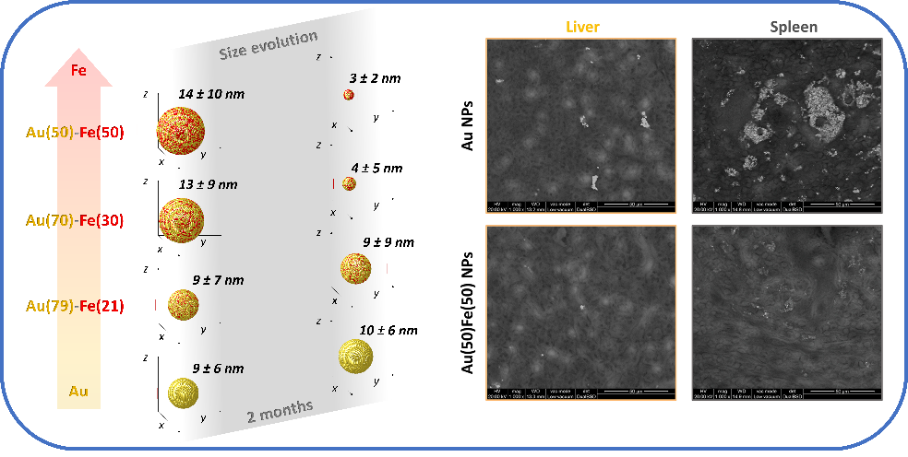
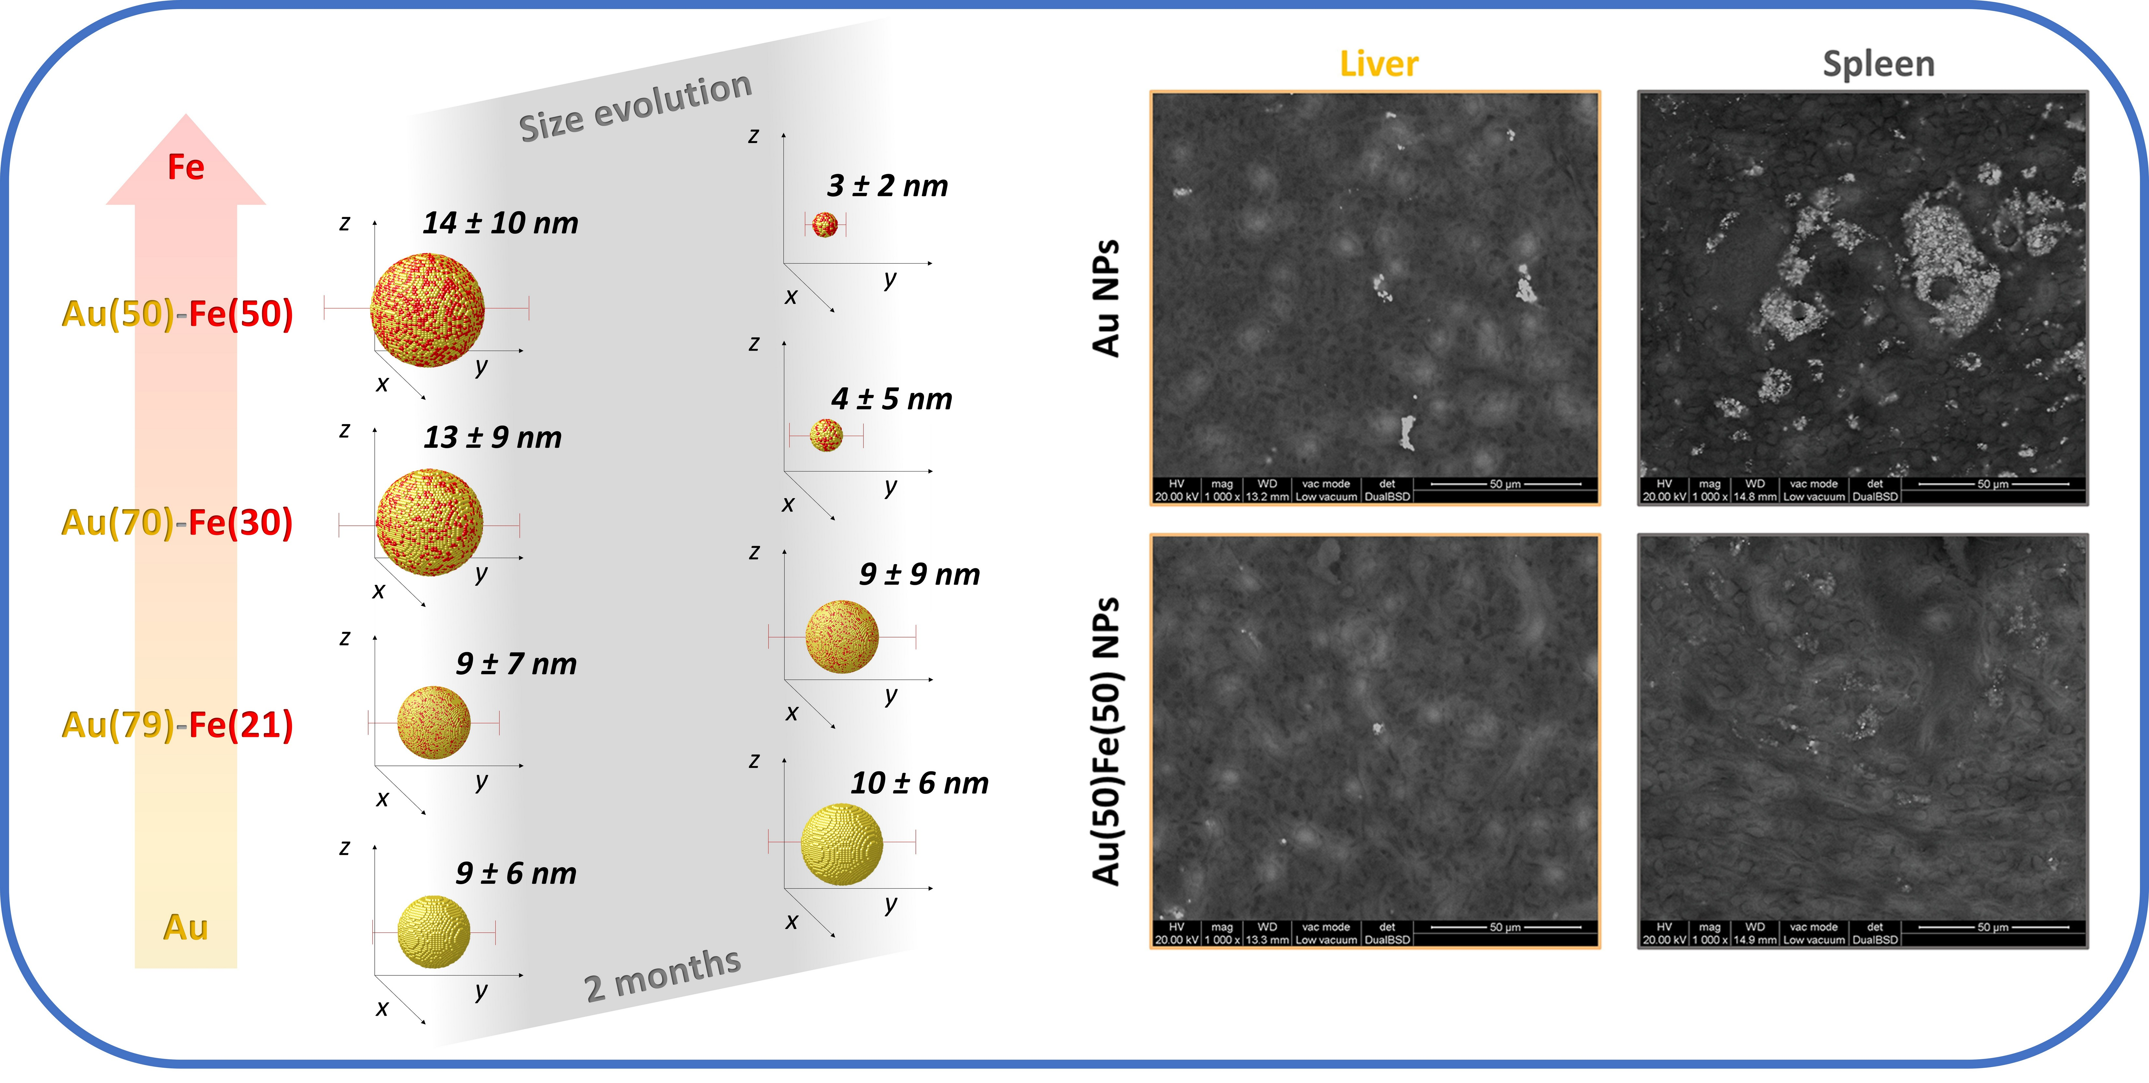
Figure 1. Left: Schematic depiction of the composition-dependent size transformation of Au-Fe nanoalloys, where an iron content above 30 at% corresponded to a size reduction below 10 nm after two months in the physiological environment. Right: The self-degradation and facilitated clearance of the Au-Fe nanoalloys was confirmed in murine models by environmental scanning electron microscopy images of their livers and spleens two months after administration. The animals treated with Au nanoparticles still show large agglomerates of gold, that are absent in the animals treated with Au-Fe nanoalloys.
REFERENCES
[1] Coviello, V., Forrer, D. and Amendola, V., ChemPhysChem 23, e202200136 (2022).
[2] Torresan, V., et al., ACS Nano 14, 12840–12853 (2020).
[3] Amendola, et al.., J. Colloid Interface Sci. 596, 332–341 (2021).
[4] Scaramuzza, S., et al., Adv. Funct. Mater. 33, 2303366 (2023).
[5] This research was funded by AIRC under the MFAG 2021-ID. 25681 project-P.I. A.V.

