A reflective holographic setup for simultaneous micro- and macro-scale imaging of biological samples
A. Minić¹, P. Atanasijević¹ D. Pavlović², B. Salatić², D. Pantelić³ and P. Mihailović¹
¹University of Belgrade, School of Electrical Engineering, Belgrade, Serbia
²University of Belgrade, Institute of Physics Belgrade, Belgrade, Serbia
³University of Belgrade, Senzor INFIZ, Belgrade, Serbia
e-mail: minicana50@gmail.com

Simultaneous imaging at multiple spatial scales can be essential for analyzing biological structures due to their complex nature, often exhibiting an intrinsic coupling of a wide range of multiphysics phenomena. A glowing example is the entangled opto-thermo-mechanical response of the Morpho didius butterfly’s wing to the incoming infrared photons. It is shown that the opto-thermally induced displacements result in both the macro bending of the wing membrane and the micro bending of the wing scales, as well as the changes in the reflection spectrum of the whole sample [1,2].
Digital holography presents itself as a suitable approach for imaging of optical and mechanical changes on the sample’s surface, at both the macro- and the microscopic level. However, standard reflective digital holographic setups typically operate at a distinct magnification scale, as the need for the microscope objective to be very close to the sample’s surface prevents simultaneous macro-scale imaging. In this study, we demonstrate a compact reflection-configured off-axis digital holographic setup, enabling simultaneous micro- and macro-scale imaging of biological membrane samples with complex photonic structures on both sides. We overcome the difficulties in dual-scale holographic recording by separating the macro- and micro-scale imaging to the opposite membrane sides using two distinct optical paths. The photograph of the setup is shown in Fig. 1 (a). It consists of a single laser source at 532 nm, illuminating both sides of the sample, and two synchronized cameras, one capturing the wide-field image and the other capturing the real, magnified image after the microscope objective. To demonstrate the operation of the proposed holographic macro-microscope, we image the wing of a M. didius butterfly suspended in air. The reconstructed macroscopic and microscopic intensity images are shown in Fig. 1 (b) and (c), respectively. Both images show distinct structural features – scale patterns on the membrane and the overlapping scales. Based on the results presented, the proposed reflective macro-microscope shows promise in imaging a wide range of complex biophotonic specimens, enabling comprehensive analysis of their inseparable structural multiphysics at a dual scale.
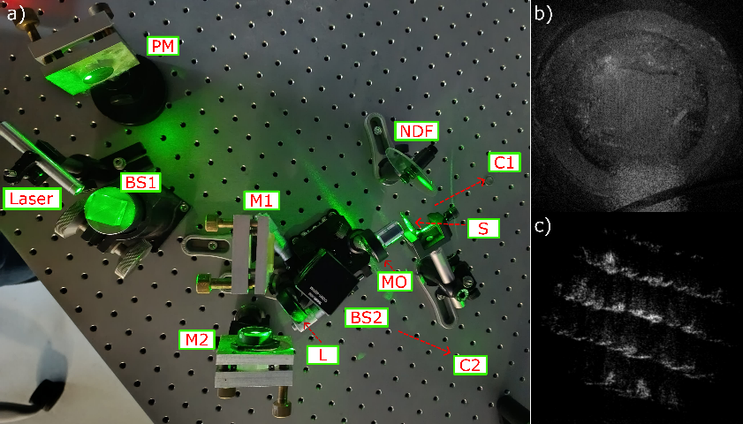
- b)
Figure 1. a) Photograph of the proposed macro-microscope. M. didius macro-scale (b) and micro-scale (c) intensity images. BS – beam splitter, M – mirror, PM – parabolic mirror, L – lens, C – camera, S – sample, NDF – neutral density filter.

Acknowledgment. The research was supported by the Serbian Ministry of Science, Technology, and Innovation (451-03-65/2024-03/200103). The research was partially conducted in the premises of the Palace of Science, Miodrag Kostić Endowment.

REFERENCES
[1] A. Pris et al., Nature Photon 6, 195–200 (2012).
[2] P. Atanasijević et al., Opt. Laser Technol., 159, 108919 (2023).

