End-to-end deep learning reconstruction of simulated off-axis holograms
M. Marinković¹, P. Atanasijević¹, M. Badža Atanasijević^{1,2}, F. Krajinić^{1,3}, P. Mihailović¹
¹University of Belgrade, School of Electrical Engineering, Belgrade, Serbia
²Innovation Center of the School of Electrical Engineering in Belgrade, Belgrade, Serbia
³University of Belgrade, Institute of Physics Belgrade, Belgrade, Serbia
e-mail: marinkovic.d.marija@gmail.com

In recent years, hologram reconstruction using deep learning models has garnered significant attention due to its potential to accelerate and simplify the reconstruction process, and reduce its computational cost, making holographic imaging more accessible [1,2]. To this day, most reported studies on both simulated and experimental holograms focus on either near-field or in-line approaches, where the object can often be recovered even from low-resolution inputs [3-5]. The best-performing architectures, e.g., generative adversarial networks (GANs), are usually computationally heavy. On the other hand, typically reported U-net-like architectures are usually extended in complexity via the utilization of residual units, multi-path bottlenecks, or multi-branch decoders [3-5].
In this study, we investigate the feasibility of applying an end-to-end deep learning approach for reconstructing high-resolution, off-axis holograms at higher propagation distances using a dataset of simulated 1024x1024 holograms. The hologram simulation process was conducted using MNIST [6] images as amplitudes of the complex object field with the randomized phase and the wavelength of 532 nm. The field is further propagated to a distance of 95 cm, where it interferes with a spherical reference wave at an angle of ~3°, creating the final hologram. The zoomed portion of a representative simulated hologram is shown in Fig. 1 (a).
The proposed autoencoder model employs multiple attention mechanisms – convolutional block attention modules in the encoder, squeeze-and-excitation blocks in the decoder and bottleneck, and attention-gated skip connections - alongside multi-feature extraction layers, dropout, and input striding, resulting in 12 million parameters. The model was developed in Google Colab using PyTorch, and was trained, validated, and tested in a ratio 80%:10%:10% on 10,000 holograms using an A100 GPU. We tested the model’s performance using the structural similarity index, and gained the result of 0.93±0.03, which is comparable to similar, in-line approaches [4,5]. Fig. 1 (b) and (c) show the ground truth and model prediction images, demonstrating the performance of the proposed approach.
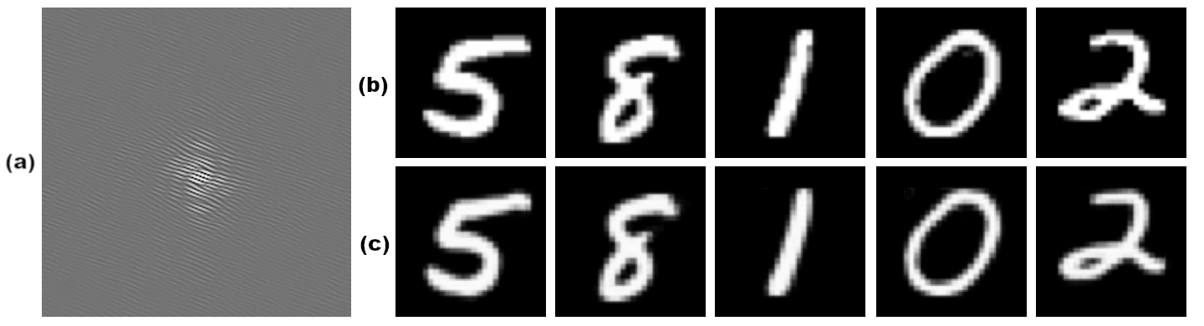
The presented results promise that the proposed model will serve as a strong starting point in the future transition to experimental data, filling in the niche of deep learning off-axis hologram reconstruction at higher propagation distances.
Figure 1. (a) The zoomed portion of a representative hologram, showing the interference fringes. (b) Ground truths and (c) model prediction images.

Acknowledgment. The research was supported by the Serbian Ministry of Science, Technology, and Innovation (grants 451-03-65/2024-03/200103 and 451-03-136/2025-03/200223). The research was partially conducted in the premises of the Palace of Science, Miodrag Kostić Endowment.

REFERENCES
[1] G. Situ, Light: Advanced Manufacturing 3, 278 (2022).
[2] T. Zeng, Y. Zhu, E.Y. Lam, Opt. Express 29, 40572 (2021).
[3] X. Sun, C. Xiong, Z. Ren, Opt. Express 33, 3414 (2025).
[4] A.S. Svistunov, D.A. Rymov, R.S. Starikov, Appl. Sci. 13, 6125 (2023).
[5] H. Wang, M. Lyu, G. Situ, Opt. Express 26, 22603 (2018).
[6] L. Deng, IEEE Signal Processing Magazine, 29(6), 141–142 (2012).

