Laser-Induced Graphene and MXene on Biocompatible Polymer Substrates as Physical Sensors

Marko Spasenović, Teodora Vićentić, Anđela Gavran, Vanja Vojnović, Ivan Pešić, Katarina Tošić, Milena Rašljić-Rafajilović, Stefan Ilić, Marija V. Pergal

Center for Microelectronic Technologies, Institute of Chemistry, Technology and Metallurgy – National Institute of the Republic of Serbia, Belgrade, Serbia

Email: marko.spasenovic@ihtm.bg.ac.rs

Laser-induced graphene (LIG) offers a highly adaptable platform for applications such as physiological sensing, electrode fabrication, gas detection, and biosensing [1, 2]. Traditionally, research has centered on commercial polyimide (PI) tape as the substrate for LIG production. While PI enables the formation of LIG with favorable electronic properties, its limited adhesion and lack of stretchability pose challenges for wearable device integration. To overcome these constraints, we introduce a novel strategy: laser induction of graphene on biocompatible, synthesized cross-linked polymers. These include sodium alginate, PDMS/PEG composites, cross-linked polyurethanes (PUs) derived from ethoxypropyl-terminated PDMS macrodiol, and custom-synthesized polyimides. These materials exhibit desirable mechanical strength, non-cytotoxicity, and biocompatibility, making them promising candidates for wearable sensor platforms. Our study systematically identifies optimal chemical formulations and laser processing conditions for generating LIG on these substrates. Additionally, we explore MXene (Ti₃C₂Tₓ) layers as alternative active sensing components. The resulting devices are thoroughly characterized using optical, mechanical, biological, and chemical techniques. Finally, we demonstrate the real-world utility of LIG and MXene-based wearable patches for monitoring vital signs such as heartbeat, respiration, and limb movement. These findings lay the groundwork for next-generation, biocompatible, unobtrusive, and cost-effective thin-film sensors designed for continuous physiological monitoring.

This research was supported by the Science Fund of the Republic of Serbia, #4950, Polymer/graphene heterostructures for physiological sensors – Polygraph.

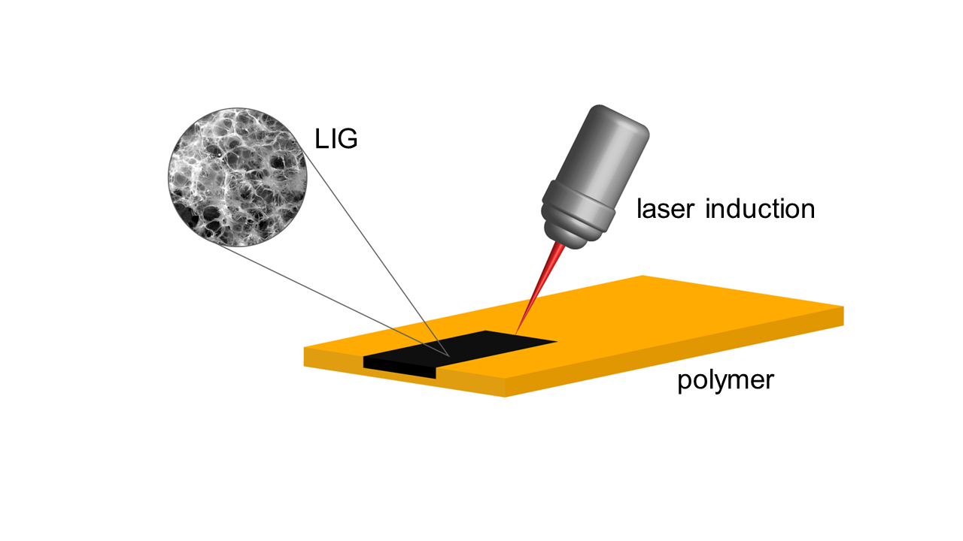

**Figure 1.** Representation of Laser Induction of Graphene on Polymer Substrate.

# References

1. Wang, M., Yang, Y., and Gao, W., *Trends Chem*. **3,** 969-981 (2021).

2. Vićentić, T., et al, *Sensors* **22**, 6326 (2022).