**Inverse Design for Femtosecond-Laser Photonic Surfaces with Direct Gradient Optimization**

A. Haboub1*, A. Khelif 2, and B. Aissa1

*1 Qatar Environment and Energy Research Institute, Materials Center,*

*Hamad Bin Khalifa University, Doha, Qatar.*

*2 College of Science and Engineering, Hamad Bin Khalifa University, Doha, Qatar.*

e-mail: amhaboub@hbku.edu.qa

The inverse design of photonic surfaces produced by high-throughput femtosecond laser processing is limited by a strongly non-linear, many-to-one mapping from laser parameters (power, speed, hatch spacing) to the resulting optical spectrum. Tandem Neural Networks (TNNs) mitigate this ill-posedness by pairing a forward surrogate with a separately trained inverse network, but they still rely on artificial noise injection to uncover diverse solutions and still explore the design space only sparsely. We propose Direct Gradient Optimization (DGO), a single-network alternative that treats the pre-trained forward surrogate as a differentiable proxy for the laser–material interaction and back-propagates errors all the way to the process parameters. This strategy (i) eliminates inverse-model training, (ii) allows the embedding of practical constraints such as laser-power penalties to be encoded directly in the loss function, and (iii) yields transparent sensitivity information through native gradients and SHapley Additive exPlanations (SHAP).

Two optimization modes are assessed: a single-start DGO and a parallel multi-start “Tournament” DGO that launches multiple random seeds, runs a brief qualification phase, and refines only the five most promising candidates. Across 10000+ inverse-design tasks, Tournament-DGO cuts the average spectral root-mean-squared error (RMSE) from 1.29 % (best TNN) to 0.70 %, and boosts design novelty (quantified by the Normalized Euclidean Parameter Distance, NEPD) from 0.26 to 0.38. A SHAP-based meta-analysis shows that convergence is dominated by the initial hatch spacing, explaining why broad sampling followed by pruning addresses this sensitivity. DGO delivers state-of-the-art accuracy, enhanced robustness, and diverse inverse solution without noise heuristics or extra model training. Its ability to embed manufacturability constraints directly in the optimization loop establishes a powerful, energy-aware platform for scalable photonic devices, thermal emitters, and meta surfaces.

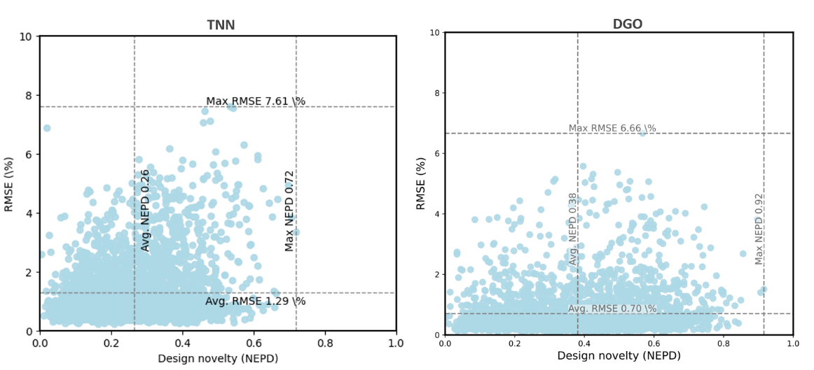

Figure 1. Comparison of TNN (left) and DGO (right) across 10,000+ inverse-design tasks. Points show spectral RMSE vs design novelty (NEPD). DGO achieves lower mean error (0.70\% vs 1.29\%) and higher novelty (0.38 vs 0.26).

REFERENCES

[1] M. Park, L. Grbčić, et al., Adv. Sci. 11(26), 2401951 (2024).

[2] L. Grbčić, M. Park, et al., npj Comput. Mater. 11(1), 35 (2025).